**CHAUTAUQUA INSTITUTION**

**ARCHITECTURAL AND LAND USE REGULATIONS**

**TABLE OF CONTENTS**

Article 1 1.1 Statement Of Philosophy 4

1.2 History And Origin Of Rules And Regulations 5

1.3 Statement of Intent 6

1.4 Objectives 7

1.5 Relationships With Other Laws And Ordinances 8

1.6 Property Maintenance Codes 8

Article 2 2.1 Definitions 9

2.2 Rules Of Construction 21

Article 3 3.1 Establishment Of Districts 22

3.2 District Map 23

3.3 Interpretation Of Boundaries 23

Article 4 District Regulations

4.1 Use Matrix 25

4.2 General Regulations Applicable To All Districts 26

4.3 Mixed Use Core District 31

4.4 Neighborhood Traditional District 38

4.5 Garden District Sub-District 45

4.6 Miller Park / Lakefront District 46

4.7 Neighborhood Suburban District 53

4.8 Highlands Sub-District 59

4.9 Woodlands Sub-District 62

4.10 Multi-Family Suburban District 64

4.11 Graphic Examples 67

4.12 Standards For Treatment of Historic Properties 71

Article 5 Supplemental Regulations

5.1 Accessory Units 75

5.2 Ancillary Equipment 77

5.3 Basement Entry Wells And Window Wells 79

5.4 Combining Lots 80

5.5 Exterior Lighting 81

5.6 Exterior Painting 81

5.7 Fences, Garden Walls and Retaining Walls 82

5.8 Hardscape On Private Property and On Institution Property 83

5.9 Landscape Projects 86

5.10 Parking/Storage Of Bicycles and Personal Mobility Devices 89

5.11 Parking/Storage Of Private Motor Vehicles 90

5.12 Outdoor Storage 93

5.13 Tree Requirements And Protection 94

5.14 Miscellaneous Provisions 96

Article 6 Review Processes And Compliance Certificates

6.1 General Provisions 101

6.2 Compliance Certificate 102

6.3 Compliance Process Matrix 102

6.4 Application 107

6.5 Action By Administrator 110

6.6 Appeal Of The Administrator’s Decision To The ARB 112

6.7 Establishment Of The ARB 112

6.8 Actions Of The ARB 114

6.9 Appeal Of The ARB’s Decision 116

6.10 Variances 117

6.11 Demolition 119

6.12 Rebuilding A Structure Demolished Thru Fire Or Other Casualty 123

6.13 Special Exception Uses 124

6.14 Public Notice OF Meetings 125

6.15 Commencement Of Work And Time Frames 127

6.16 Informal Discussion With The ARB 128

Article 7 Nonconforming Structures, Nonconforming Uses

7.1 Continuation 129

7.2 Maintenance And Improvement 130

7.3 Conversion And Termination 130

Article 8 Construction Requirements

8.1 Time Of Construction 132

8.2 Owner and Contractor Responsibilities & Rules For Construction 133

Article 9 Violations And Penalties

9.1 Violations Of The Regulations 136

9.2 Additional Fees 137

9.3 Non-Exclusive Remedies 138

Article 10 10.1 Amendments 139

10.2 Application 139

10.3 No Implied Preemption 139

10.4 Effective Date 140

**ARTICLE 1**

**STATEMENT OF PHILOSOPHY,**

**HISTORY AND ORIGIN OF RULES AND REGULATIONS,**

**INTENT, OBJECTIVES OF RULES AND REGULATIONS, AND RELATIONSHIPS WITH OTHER LAWS AND ORDINANCES**

* 1. **STATEMENT OF PHILOSOPHY**

**Developmental History of Chautauqua**

The collection of buildings at the Chautauqua Institution represents many of the historical forces that culminated in the *Chautauqua Movement* and that were central to American history as a whole.

The Institution grounds retain the character of an idealized country village, a nostalgic re-creation of the rural background of the founders and most of the early constituents who had moved away from their rural roots as part of the general 19th-century rural to urban demographic shift.

The early cottages, in their rectilinear form, suggest the tents of the first assemblies, and the central placing of the Amphitheater - and its symbolic assertion of the importance of the lecture platform and the performance of the arts in the life of Chautauqua - recalls the 19th-century lyceum movement of popular lectures and an American tradition of general education.

The evolution of Chautauqua’s built environment speaks to the fluid nature of the public’s experience with the Institution and its programming as well as the economic and social cycles that have defined their collective history.

**Statement of Architectural Value**

The grounds of the Chautauqua Institution contain a unique array of representative period architecture. From its early, intensely developed core area dating to the 19th century through its later, suburban-style expansion, to its current focus on renewal and restoration of early homes, the grounds of the Chautauqua Institution are a rich visual expression of a seamless history.

Most buildings at Chautauqua are vernacular - that is they were built, for the most part, by local craftsmen and they represent a folk interpretation of contemporaneous popular styles, including a range of pre-fabricated models that span a period of more than 100 years. A number of the buildings rise above the vernacular and are truly iconic within a Chautauqua landscape characterized by pedestrian boulevards between formal allies of trees, open air public buildings, and life lived in public spaces and on open porches.

**Affirmation of Purposeful Stewardship**

Maintaining the physical fabric of the Chautauqua grounds is an essential contribution to safeguarding the historic, cultural, and aesthetic integrity of the Chautauqua Institution.

While much of the property within the Chautauqua Institution is privately owned, the use of such property must reflect and value the community’s pursuit of spiritual, cultural, and intellectual growth. These Architectural and Land Use Regulations protect against the diminution of the intrinsic character of Chautauqua as it was and as it is today.

***WE ARE THE STEWARDS OF A NATIONAL TREASURE*.**

* 1. **HISTORY AND ORIGIN OF RULES AND REGULATIONS IN THE**

**CHAUTAUQUA INSTITUTION**

The Chautauqua Institution traces its origin to 1871, when the Erie Conference of the Methodist Episcopal Church rented portions of the present grounds, which were then called Fair Point, to various church groups and for the holding of camp meetings. In 1874, John Heyl Vincent and Lewis Miller held the first Chautauqua Lake Sunday School Assembly on the grounds. It generally is thought that the first assembly was held under the auspices of the Methodist Normal Department of the Sunday School Union of the Methodist Episcopal Church. In 1876, the Chautauqua Lake Summer School Assembly was chartered as a corporation. In 1881, the New York State legislature chartered the Chautauqua School of Theology. In 1883, the legislature chartered the Chautauqua University and, that same year, the Chautauqua Lake Summer School Assembly changed its name to the Chautauqua Assembly. In 1902, the three separate entities – the Chautauqua School of Theology, the Chautauqua University, and the Chautauqua Assembly - were merged and consolidated into a single entity chartered by the New York legislature as the Chautauqua Institution by Chapter 196 of the Laws of 1902.

That 1902 charter provides in part:

“The purpose and object of said corporation shall be to promote the intellectual, social, physical, moral and religious welfare of the people. To this end, it may hold meetings and provide for recreation, instruction, health and comfort on its grounds at Chautauqua; conduct schools and classes; maintain libraries, museums, reading and study clubs and other agencies for home education; publish books and serials and do such other things as are needful or proper to further its general purposes . . .”

The charter continues to provide that:

“The government in control of said corporation shall be vested, as heretofore, in twenty-four trustees. The provisions of the General Corporation Law and the Membership Corporation Law not inconsistent with this act relating to directors and boards of directors shall apply to said trustees.”

The property comprising the central grounds of the Chautauqua Institution was owned in 1871 by the Erie Council of the Methodist Episcopal Church and subsequently was transferred to the Chautauqua Lake Sunday School Assembly (and, thereafter, to the Chautauqua Institution). Originally, lots were leased on long-term leases from the Chautauqua Lake Sunday School Assembly (and, thereafter, the Chautauqua Institution) to individuals, who initially constructed platform tents on the leased property and, thereafter, summer cottages. In 1933 the Chautauqua Institution entered into receivership. As a means of generating capital to continue its programming and, ultimately, exit its receivership, the Institution starting in 1934 began to ask lease-holders to purchase their lots at a percentage of the lots’ assessed values. In 1937, the Chautauqua Institution successfully concluded its receivership, and its charter was amended. It continued to buy up leases and sell lots for many years. As residents purchased the previously leased lots, the transaction documents required that they accept the by-laws, ordinances, rules, and regulations of the Chautauqua Institution. Deeds to property on the grounds of the Chautauqua Institution contain the following provisions:

“The second parties have purchased the premises above described and agree to hold, use and dispose of the same, subject to all of the by-laws, ordinances, rules and regulations now existing and those which may hereafter be made, of Chautauqua Institution, and in complete conformity with the general design and corporate purchases thereof, this conveyance being given and accepted under the following terms and conditions, all of which the grantees or their heirs, executors, administrators and assigns agree to observe and perform.”

Pursuant to the powers vested in the Board of Trustees of the Chautauqua Institution (the “Board of Trustees”), and consistent with the provisions of the deeds given to the various owners of property within the Chautauqua Institution, on November 9, 1985, the Board of Trustees duly adopted as part of its rules and regulations, Architectural and Land Use Regulations. These Architectural and Land Use Regulations have been periodically updated and amended by the Board of Trustees and bind owners of properties within the Institution. Additional rules and regulations relating to the use and sale of alcohol, use of the waterfront, traffic regulations, sale and licensing of real property, and other matters are addressed by other rules and regulations of the Chautauqua Institution.

* 1. **STATEMENT OF INTENT**

To better provide for the recreation, health, safety, general welfare and comfort of property owners and persons from time to time present within the boundaries of the Chautauqua Institution, to encourage active stewardship of historic buildings and the grounds of the Chautauqua Institution and to better promote the general purposes and objectives of the Chautauqua Institution as set forth in its charter and by-laws, the following rules and regulations are adopted for the specific purposes of establishing comprehensive controls and restrictions for the planning, coordination, maintenance, upkeep, development and redevelopment of all lands, structures, accessory structures and buildings (other than lands, structures, accessory structures and buildings while owned or controlled by the Chautauqua Institution) within the boundaries of the Chautauqua Institution.

* 1. **OBJECTIVES**

The objectives of the regulations are to: provide for the appropriate and best use of land; provide for the preservation, protection, and conservation of historic buildings, places of historic interest and the natural resources of land, water, and air; provide for the safe movement of traffic as well as the movement of people and goods; provide for the use and occupancy of buildings; provide for the healthful and convenient distribution of population; provide for promotion of the aesthetic amenities of beauty and visual interest; guide and control the planning, development and redevelopment of all land, structures and buildings within the boundaries of the Chautauqua Institution; and provide procedures for the administration thereof to promote and protect the public health, safety, convenience, comfort, prosperity and general welfare of the Chautauqua Institution including, but not limited to, its property owners, residents, visitors and guests.

To accomplish these objectives, the lands within the boundaries of the Chautauqua Institution shall be divided into districts of such number and shape as may from time to time be determined by the Board of Trustees best suited to carry out the objectives of the regulations, and within these districts the Board of Trustees may regulate, determine, and establish:

* Standards and criteria for the architectural character, height, number of stories, size, bulk, location, erection, construction, repair, reconstruction, preservation, alteration, demolition and use of buildings and other structures, including for trade, professional, residential and other purposes;
* Standards and criteria for the use of land and water, including for trade, professional, residential and other purposes;
* The size of yards, parking areas, and other open spaces;
* The percentage of lot area that may be occupied;
* The size of structures in relationship to the size of lots through the concept of a floor area ratio;
* The density of population;
* Conditions under which various classes of nonconforming structures and nonconforming uses may continue, including authority to set fair and reasonable amortization schedules for the elimination of nonconforming uses and nonconforming structures; and
* Controls governing the alteration or demolition of buildings and other structures, including those determined to be of historical or architectural significance and that, by their exterior façades, contribute to the image, beauty, ambiance and reputation of the Chautauqua Institution and its physical charm and visual interest.

Districts within the boundaries of the Chautauqua Institution shall be established and regulated with the objective that all such regulations shall be uniform throughout each district, but while recognizing that the regulations in one district may differ from those in other districts. For each district designated for the location of commercial enterprises, residences or buildings designed for specific use, the regulations may specify those uses that shall be excluded or subjected to reasonable requirements of a special nature.

* 1. **RELATIONSHIP OF THE REGULATIONS WITH THE LAWS OF NEW**

**YORK STATE AND OF THE TOWN OF CHAUTAUQUA**

The provisions of these regulations shall supplement any and all laws of the State of New York, ordinances of the Town of Chautauqua, and any and all rules and regulations promulgated by authority of such laws and ordinances related to the purpose and scope of these regulations including, but not limited to, the New York State Uniform Fire Protection and Building Code and the Town of Chautauqua Zoning Ordinances.

* 1. **PROPERTY MAINTENANCE CODES WITHIN THE CHAUTAUQUA**

**INSTITUTION**

Property owners must maintain their properties and keep them in “habitable” condition defined by the New York State Building Code and requirements of the Town of Chautauqua Code Enforcement Officer. In apparent neglectful situations, maintenance necessary to prevent “demolition by neglect” shall be required of property owners to prevent and reverse deterioration of a structure and its elements. This maintenance requirement shall be enforced by the Administrator of Architectural & Land Use Regulations penalty when discovered and found to be caused by neglect following thorough investigation into the circumstances leading to the deterioration. Financial circumstances that may have contributed to the neglect shall be part of the investigative process.

Code enforcement issues related to property maintenance are regulated by the Town of Chautauqua. Examples include, but are not limited to, peeling paint, broken windows, and whether or not a building is structurally sound. To report or inquire about such issues, contact the Town of Chautauqua, Office of Code Enforcement, at (716) 753-7342 extension 14.

**ARTICLE 2**

**DEFINITIONS AND RULES OF CONSTRUCTION**

* 1. **DEFINITIONS**

For the purpose of Articles 2 through 10 of these Regulations, including the charts contained herein and the legends appearing thereon, the following capitalized terms shall have the meanings ascribed to them in this Article 2. Other terms and words used in these Regulations, whether appearing in their capitalized or lower case forms, shall for purpose of these Regulations be used in and given their ordinary English-language meaning. Due to the varied conditions around the grounds, the administrator has the authority to make the final determination or interpretation of a definition or an application of a definition as the case may be.

* + 1. **ACCESSORY STRUCTURE**. A subordinate Structure the presence or use of which is merely incidental to the primary Structure on a Lot.
    2. **ACCESSORY UNIT**. A housing unit that is clearly secondary and incidental to the primary housing unit on a Lot, such as an apartment in a Basement or Garage, and that shall be no smaller than 250 square feet and no larger than 40% of the overall Building square footage, shall contain separate bathing and cooking facilities, and shall have a separate ingress and egress from that of the primary housing unit.
    3. **ACCESSORY USE**. A subordinate use that is merely incidental to the primary use of Land or a Structure.
    4. **ADDITION**. An extension or increase in floor area, number of Stories, or height, width or length of a Building, Structure or Accessory Structure, including the creation or expansion of a Basement.
    5. **ADMINISTRATOR**. The person appointed by the President of the Chautauqua Institution to administer the Regulations.
    6. **ANCILLARY EQUIPMENT**. Exterior mechanical equipment, whether noise emitting or otherwise, used primarily for heating and cooling, supplemental power generation, kitchen, bath, water heater, washer or dryer exhaust, and communications-related activities, including solar, wind and geothermal equipment, air conditioning units and compressors, generators, satellite dishes, and communications equipment. Ancillary Equipment shall also include supplemental Structures required by building codes, such as lifts or ramps required by the Americans With Disabilities Act.
    7. **APPLICANT**. The property owner or contract vendee of the property making the application to the Administrator or the ARB.
    8. **ARCHITECTURAL REVIEW BOARD** or “**ARB**.” The committee established by the By-Laws of the Chautauqua Institution and referenced in Article 6.7. of these Regulations.
    9. **AVERAGE ESTABLISHED NATURAL GRADE** Theelevation at which a structure or proposed structure touches the undisturbed existing ground level. On sloping sites this can be considered the average of grade points at all corners (or projected corners for proposed structures).
    10. **AWNING** An element of decoration or protection from either sun or weather that extends outward from a structure. Awnings can be permanent, removable retractable or utilized off season. They are considered Structures as defined herein and are subject to setback requirements. However, some latitude is offered in the form of encroachments and special criteria contained in the footnotes of the Building Setbacks sections of these Regulations for each district. Retractable awnings and removable awnings/structures are reviewed as if they will be permanent. Impacts to neighboring property will also place limitations on their use.
    11. **BASEMENT**. That space of a Building that is substantially below grade and that has no more than 36 inches of its height (measured from the finished floor of the first Story) above the average established natural grade level of the ground adjoining the Building.
    12. **BED AND BREAKFAST**. An owner-occupied dwelling in which overnight accommodations and a morning meal are provided to not more than ten transient lodgers and that contains at least three but not more than five bedrooms for such lodgers.
    13. **BOARD OF TRUSTEES**. The Board of Trustees of the Chautauqua Institution.
    14. **BUILDING**. A Structure that is permanently affixed to the Land, has one or more floors and a roof, is bounded by either Open Space or Lot lines, and is used as a shelter or enclosure for persons or property. Where the context requires or unless otherwise noted, the term shall be used interchangeably and synonymously with the term "Structure" and shall be construed as if followed by the words "or any part or parts thereof."
    15. **BUILDING FOOTPRINT**. The area enclosed by the perimeter of the points (connected as needed to form a line) where a Building touches the ground, including chimneys, window wells, stair wells, porches and steps; provided, however, bay windows, awnings, and other exterior portions of a Structure that cantilever over and do not make contact with the ground (and where the ground under such bay windows, awnings, and other exterior portions of a Structure is left as permeable Green Space) are not included in the Building Footprint.
    16. **BUILDING HEIGHT**. The vertical distance measured from the average established natural grade level of the ground adjoining the Structure to the eave line or to the highest point of the roof, as the context requires.
    17. **BUILDING PROJECT**. The alteration of a Building, Structure, or Accessory Structure through Addition, Reconstruction, Rehabilitation, Renovation, Restoration, or Substantial Rehabilitation.
    18. **Car Ports / Vehicle Storage Units -** Prefabricated or site-built car ports or vehicle coverage and storage structures.
    19. **CHAUTAUQUA HISTORIC LANDMARK**. The grounds of the Chautauqua Institution as designated by the Department of the Interior by letter dated September 7, 1989.
    20. **COMPLETE DEMOLITION**. The razing and/or removal of an entire Building, Structure, or Accessory Structure.
    21. **COMPLIANCE CERTIFICATE**. Architectural and Land Use Certificate issued by the Administrator upon project approval.
    22. **COMPLIANCE PROCESS MATRIX**. The matrix contained in Article 6.3. of these Regulations that assists Applicants in determining the scope of work of any proposed project, including any New Construction, Building Project and Landscaping Project, and any Administrator and/or ARB approvals required for such a project.
    23. **CONTRACTOR**. Any entity such as a business (corporation, partnership, LLC, LLP, sole proprietorship), non-profit group/corporation, or individual that enters into any contract or agreement to provide services to a property owner or business within Chautauqua Institution. This includes primary contractors as well as sub-contractors. This includes but is not limited to carpenters, painters, plumbers, electricians, cable/internet technicians, HVAC technicians, landscapers, tree services, repairman, property maintenance companies, handymen, and all other trades associated with building construction. This does not include housekeepers and non-building related service providers.
    24. **DANGEROUS**. Any Building, Structure, or Accessory Structure or portion thereof with any of the structural conditions or defects described below:

(a) The stress in a structural member or structural connection due to all factored dead and live loads is more than one and one-third (1 1/3rd) the nominal strength allowed in the Building Code of New York State for new Buildings of similar structure, purpose or location.

(b) Any structural member or structural connection is likely to fail, to become detached or dislodged, or to collapse.

(c) A Building or any portion of a Building, structural member, structural connection, building material, building component or ornamentation on the exterior of a Building is not of sufficient strength or stability, or is not anchored, attached or fastened in place, so as to be capable of resisting a wind pressure of two thirds (2/3rds) of that specified in the Building Code of New York State for such Buildings.

(d) A Building or any portion of a Building is likely to collapse partially or completely because of dilapidation, deterioration or decay; because of construction in violation of the Building Code of New York State; because of the removal, movement or instability of any portion of the ground necessary for the purpose of supporting a Building; because of deterioration, decay, or inadequacy of the foundation of a Building; because of damage due to fire, earthquake, wind or flood; or because of or any other similar event or condition.

(e) The exterior walls or other vertical structural members list, lean or buckle to such an extent that a plumb line passing through the center of gravity does not fall inside the middle one-third (1/3rd) of the base.

* + 1. **DEMOLITION**. One or more of Investigative Demolition, Connective Demolition, Partial Demolition, Substantial Demolition, or Complete Demolition, as the context requires.
    2. **DENOMINATIONAL HOUSE**. A Building owned and operated by a Section 501(c)(3) or other similar not-for-profit, charitable organization afforded denominational status by the Chautauqua Institution.
    3. **DISTRICT MAP**. The District Map of the Chautauqua Institution as amended from time to time by the Board of Trustees, a copy of which appears in Article 3.2. of these Regulations.
    4. **ELEVATION**. The view of a Structure on a vertical plane parallel to one of its sides.
    5. **EMERGENCY WORK**. Work required as a result of “unexpected damage” that occurs during the season that would create a significantly uncomfortable experience while here on the grounds; a situation that is causing or will cause damage if it is not rectified quickly (roof leaks, damaged gutters, etc.); repairs to electrical and/or mechanical systems that are significant inconvenience to the occupants (A/C problems, water/sewer problems, etc.); an unsafe condition that exists that needs to be addressed quickly, and will have little disruption to neighboring properties. Upon completed application and review, the Administrator shall issue an Emergency Compliance Certificate which must be posted on the address side of the affected property in a location visible from the street or walkway in front of the property.
    6. **ENCROACHMENT INTO THE SETBACK**. The intrusion of a Building, Structure, Accessory Structure or other object into the required minimum Setback.
    7. **FAMILY**. An individual or two (2) or more persons living together as a single housekeeping unit in a dwelling.
    8. **FENESTRATION**. The architectural adornment of a Building consisting of windows, decorative doors, trim, shutters, railings, columns, brackets, banding festoons and other decorative items that adorn the exterior wall of the Building; provided, however, for purpose of these Regulations Garage doors (whether or not decorative), blank doors, and items that do not provide visual interest do not constitute Fenestration.
    9. **FINISHED FLOOR HEIGHT**. The vertical measurement of the first floor level above the average established natural grade level of the ground adjoining the Building.
    10. **FLOOR AREA RATIO** or “**FAR**.” A measurement of intensity of building development on a site, calculated as the sum of the areas encompassed by the outside face of the exterior walls on each floor of the Building(s), divided by the Lot Area. As an example, a FAR of 1.0 means that one (1) square foot of Building may be constructed for everyone (1) square foot of Lot Area.
    11. **FRONT YARD**. The open area that extends across the full width of the Lot and extends from the front property line to the nearest portion of the primary Building or porch. The front is usually defined as the address side but may be different on corner lots, lots bounded on multiple street/walkway frontages and irregular lots. In the case of new construction, the administrator may permit a side other than the address side to be the front. Once this is determined all other yards will be defined accordingly. There shall be more than one front per lot.
    12. **GARAGE**. A Building or enclosed space used as an accessory to or part of a primary Building for the storage of motor vehicles, bikes, equipment, or other storage needs (whether or not so used) and in which no business, occupation or service is conducted.
    13. **GRANDFATHERED USE**. A use of Land or a Structure that was nonconforming on the effective date of these Regulations, or that became nonconforming as a result of the enactment of these Regulations, and that is disfavored in the district in which the Land is located but that nevertheless may continue, subject to the authority of the Board of Trustees to set fair and reasonable amortization schedules for the elimination of the particular use in that district or within the grounds of the Chautauqua Institution generally.
    14. **GREEN SPACE**. The area of a Lot that remains in a vegetative form.
    15. **HALF STORY**. Attic space contained within the roof area of a Building when (a) the usable portion of the space (having a floor to ceiling height of 5 feet or more) is less than 65% of the Building Footprint and (b) less than 50% of the roof area is punctuated with dormers and/or turrets.
    16. **HARDSCAPE**. Surface area of a Lot that does not contain a Building, Structure, or Accessory Structure but that is covered with impervious or partially impervious materials such as concrete, asphalt, pavers, or other hard surfaces.
    17. **HISTORIC PROPERTY**. A Building, Structure, Accessory Structure, Lot, site, garden, object, or work of art (including monuments, statues and related improvements), including the adjacent area necessary for the proper appreciation or full use or enjoyment thereof, deemed worthy of preservation for one or more of the following reasons:

(a) It is listed as a contributing property on the grounds of the Chautauqua Institution as designated by the Department of the Interior by letter dated September 7, 1989.

(b) It is an outstanding or particular example representative of its era.

(c) It is the last or one of the few remaining examples within the boundaries of the Chautauqua Institution of a past architectural style.

(d) It is associated with an ongoing use, an event, or a person of historic or cultural significance to the Chautauqua Institution.

(e) It contributes to the historic and architectural significance of the Chautauqua Historic Landmark.

(f) `While not of historic significance as set forth above, it nonetheless makes an important contribution to the architectural fabric, character and heritage of the Chautauqua Institution.

* + 1. **HOTEL, BOARDING HOUSE AND ROOMING HOUSE**. A Building, other than a Building used as an apartment or a Bed and Breakfast, providing rental rooms or overnight accommodation units for transient or permanent guests and in which meals may or may not be provided for such guests.
    2. **IMPERVIOUS SURFACE**. The area of a Lot covered by Buildings, Hardscape or other surfaces (including paving, walkways, window wells, exterior stairs or any other nonpermeable surface) that prevent full or partial absorption of water into the ground.
    3. **IMPERVIOUS SURFACE RATIO** or “**ISR**.” A measurement of intensity of imperviousness on a site calculated as the sum of the areas of Impervious Surfaces divided by the Lot Area. As an example, an ISR of 0.65 means that 0.65 square feet of Building and/or other Impervious Surface exists on a Lot for everyone (1) square foot of Lot Area.
    4. **INTERIOR SIDE YARD**. A Side Yard that is not a Street Side Yard.
    5. **INVESTIGATIVE DEMOLITION**. The removal of part of a Structure or surface of a Structure (such as exterior siding, interior plaster or wall finishes) to investigate the construction methodology, structural soundness, mechanical systems, or other internal attributes of a Structure.
    6. **LAND OR LANDS**. The real property located within the boundaries of the Chautauqua Institution as shown on the Official Map.
    7. **LANDSCAPING OR LANDSCAPING PROJECT**. Any material change in grade of the Open Space on any Lot or the street right of way adjacent to any Lot or a material change (the addition or deletion) in the existing trees and perennial plants and vegetation on any Lot or a material change (the addition or deletion) in the amount of Impervious Surface on any Lot; provided, however, that projects consisting only of the planting of trees, bushes, flowers, and other plants (regardless of number) shall not constitute a Landscaping Project.
    8. **LEGALLY EXISTING NONCONFORMING STRUCTURE**. A Building and/or Structure as it existed on November 9, 1985 (the effective date of the initial Regulations) or as it subsequently has been constructed, renovated, rehabilitated, modified, expanded, or altered in a manner consistent with the Regulations at the time of such construction, Renovation, Rehabilitation, modification, expansion or alteration (including, without limitation, with the approval or either the Administrator or the ARB where the Regulations, at the time of such construction, Renovation, Rehabilitation, modification, expansion or alteration, required such approval) and that does not conform to the current Regulations for the district in which the Building, Structure or Accessory Structure is situated.
    9. **LEGALLY EXISTING NONCONFORMING USE**. A use of Land or a Structure, including a Parking Space, that existed on November 9, 1985 (the effective date of the initial Regulations) or that subsequently was approved by either the Administrator or the ARB, as the case may be, and that does not conform to the current Regulations for the district in which the property subject to such previously existing or approved use is located; provided, however, and for the avoidance of doubt, a Parking Space on private property approved after November 9, 1985, by either the Administrator or the ARB, as the case may be, does not need to have been installed or actively used as a designated Parking Space to constitute or remain a Legally Existing Nonconforming Use.
    10. **LOT**. A parcel of Land occupied or intended for occupancy by a Building, and described on a recorded plat, recorded survey map or by a metes and bounds description, and shown on the Official Map of the Chautauqua Institution, or a parcel of Land officially subdivided from a larger parcel of Land in accordance with the Regulations. When the context requires, the term “Lot” means one or more adjacent or abutting Lots, plots or parcels of Land under common ownership.
    11. **LOT AREA**. The total area encompassed by the boundary lines of a Lot.
    12. **LOT COVERAGE**. The percentage of the Lot Area covered by the Building Footprint and all Impervious Surfaces.
    13. **LOT WIDTH**. The distance from one Side Yard Lot line to the other, measured along the front Lot line.
    14. **MAINTENANCE**. The routine work of preserving (preventing deterioration or keeping functional) a Building, Structure or Accessory Structure that does not materially change the appearance of the Building, Structure, or Accessory Structure, including interior and exterior painting, carpet replacement, and minor repairs (as determined by the Administrator).
    15. **MINIMUM LOT AREA**. The smallest amount of area encompassed within the boundary lines of a Lot that shall be required to establish a use or a Building on the Lot.
    16. **MULTI-FAMILY DWELLING**. A Building, or portion of a Building, or a series of connected Buildings (including cooperatives, condominiums, apartments, efficiency apartments, duplexes, and townhouses) used or designed as a residence for two or more Families living independently of each other and having individual living units, each of which has cooking facilities and contains a living room and/or one or more bedrooms.
    17. **NEW CONSTRUCTION**. A new Building, Structure or Accessory Structure, or a new Addition to an existing Building, Structure or Accessory Structure.
    18. **NONCONFORMING STRUCTURE**. A Building, Structure or Accessory Structure that (a) after November 9, 1985 (the effective date of the initial Regulations) was constructed, renovated, rehabilitated, modified, expanded, or altered in a manner inconsistent with the Regulations in effect at the time of such construction, Renovation, Rehabilitation, modification, expansion or alteration and without the approval of the Administrator, the ARB, the Chautauqua Institution or any employee, officer or representative thereof, and (b) that does not conform to the current Regulations for the district in which the Building, Structure, or Accessory Structure is situated.
    19. **NONCONFORMING USE**. A use of either Land or a Structure that arose for the first time after November 9, 1985 (the effective date of the initial Regulations) that, (a) at the time of the initial use, required the approval of the Administrator, the ARB, the Chautauqua Institution or any employee, officer or representative thereof, (b) was not at the time of its initial use, and has not since been, approved, and (c) does not conform to the current Regulations for the district in which the Land or Structure is located.
    20. **OFFICIAL MAP**. The Official Map of the Chautauqua Institution that, among other things, references Setbacks and Lot lines, as amended from time to time by the Board of Trustees, a copy of which shall be kept and maintained in the office of the Administrator.
    21. **OPEN PORCH**. A porch area that is not separated from outside weather, but which may contain screening material, roll down sunshades, awnings, or lattice work.
    22. **OPEN SPACE**. The area of a Lot at ground level that is unoccupied by Buildings or other Structures.
    23. **PARKING SPACE**. A space designed for the parking of a motor vehicle that either (a) existed on November 9, 1985, (the effective date of the initial Regulations) and that during Summer Assembly Seasons is used for the parking of a motor vehicle with the permission and approval of the Chautauqua Institution or (b) was approved after November 9, 1985, (the effective date of the initial Regulations) by either the Administrator or the ARB, as the case may be, for the parking of a motor vehicle during the Summer Assembly Season and that, at the time of its approval, met the then-existing requirements of the Regulations for such use. When the context so requires, the term Parking Space shall also mean a newly created space designed for the parking of a motor vehicle that was approved after the effective date of these Regulations by either the Administrator or the ARB.
    24. **PARTIAL DEMOLITION**. The razing and/or removal of limited components or portions of a Building, Structure, or Accessory Structure.
    25. **PERMITTED USE**. A use of Land or a Structure allowed by the Regulations.
    26. **PRESERVATION**. The act or process of applying measures necessary to sustain the existing form, integrity, and materials of an Historic Property, including Maintenance and repair of historic materials and features, measures to protect and stabilize the property, and limited and sensitive upgrading of mechanical, electrical, and plumbing systems and other code-required work to make properties functional, but excluding New Construction and Building Projects.
    27. **PERSONAL SERVICES**. Use of Land or a Structure as an office or establishment for individuals or entities (including, without limitation, doctors, lawyers, pharmacists, brokers, insurance agents, realtors, consultants, interior designers, architects, engineers, barbers and beauticians) to provide personal or professional services.
    28. **PUBLIC NOTICE**. The notice specified in Article 6.14. of these Regulations to be afforded in connection with meetings of the ARB.
    29. **REAR YARD**. The open area that extends across the full width of the Lot from the rear property line to the nearest portion of the primary Building or porch. In the case of corner Lots, the Rear Yard shall be the Yard opposite the front street line of the Lot as determined by the Administrator.
    30. **RECONSTRUCTION**. The act or process of recreating, by means of New Construction, the form, features and detailing of a nonsurviving site, landscape, Building, Structure, Accessory Structure or object, for the purpose of replicating its appearance at a specific period of time and in its historic location.
    31. **REGULATIONS**. These Architectural and Land Use Regulations, as adopted by the Board of Trustees and as they may be modified or amended from time to time hereafter.
    32. **REHABILITATION**. The act or process of making possible a compatible use for a Building, Structure, or Accessory Structure through repair, alterations and Additions while preserving those portions or features that convey its historical, cultural or architectural values.
    33. **RENOVATION**. The act or process of altering, transforming, or modernizing a Building, Structure, or Accessory Structure with regard and respect for its original or historic past.
    34. **REPAIR**. As part of Reconstruction, Rehabilitation, Preservation, Renovation or Restoration; The act or process of fixing damage or deterioration and/or restoring something back to near original condition or working order.
    35. **RESTAURANT, CATERING OR FOOD SERVICE**. A Building or part of a Building, and all related Accessory Structures, or any other place or location where meals, beverages or food items are prepared and/or served, whether for consumption on or off the premises, either gratuitously or for profit, to the general public.
    36. **RESTORATION**. The act or process of accurately depicting the form, features, materials and character of a Building, Structure, or Accessory Structure as it appeared at a particular period of time by means of the removal of features from other periods in its history and Reconstruction of missing features from the restoration period, including the limited and sensitive upgrading of mechanical, electrical, and plumbing systems and other code-required work to make properties functional.
    37. **RETAIL STORE**. A Building or part of a Building (other than a Restaurant, Catering or Food Service location) offering and/or selling commodities, goods, or services (other than Personal Services) to the general public.
    38. **SETBACK**. The permitted or prescribed minimum distance from a property line to the plane of a Structure (i.e. exterior face of wall, porch edge, awning).
    39. **SIDE YARD**. The open area that extends the full depth of the Lot from the front property line to the rear property line and extends from the side property line to the nearest portion of the primary Building or porch.
    40. SIGNS. Any element that includes words, letters and or symbols of any language. Signs and flags are regulated under the Rules & Regulations of Chautauqua Institution.
    41. **SINGLE-FAMILY HOME**. A detached Building on a permanent foundation that is designed to be dwelt in or occupied by one Family.
    42. **SPECIAL EXCEPTION**. A use that is potentially compatible with the allowable uses in the district but which, because of its nature and as specified in the Use Matrix, needs to be reviewed further and approved to assure that secondary issues will not be created.
    43. **STREET SIDE YARD**. The open area that faces a street and extends the full depth of the Lot from the front property line to the rear property line, and that extends from the street-side property line to the nearest portion of the primary Building or porch.
    44. **STORY**. That portion of a Building that is between one floor level and the next higher floor level or between the highest floor level and the roof.
    45. **STRUCTURE**. Anything constructed or erected (other than moveable landscape features), the use of which requires a permanent location on the Land or attachment to something having a permanent location on the Land, including but not limited to Buildings, Porches, Decks, Steps, Stairs, Awnings, Carports, Swimming Pools, Tanks, Sheds and Signs. Exterior basement stairs and window wells (and their associated guardrails or coverings) that start at grade and descend to a point below grade are not considered structures as applied to building setback requirements. Refer to ALU Regulations 5.3.
    46. **SUBSTANTIAL DEMOLITION**. The razing and/or removal of the majority of components or portion of a Building, Structure, or Accessory Structure.
    47. **SUBSTANTIAL REHABILITATION**. The Rehabilitation of any Structure in which the total of work areas (including Additions) exceeds either (a) one-half (1/2) of the existing Building’s habitable square footage or (b) one-half of the Building Footprint that results in exterior changes or repairs, replacements, Renovations and/or Additions that in the judgment of the Administrator affect the Structure, its relationship to neighboring Structures, its contribution as a Historic Property to the Chautauqua Historic Landmark, or the ambiance of the Chautauqua Institution.
    48. **SUBSTANTIAL STRUCTURAL DAMAGE**. A condition where:

1. In any Story, the vertical elements of the lateral-force-resisting system, in any direction and taken as a whole, have suffered damage such that the lateral load-carrying capacity has been reduced by more than 20 percent from its pre-damaged condition, as determined by a licensed structural engineer, or
2. The vertical load carrying components supporting more than 30 percent of the Structure’s floor or roof area have suffered a reduction in vertical load-carrying capacity to below 75 percent of the Building Code of New York State required strength levels calculated by either the strength or allowable stress method as determined by a licensed structural engineer.
   * 1. **SUMMER ASSEMBLY SEASON**. The period of time when the Chautauqua Institution operates its arts, educational, religious and recreational programming and a gate pass is required to enter and exit the grounds and to attend such programming.
     2. **TECHNICALLY INFEASIBLE**. An alteration of a Building, Structure or Accessory Structure that has little likelihood of being accomplished on an economical basis when compared to New Construction because:

(a) The existing structural conditions require the removal or alteration of a significant number of load-bearing members that are an essential part of the structural frame as determined by a licensed architect or structural engineer, or

1. Other existing physical constraints or site constraints prohibit the modification or the addition of elements, spaces or features that are in full and strict compliance with the minimum requirements for New Construction and that are necessary to provide accessibility as determined by a licensed architect or structural engineer.

**2.1.91.1**. **TENT** – A permanent or temporary structure constructed of tensile or non-tensile canvas or other fabric/material and structural components detached from or attached to a structure on any lot or open space creating coverage or enclosed space. Erection of permanent and/or temporary tents require an application and approval by the Administrator of Architectural and Land Use Regulations. Permanent or long-term (longer than 5 days) requires approval from the Architectural Review Board.

* + 1. **USE MATRIX**. The matrix contained in Article 4.1. of these Regulations that indicates the allowable uses of Land, Buildings, Structures and Accessory Structures within the various districts.
    2. **VARIANCE.** A waiver from the otherwise applicable requirements of these Regulations as they apply to Lands, Buildings, Structures, and Accessory Structures within the boundaries of the Chautauqua Institution, other than the granting of a Special Exception relating to the use thereof.
    3. **YARD**. The open area on a Lot that extends between a Building or porch and the nearest Lot line.
  1. **RULES OF CONSTRUCTION**

Words used in the present tense shall include the future tense; the singular shall include the plural; the plural shall include the singular; the words "used for" shall include the meaning "designed for;" the words “must” and "shall" are to be interpreted as mandatory and, in the absence of a Special Exception or Variance, shall be strictly complied with; "may" is to be interpreted as permissive or being allowed to carry out a provision. Article and paragraph headings are for reference only and shall not affect the interpretation or meaning of any provisions of these Regulations.

**ARTICLE 3**

**ESTABLISHMENT AND DEFINITION OF DISTRICTS AND OFFICIAL DISTRICT MAP**

* 1. **ESTABLISHMENT OF DISTRICTS**

To provide appropriate groupings of uses and appropriate densities of development within the Chautauqua Institution, the Land in the Chautauqua Institution is divided into the following districts and sub-districts:

* + 1. **Mixed Use Core District**
    2. **Neighborhood Traditional District**
       1. Garden District Sub-District
    3. **Miller Park / Lakefront District**
    4. **Neighborhood Suburban District**
       1. Highlands Sub-District
       2. Woodlands Sub-District
    5. **Multi-Family Suburban District**

**3.2. DISTRICT MAP**

**3.2.1.** The District Map, a copy of which follows Article 3.2.2., is a part of the Regulations. The District Map shall remain at all times on file in the office of the Administrator.

**3.2.2.** The boundaries of the districts are shown on the District Map. The boundaries of each district and the notations, references and all other information on the District Map are a part of the Regulations to the same extent as if the boundaries, notations, references, and information were fully set forth in these Regulations.

**3.3. INTERPRETATION OF BOUNDARIES**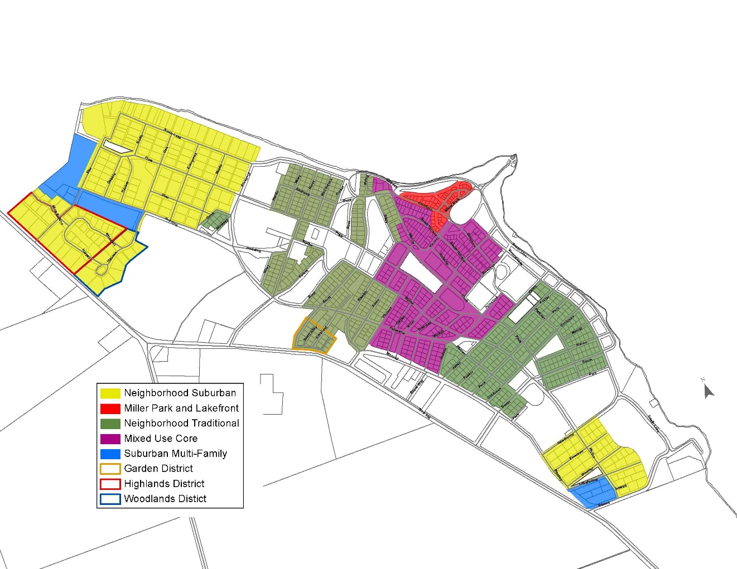



**3.3.1.** If the boundaries of any district are not clear and evident from the District Map, the following rules of interpretation shall apply:

1. Where district boundaries are indicated as following streets or alleys, then the center lines of such streets and alleys shall constitute the district boundary lines.
2. Where district boundaries are indicated as approximately following Lot lines, then such lines shall constitute the district boundary lines.
3. In the case of unsubdivided property or where a district boundary line has divided a Lot, the location of the district boundary line shall be determined by use of the scale appearing on the District Map unless the location of the district boundary line is indicated by dimensions.
4. Where a street or alley is officially vacated or abandoned by the Chautauqua Institution subsequent to the enactment of the Regulations, the Regulations applicable to each adjacent property (or portion of property) shall apply to that portion of the street or alley that has been added to the properties because of the vacation or abandonment of the street or alley.

(e) Where a district boundary line has divided a single Lot or multiple Lots that are in common ownership at the time of the enactment of the Regulations such that portions of the Lot or Lots appear in more than one district, then the Administrator or the ARB may, in their respective discretion, permit a use authorized for either portion of the Lot or Lots to extend to some additional portion of the Lot or Lots, the entire Lot, or all of the Lots.

**ARTICLE 4**

**USE MATRIX AND DISTRICT REGULATIONS**

* 1. **USE MATRIX**

The Use Matrix and the provisions of this Article 4.1. indicate and provide for the allowable uses of Land and Structures and their status within the various districts. Uses are divided into Accessory Uses (AC), Grandfathered Uses (GF), Permitted Uses (P), Nonconforming Uses (NC), and Special Exceptions (SE). The Use Matrix is intended to be descriptive of current conditions within the districts. This Article 4.1. also provides a regulatory framework for future proposed uses of properties within the districts. Thus, for example, a Bed and Breakfast in the Neighborhood Traditional district is both a Permitted Use currently and, absent changes in these Regulations, would be a Permitted Use in the future. In contrast, a Boarding House currently is a Grandfathered Use in the Neighborhood Traditional district and a Nonconforming Use in the Neighborhood Suburban district. Thus, any future proposed use of another property in either the Neighborhood Traditional district or the Neighborhood Suburban district as a Boarding House may exist in such district only as a Non Conforming Use. Such would be the case for any future proposed use of property in any district to the extent the use is not reflected as either a Permitted Use or an Accessory Use. Notwithstanding the foregoing, and for the avoidance of doubt, the Special Exception approval process for commercial uses in the Mixed Use Core district shall apply only to newly proposed commercial uses in that district, and existing commercial properties in that district shall not require additional Special Exception approval merely for a change in tenant.

|  |  |  |  |  |  |  |  |  |  |  |
| --- | --- | --- | --- | --- | --- | --- | --- | --- | --- | --- |
| **CHAUTAUQUA INSTITUTION ARCHITECTURAL AND LAND USE REGULATIONS USE MATRIX** | | | | | | | | | | |
| USE :  ACCESSORY USE (AC)  GRANDFATHERED USE (GF)  NONCONFORMING USE (NC)  PERMITTED USE (P)  SPECIAL EXCEPTION (SE) | | MIXED USE CORE  (1) | NEIGHBORHOOD TRADITIONAL  (2) | | | MILLER PARK / LAKEFRONT  (3) | NEIGHBORHOOD SUBURBAN  (4) | | | MULTI-FAMILY SUBURBAN  (5) |
| RESIDENTIAL USES | | | | | | | | | | |
| ACCESSORY UNIT | | P | P | | | P | SE | | | NC |
| BED AND BREAKFAST | | P | P | | | P | SE | | | NC |
| DWELLING (MULTI -FAMILY) | | P | SE | | | GF | GF | | | P |
| SINGLE-FAMILY HOME | | P | P | | | P | P | | | P |
| GARAGES, ACCESSORY TO USE | | NC | AC/SE | | | AC/SE | AC | | | AC |
| SHEDS, ACCESSORY TO USE | | AC | AC | | | AC | AC | | | AC |
| HOTEL /BOARDING HOUSE / ROOMING HOUSE | | P | GF | | | GF | NC | | | NC |
| PARKING (ACCESSORY TO USE) | | AC | AC | | | AC | AC | | | AC |
| COMMERCIAL USES | | | | | | | | | | |
| RESTAURANT / CATERING / FOOD SERVICE | | SE* | NC | | | NC | NC | | | NC |
| RETAIL STORE / PERSONAL SERVICES | | SE* | NC | | | NC | NC | | | NC |
| *The SE approval process applies to all newly proposed commercial uses in the Mixed Use Core district, but would not apply to a mere change of tenant engaging in the same commercial use in the same location. | | | | | | | | | | |
| OTHER USES | | | | | | | | | | |
| DENOMINATIONAL HOUSES | P | | | P | P | | | SE | NC | |
| HEALTH CLINIC | P | | | NC | NC | | | NC | NC | |

* 1. **GENERAL REGULATIONS APPLICABLE TO ALL DISTRICTS AND**

**SUB-DISTRICTS**

This Article 4.2. shall apply to Buildings, Structures, Accessory Structures, Land, and Lots located in the Mixed Use Core district, the Neighborhood Traditional district, the Miller Park / Lakefront district, the Neighborhood Suburban District, the Highlands sub-district, the Woodlands sub-district, and the Multi-Family Suburban District, and to Building Projects and New Construction relating thereto. This Article 4.2. shall also apply to Buildings, Structures, Accessory Structures, Land, and Lots located in the Garden District sub-district to the extent that the provisions and requirements of this Article 4.2. are not inconsistent with the design and pattern book guidelines applicable to the Garden District sub-district.

* + 1. **Maximum Development Potential** Development potential in this district differs within each area and needs to respect the character of each of the neighborhoods. Achieving maximum development potential will depend upon market forces, such as minimum desirable unit size, and development standards, such as minimum Lot size, parking requirements, height restrictions, and Building Setbacks. Choices will need to be made in the design process for Building Projects and New Construction. It may not be possible for all properties to be altered to reach their maximum development potentials. For example, a property owner that desires as part of New Construction or a Building Project to increase the amount of Impervious Surface on her Lot by creating a parking pad or outdoor patio area may find it impractical or impossible to do so without reducing the overall footprint of the to-be-constructed home.No Building Project or New Construction may result in any Structure being at its closest point within 10 feet of any other Structure or extending into any Setback.
    2. **Design Criteria** Because of the traditional development pattern and the communal nature in which Buildings exist and have been developed within the Chautauqua Institution, minimum design patterns have been established to continue and perpetuate this unique and desired context. The design criteria contained in this Article 4.2.2. of the Regulations apply whenever in the context of a Building Project the exterior of a Building is altered. In some rare instances the Administrator may waive the application of one or more of these design criteria to a particular Building Project if (a) the existing development pattern of the Building is not in keeping with the particular design criteria because of existing conditions or the existing architectural design of the Building and (b) it is impractical for all of these design criteria requirements to be reasonably implemented. A decision of the Administrator not to waive the application of the design criteria contained in this Article 4.2.2. of the Regulations to a particular Building Project may be appealed to the ARB.

Material choices also have important implications when Buildings are altered or constructed. While some modern materials may better address Maintenance issues, their appearance is not in keeping with the historic nature of the neighborhood. Therefore some modern materials such as vinyl siding are prohibited.

All design criteria requirements shall be met in the context of New Construction. Any failure to meet particular design criteria shall require a Variance to be granted by the ARB. The request for such a Variance shall be determined based on the criteria established in Article 6.10.

The design criteria address Building mass, site layout, Building orientation and Building form, all of which individually and collectively assist Building Projects and New Construction to best fit in with the established context of the district. This allows the property owner and design professional to choose their preferred architectural style. In terms of architectural style, the Regulations mandate only that the design style be one generally recognized by the profession of architecture.

* + - 1. **Site Layout, Orientation, and Contextual Relationship with Surrounding Structure** All Building Projects and New Construction shall orient Structures to the primary street (either using the narrowest Lot Width or based on the established pattern of the street and neighborhood as determined by the Administrator) and, where appropriate in the context of a particular Lot or site, shall be compatible in relationship with the nearby or surrounding Structures in terms of solid to void massing, rhythm and spacing between Structures, Setback patterns for porches and primary Structures (including first and second Story spacing and Setbacks), overall Building form, and architectural style.
      2. **Building Style** 
         1. A Building Project shall utilize the architectural style of the existing Structure or the existing Structure shall be modified to utilize a single design style generally recognized by the profession of architecture.
         2. New Construction shall utilize a single design style generally recognized by the profession of architecture.
      3. **Window Design** Windows are considered one of the most character-defining features of a property, especially in historical context. Historic wood windows are complex and often beautiful works of artistic handcraftsmanship. Original historic windows help preserve and, in some cases, elevate the value of the property. Removal of historic wood windows or decorative steel windows is strongly discouraged. Restoration is preferred and can be accomplished while improving energy efficiency and operation.
         1. In the context of both a Building Project and New Construction, windows on the street side façades shall be evenly distributed in a consistent pattern.
         2. In the context of both a Building Project and New Construction, window sashes and glass shall be square or vertical, unless a different proportion is allowed or required by a design style generally recognized by the profession of architecture.
         3. In the context of both a Building Project and New Construction, windows shall not be flush mounted. Windows recessed less than three (3) inches shall feature architectural trim including a header, sill and side trim, or decorative shutters. Windows recessed three (3) inches or more shall feature a windowsill.
         4. In the context of Building reconstruction or alterations Projects, window restoration and repair with energy efficiency and operational improvements shall be the first consideration instead of replacement. If window elements or complete window sashes must be replaced due to rot or damage beyond repair, the replacement window and/or components shall match the existing window in all respects, including size, materials, configuration, and muntin styles and patterns. Requests for replacement of windows with protective exterior cladding shall be considered by the Administrator, depending upon the specific situation. For New Construction, unless approved otherwise by the Administrator, windows containing decorative muntins should be constructed of true-divided lites, or shall, minimally, have the muntins installed on the exterior of the outside glass or have creating simulated divided lites. Muntins installed between the panes of glass or interior only are prohibited. Aluminum-clad wood exterior elements with wood interiors may be permitted in new window installations. In addition, fiber-reinforced plastic and/or PVC structural frame elements with wood interiors and aluminum cladding may be approved by the Administrator with prior authorization.

4.2.2.3.5 Vinyl windows are strictly prohibited except when the existing home already has a majority (more than 95%) of vinyl windows and less than 10% of the existing windows are intended to be replaced with new vinyl windows within a 5 year period. If more than 10% of the windows are to be replaced, the replacement windows may not be vinyl.

* + - 1. **Roofs** 
         1. Corrugated metal, ribbed metal, and/or fiberglass roofing are prohibited in Building Projects and New Construction. Vertical Standing Seam with concealed fastener metal roofing is permitted if the design and appearance is in historic context with the house and neighborhood, and appropriate to the selected architectural style of the Structure and approved by the Administrator. Roofing materials not listed in these Regulations shall be reviewed for appropriate historical, aesthetic and appropriate context by the Administrator. All roofing fasteners shall be concealed unless there is historic or artistic context if prior approval is received from the Administrator.
         2. In the context of both a Building Project and New Construction, Buildings shall contain either a pitched roof or a flat roof with a decorative parapet wall, whichever is more compatible with the architectural style of the Building.
         3. In the context of Building Projects and New Construction, porches located on any floor above the first floor shall not be covered by the Building’s main roof and, instead, roofs over any all such non-first floor porches shall be separate and additive to the face of the Building; provided, however, this requirement shall not apply in the case of a Building Project where an existing roof already covers such non-first floor porch space and neither the roof nor the porch space is to be altered as part of the Building Project.
         4. Because large roof areas are uncommon in Chautauqua’s traditional districts, the use of dormers, setbacks, and breaks in the roof plane shall be incorporated into all Building Project and New Construction roof design, especially when the site contains multiple Lots.
      2. **Building Materials** 
         1. In the context of Building Projects and New Construction, Building materials shall be appropriate to the selected architectural style and shall be consistent throughout the Structure. All exterior finish materials shall have an authentic appearance appropriate to the selected architectural style.
         2. Vinyl and aluminum siding are prohibited in Building Projects and New Construction; provided, however, existing vinyl and aluminum siding may remain and, in the case of Building Projects involving Structures with existing vinyl or aluminum siding, be repaired and new vinyl siding may be used for minor Additions, Renovations, and Rehabilitations, but not for Substantial Rehabilitations (more than 50% of the total area of siding) or New Construction.
         3. Vinyl windows See Article 4.2.2.3 of these Regulations. ~~are prohibited in Building Projects and New Construction; provided, however, existing vinyl windows may remain and, in the case of Building Projects involving Structures with existing vinyl windows (and/or other vinyl components), be repaired and new vinyl windows may be used for minor Additions, Renovations, and Rehabilitations, but not for Substantial Rehabilitations or New Construction.~~
         4. Metal and fiberglass doors may be substituted for wooden doors in Building Projects and New Construction if they feature a realistic wooden grain and are architecturally appropriate to the style of the Building.
         5. Composite materials are allowed in Building Projects and New Construction but must not have a plastic or highly glossy appearance and shall be of a correct scale to the selected architectural style. Over scaled or exaggerated composite materials that do not create an authentic appearance are prohibited in Building Projects and New Construction.
         6. Railing components and architectural detailing, ginger breading, and similar architectural finishing effects used in Building Projects and New Construction shall not have a plastic or glossy appearance and, in addition, shall either have imbedded coloring or shall be painted to complement the color scheme of the Structure. These components and details shall also be compatible with, and appropriately scaled to, the selected architectural style of the Building. Cable, Glass, or Other. Alternative railing materials and/or systems shall be considered ONLY in new construction and where code-required railing additions are required and will be reviewed on a case-by-case basis.
         7. Treated wood used in Building Projects and New Construction shall be painted to complement the color scheme of the Structure. Treated wood used as deck flooring may be stained rather than painted. Treated Wood Deck Flooring shall match the size and configuration of original Historic decking in Replacements, Building Projects and Additions.
  1. **MIXED USE CORE DISTRICT**

This Article 4.3. shall apply to Buildings, Structures, Accessory Structures, Land, and Lots located in the Mixed Use Core district, and to Building Projects and New Construction relating thereto.

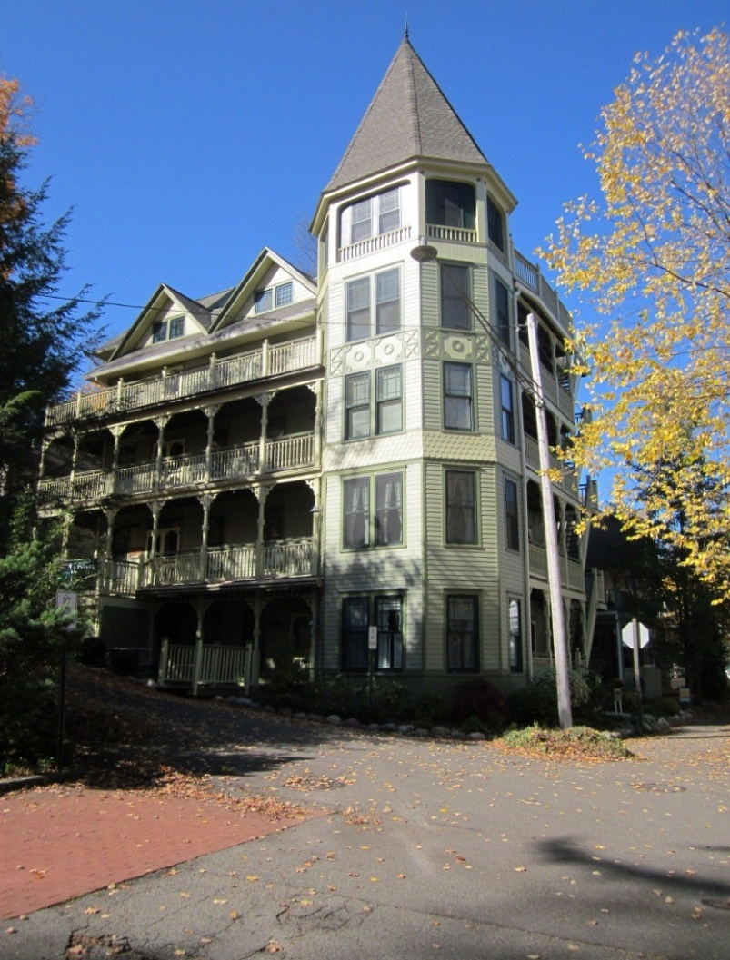

Typical Structure in the Mixed Use Core District

* + 1. **History and Composition of Mixed Use Core District** The Mixed Use Core represents the first era of development within the Institution as well as a significant amount of early redevelopment where homes were enlarged, rebuilt or connected together to form additional and diverse accommodations for a variety of people coming to enjoy Chautauqua.

Generally, this district contains the most intense development on the grounds. Many of the Buildings date from the beginning of the Institution through the beginning of World War I. Many of the Structures were designed in the vernacular style showing traces of Gothic, Victorian, Colonial Revival and Craftsman detailing. Many of the early Buildings subsequently were expanded and converted to rooming homes, mixed-use Buildings, and apartments. A number of these Structures, while first built as Single-Family Homes or rooming houses, were converted to condominiums in the 1980s. This has provided a uniquely eclectic composition and more variety of buildings, sizes scale and design compared to the more consistent districts found in later development. This mix offers unique visual insight into the history and development that occurred during the first 30 years of the Institution and reflects the changes over time as the Institution had matured and grown.

This district also contains Bestor Plaza and an array of larger Institution-owned Buildings. Common features include: narrow rectangular Lots, mixed-use Buildings built toward the front of the Lot with reduced Setbacks, front porches and primary entrances facing the streets, sidewalk connections leading to the street, limited vehicular access, recognized architectural styles, and use of consistent and appropriate materials.

* + 1. **Purpose and Intent** The purpose of the Mixed Use Core guidelines is to protect the character created by the late 19th Century development of this area of the Chautauqua Institution. The Regulations recognize the wide variety of building design styles present within this district and set out to preserve this unique development pattern. Emphasis is placed on preserving and restoring existing Buildings that reflect this character, rather than on Demolition and New Construction. However when New Construction is utilized, the Regulations encourage development that is consistent with the existing historic context and development pattern. The Regulations encourage the connection of inside space with the public domain through the use of porches as secondary living space to reinforce the communal nature of life in this district. Private parking is discouraged or appropriately concealed to reinforce the pedestrian nature of the district. Garages are an intrusion within this district.
    2. **Maximum Lot Size, Intensity, and ISR**

|  |  |  |
| --- | --- | --- |
| MINIMUM LOT SIZE, MAXIMUM INTENSITY & MAXIMUM ISR | | |
| **Regulation** | | **Mixed Use Core** |
| Minimum Lot Width | | 40 feet |
| Minimum Lot Area | | 2,000 Square Feet |
| Maximum FAR | | 1.37 (See exemptions below) |
| Maximum ISR | |  |
|  | Single Lot | Single Lots: 80% total site area including all surfaces of driveways, parking lots, walkways, window wells, patios, etc. 20% of site area must remain green and pervious |
| Multiple Lots | Multiple Lots: 70% total site area including all surfaces of driveways, parking lots, walkways, window wells, patios, etc. 30% of site area must remain green and pervious |

* + 1. **FAR Exemptions.** 
       1. Any floor area located within a finished Basement that has a finished first floor height no greater than 36 inches off of the average established natural grade level of the ground adjoining the Building and does not have window wells facing the primary street shall not be included in the FAR calculation.
       2. Any finished attic space that is compliant with all height, Setback, tower, turret, and dormer Regulations and that is less than 65% of the at-grade footprint of the Building shall not be included in the FAR calculation.
       3. Garage space is not exempt from FAR calculations.
    2. **Maximum Building Height**

|  |  |  |
| --- | --- | --- |
| MAXIMUM BUILDING HEIGHT | | |
| **Building Height** | **Eave Line** | **Highest Point of Roof** |
|  | 34’ | 46’ |
| Refer to Article 2 for definitions and diagrams regarding the measurement of Building Height and to Article 5.14.9. for the exemptions to Building Heights for chimneys and Ancillary Equipment. For additional information, refer to the diagrams contained in Article 4.11. The Administrator shall have the authority to allow de minimis variances in height that may exceed these maximums if the variance is less than 8”. | | |

* + 1. **Building Setbacks**

|  |  |  |  |
| --- | --- | --- | --- |
| MINIMUM BUILDING SETBACKS | | | |
| Building Setbacks. Please refer to the Official Map to determine if there are pre-existing, required Setbacks applicable to a particular Lot. The Official Map is located in the office of the Administrator | | Reconstruction, Rehabilitation, Renovation, or Restoration of Existing Structure | Additions and New Construction |
| Front Yard | Stoop Steps | 0’ | 0’** |
| First and Second Floor Open Porch | 0’ | 0’** |
| Third Floor Open Porch. If less than 40% of wall plane/greater than 40% wall plane. | existing* | 2’/6’** |
| Building up to 34 feet of height | existing* | 6’** |
| Building above 34 feet of height (requires Variance) | existing* | 10’** |
| Street Side Yard | Zero side below 34’/above 34’ | existing* | 3’/5’** |
| 10 foot side, below 34’/above 34’ | existing* | 10’/12’** |
| Not specified below 34’/above 34’ | existing* | 5’/7’** |
| Interior Side Yard | Zero Side, below 34’/above 34’ | existing* | 3’/5’** |
| 10 foot side, below 34’/above 34’ | existing* | 10’/12** |
| Not specified, below 34’/above 34’ | existing* | 5’/7’** |
| Rear Yard | Zero rear, below 34’/above 34’ | existing* | 0’/4’** |
| 10 foot side, below 34’/above 34’ | existing* | 10’/14’** |
| Not Specified, below 34’/above 34’ | existing* | 5’/9’** |
| * Many Structures within the Institution have preexisting or previously approved encroachments that render the Structure a Legally Existing Nonconforming Structure within the meaning of these Regulations. Those encroachments are recognized and allowed to remain. Expansion of such an encroachment can be requested of and granted by the Administrator under the minor encroachment provisions set forth below or by the ARB if either (a) the Administrator denies such request or (b) the requested expansion exceeds the minor encroachment criteria and the expansion meets the criteria established for Variances. Such encroachments do not carry forward in the case of a Demolition (other than an Investigative Demolition) followed by New Construction or if a Building is relocated on a Lot as part of a Building Project. Minor encroachments into normally prescribed Setbacks may be allowed to accommodate an Addition to align with the side of the existing Structure, provided: (a) the total floor area of the encroaching portion of an Addition shall not exceed 50 square feet; (b) no portion of the encroachment shall exceed 34 feet in height; and (c) the Encroachment Into The Setback is not greater than 8 inches.  **No portion of any Structure, with the exception of overhangs, shall come within 10 feet of a neighboring Structure  For additional information, refer to the diagrams contained in Article 4.11 | | | |

* + 1. **Roof Lines and Slopes** The required Setbacks provided for in Article 4.3.6. increase for Buildings with a wall or walls above 34 feet in height (except for the provisions associated with towers and turrets provided herein). At 34 feet, or below, a cornice line shall be provided, and the roofline shall begin. The roof slope shall not exceed 45 degrees (12:12 pitch). The roof peak shall not exceed the maximum height of 46 feet. If a sloped roof is not characteristic of the design style, the wall shall be accentuated with a cornice line at or below 34 feet in height. Any portion of a wall exceeding 34 feet in height shall be set back as specified in the Minimum Building Setbacks chart contained in Article 4.3.6. For additional information, refer to the diagrams contained in Article 4.11.
       1. **Towers and Turrets** A tower or a turret may exceed the 34 foot height requirement but must utilize the additional Setbacks required for heights above 34 feet. The walls of a tower or turret shall not exceed 16 feet in any one horizontal dimension. For a tower or turret with a nonstraight (rounded) wall, this dimension shall be calculated using the smallest rectangle that will enclose the horizontal wall of the tower or turret. For additional information, refer to the diagrams contained in Article 4.11.
       2. **Dormers** The vertical plane of a dormer must comply with the additional setback requirements for height above 34 feet. The width of the dormer wall or, in the case of multiple dormers, the total width of all the dormer walls shall not exceed 50% of the roof width, or 20 feet of width, whichever is less. Dormers shall be compatible with the chosen architectural style. For additional information, refer to the diagrams contained in Article 4.11.
    2. **General Design Criteria** AllBuilding Projects shall comply with the Secretary of Interior Standards for the Treatment of Historic Properties, which are contained in Article 4.12., based on the Building Project’s methodology.
    3. **Pedestrian Connections**
       1. All Building Projects and New Construction shall provide for the primary Building to have a front porch with a minimum functional depth of 4 feet in the case of an existing Building and 6 feet in the case of New Construction.
       2. All Building Projects and New Construction shall provide for all Buildings to be connected to the sidewalk or street edge by a minimum of a 30” wide impervious or semi-pervious walkway.
       3. All Building Projects and New Construction shall provide for any Multi-Family Dwelling or Accessory Unit to be connected to the sidewalk or street edge by a minimum of a 30” wide impervious or semi-pervious walkway and shall otherwise meet all applicable design standards for such uses, including those outlined within the Accessory Unit criteria.
    4. **Building Form** 
       1. When an existing Building is altered through the creation of an Addition, then the overall form of the Building shall be retained and utilized in the creation of the Addition.
       2. When an existing Building is altered through the creation of an Addition, then the existing floor height off of the average established natural grade level of the ground adjoining the Building shall be maintained for both the existing Building and the Addition; provided, however, in the case of a new Basement or new Accessory Unit located in a Basement, the requirements of these Regulations applicable to Accessory Units, including Article 5.1. hereof, shall apply to such Basement or Accessory Unit.
       3. New Construction shall be built to have the appearance of a house raised above the average established natural grade level of the ground adjoining the Building by 16 inches. The appearance of slab on grade construction is prohibited.
       4. New Construction shall create a Building having a width-to-height ratio not greater than 1:1. Any New Construction that seeks to create a Building with a width-to-height ratio greater than 1:1 shall require a Variance from the ARB. The request for such a Variance shall be determined based on the criteria established in Article 6.10. and, if granted, shall require that the to-be-constructed Building feature architectural Fenestration (such as pilasters, arcades, building line and roof line off-sets, materials and other appropriate architectural features) to create a bay system that divides the designed Building into identifiable segments each of which has a maximum width-to-height ratio of 1:1.
    5. **Exterior Wall Composition** 
       1. When in the context of a Building Project an existing Building is altered, then the overall exterior wall composition shall be retained. For the avoidance of doubt, when in the context of a Building Project an existing Building is expanded, then the overall exterior wall composition of the existing Building shall be utilized in the Addition.
       2. In the context of both a Building Project and New Construction, doors, windows and other appropriate Fenestration shall be incorporated into all sides of a Building. There shall be no blank façades. For multi-Story Buildings, no portion of a façade corresponding to the height between two floors shall contain a blank area greater than 12 feet in width.

* + - 1. In the context of both a Building Project and New Construction, at least 30 percent of primary and secondary street façades shall consist of Fenestration. At least 20 percent of interior side and rear façades shall have Fenestration. At least two-thirds of the Fenestration shall be transparent (i.e., window glass). One-third may consist of trim work, shutters, brackets and other architectural features. Entry doors shall be counted toward Fenestration if side panel or decorative windows are provided. Garage doors do not count toward Fenestration.
      2. Where in the context of both a Building Project and New Construction, a Structure is situated on a corner Lot, a through Lot, or on a Lot that, by the nature of the site layout, results in a façade of the Structure being clearly visible from a right-of-way, then the Structure shall be designed with full architectural treatment on all sides visible from rights-of-way. Full architectural treatment shall include roof design, wall materials, architectural trim, and door and window openings. Construction materials and detailing should be similar throughout the Structure even though the Structure will have primary and secondary façades.
    1. **Garages** Garages are prohibited in Building Projects and New Construction in the Mixed Use Core district.
    2. **Fire Pits, Open Fires or Exterior Fireplaces** Wood BurningFire pits, campfires, exterior fireplaces, and open fires of any kind are prohibited in this District.

**4.3.14** **Swimming Pools, Hot Tubs, Outdoor Spas, other Outdoor Bathing Accessories (Including Portable/Temporary Units)**- Prohibited without approval from the Architectural Review Board following application for a Compliance Certificate. These elements are considered “Structures” under these Regulations and are required to follow all building limitations and requirements. Criteria for reviewing these requests will include, but not be limited to, proximity and possible impact to neighbors and the community, community walks/roadways, proximity and possible impact to Chautauqua Institution activities, perceived safety and aesthetic impact.

* 1. **NEIGHBORHOOD TRADITIONAL DISTRICT**

This Article 4.4. shall apply to Buildings, Structures, Accessory Structures, Land, and Lots located in the Neighborhood Traditional district, and to Building Projects and New Construction relating thereto.

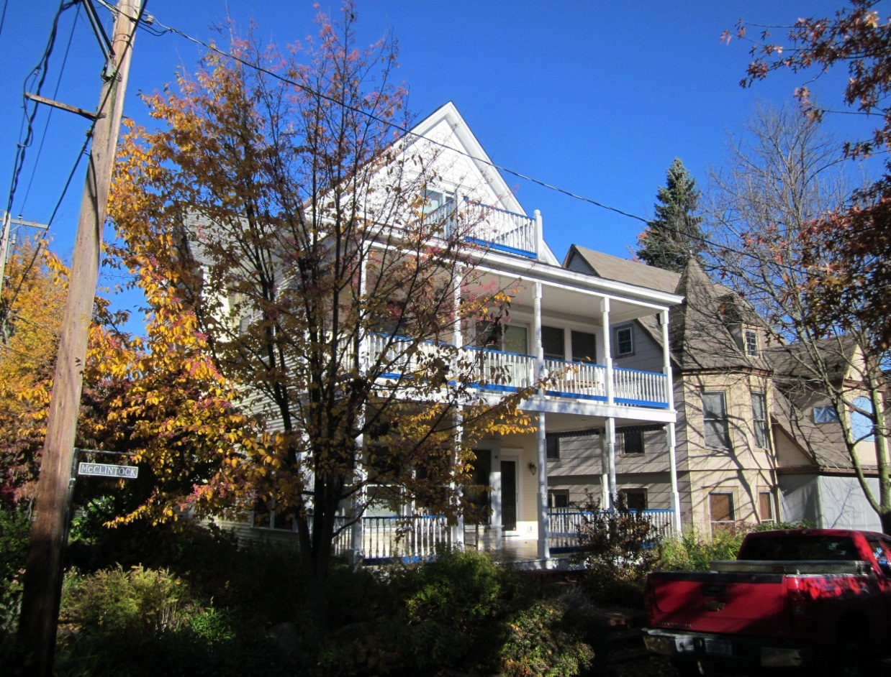

Typical Structure in the Neighborhood Traditional District

**4.4.1. History and Composition of Neighborhood Traditional** The Neighborhood Traditional district of the Institution represents the first expansion out from the historic Mixed Use Core. This district predominantly maintains the appearance of Single-Family Homes. Some homes have been converted to Multi-Family Dwellings, however many retain their appearance as Single-Family Homes. Denominational Houses are also common within the district, especially along the Brick Walk, south of the Amphitheatre.

Generally, homes built within the Neighborhood Traditional district were constructed prior to World War I and predominantly date from the 1880s through the 1920s. Many of the homes were designed in the vernacular style showing traces of Gothic, Victorian, Colonial Revival and Craftsman detailing. Architectural styles are identifiable and the materials, detailing and proportions are appropriate to these styles. Earlier homes are typically more modest and located toward the center of the original plat with more expressive and larger Structures built to the edges and along the waterfront. A number of simple, one-Story vernacular cottages are scattered throughout the district. Most homes consist of two-Stories with an attic area containing additional living space. Homes are slightly raised off of grade, typical of the time period. A variety of roof forms exist, however the most common is the gable roof with side dormers and the gable end facing the street.

Porches are a predominant feature within the district. Porches are typically one-Story or two-Story in nature and are additive to the main Structure with a lower, separate roof line. Railing designs are simple and vernacular in style. Window Fenestration is vertical in nature and typically located on all façades. Materials are predominantly wood, both clapboard and shingles. Masonry is less common.

The majority of the Lots are 40 feet wide by 50 feet deep. Homes are located to the fronts of the Lots with the porch built on the property line and the main plane of the Building set back 4-6 feet. Buildings are spaced approximately 10 feet apart. Primary entrances face the street. The district is heavily canopied by trees. Many of the trees are located on Institution property in front of the Structures. Vehicle parking was not original and is not available on all Lots. When it is present, it typically takes the form of a driveway located to the side of the Structure that allows a single car to park behind the plane of the front porch. Garages are rare and were typically added within the last few decades.

**4.4.2. Purpose and Intent** The purpose of the Neighborhood Traditional guidelines is to protect the character created by the late 19th and early 20thcentury development of this area of the Chautauqua Institution. The Regulations recognize the wide variety of building design styles present within the district and set out to preserve this unique development pattern. Emphasis is placed on preserving existing Buildings that reflect this context rather than on Demolition and New Construction. However, when New Construction is utilized, the Regulations encourage development that is consistent with the existing historic context and development pattern. The Regulations encourage the connection of inside space with the public domain through the use of porches as secondary living space to reinforce the communal nature of life in this district. Private parking is discouraged or appropriately concealed to reinforce the pedestrian nature of the district.

* + 1. **Maximum Lot Size, Intensity, and ISR**

|  |  |  |
| --- | --- | --- |
| MINIMUM LOT SIZE, MAXIMUM INTENSITY & MAXIMUM ISR | | |
| **Regulation** | | **Neighborhood Traditional** |
| Minimum Lot Width | | 40 feet |
| Minimum Lot Area | | 2,000 Square Feet |
| Maximum FAR | | 1.0 (See exemptions below) |
| Maximum ISR | |  |
|  | Single Lot | Single Lots: 75% total site area including all surfaces of driveways, parking lots, walkways, window wells, patios etc. 25% of site area must remain green and pervious |
| Multiple Lots | Multiple Lots: 65% total site area including all surfaces of driveways, parking lots, walkways, window wells, patios etc. 35% of site area must remain green and pervious |

**4.4.4. FAR Exemptions.**

* + - 1. Any floor area located within a finished Basement area that has a finished first floor height no greater than 36 inches off of the average established natural grade of the ground adjoining the Building and does not have window wells facing the primary street shall not be included in the FAR calculation.
      2. Any finished attic space that is compliant with all height, Setback, tower, turret, and dormer Regulations and that is less than 65% of the at-grade footprint of the Building not be included in the FAR calculation.
      3. Garage space is not exempt from FAR calculations.
    1. **Maximum Building Height**

|  |  |  |
| --- | --- | --- |
| MAXIMUM BUILDING HEIGHT | | |
| **Building Height** | **Eave Line** | **Highest Point of Roof** |
|  | 24’ | 36’ |
| Refer to Article 2 for definitions and diagrams regarding the measurement of Building Height and to Article 5.14.9. for exceptions to Building Heights for chimneys and Ancillary Equipment. For additional information, refer to the diagrams contained in Article 4.11. The Administrator shall have the authority to allow de minimis variances in height that may exceed these maximums if the variance is less than 8”. | | |

* + 1. **Building Setbacks**

|  |  |  |  |
| --- | --- | --- | --- |
| **MINIMUM BUILDING SETBACKS** | | | |
| Building Setbacks. Please refer to the Official Map to determine if there are pre-existing, required Setbacks applicable to a particular Lot. The Official Map is located in the office of the Administrator | | Reconstruction, Rehabilitation, Renovation, or Restoration of Existing Structure | Additions and New Construction |
| Front Yard | Stoop Steps | 0’ | 0’** |
| First and Second Floor Open Porch | 0’ | 0’** |
| Third Floor Open Porch. If less than 40% of wall plane/greater than 40% wall plane. | existing* | 2’/6’** |
| Building up to 24 feet of height | existing* | 6’** |
| Building Above 24 feet of height (requires Variance) | existing* | 10’** |
| Street Side Yard | Zero side below 24’/above 24’ | existing* | 3’/5’** |
| 10 foot side, below 24’/above 24’ | existing* | 10’/12’** |
| Not specified below 24’/above 24’ | existing* | 5’/7’** |
| Interior Side Yard | Zero Side, below 24’/above 24’ | existing* | 3’/5’** |
| 10 foot side, below 24’/above 24’ | existing* | 10’/12’** |
| Not specified, below 24’/above 24’ | existing* | 5’/7’** |
| Rear Yard | Zero rear, below 24’/above 24’ | existing* | 0’/4’** |
| 10 foot side, below 24’/above 24’ | existing* | 10’/14’** |
| Not Specified, below 24’/above 24’ | existing* | 5’/9’** |
| * Many Structures within the Institution have preexisting or previously approved encroachments that render the Structure a Legally Existing Nonconforming Structure within the meaning of these Regulations. Those encroachments are recognized and allowed to remain. Expansion of such an encroachment can be requested of and granted by the Administrator under the minor encroachment provisions set forth below or by the ARB if either (a) the Administrator denies such request or (b) the requested expansion exceeds the minor encroachment criteria and the expansion meets the criteria established for Variances. Such encroachments do not carry forward in the case of a Demolition (other than an Investigative Demolition) followed by New Construction or if a Building is relocated on a Lot as part of a Building Project. Minor encroachments into normally prescribed Setbacks may be allowed to accommodate an Addition to align with the side of the existing Structure, provided: (a) the total floor area of the encroaching portion of an Addition shall not exceed 50 square feet; (b) no portion of the encroachment shall exceed 24 feet in height; and (c) the Encroachment into The Setback is not greater than 8 inches.  ** No portion of any Structure, with the exception of overhangs, shall come within 10 feet of a neighboring Structure  For additional information, refer to the diagrams contained in Article 4.11. | | | |

**4.4.7. Roof Lines and Slopes** The required Setbacks provided for in Article 4.3.6. increase for Buildings with a wall or walls above 24 feet in height (except for the provisions associated with towers and turrets provided herein). At 24 feet, or below, a cornice line shall be provided and the roofline shall begin. The roof slope shall not exceed 45 degrees (12:12 pitch). The roof peak shall not exceed the maximum height of 36 feet. If a sloped roof is not characteristic of the design style, the wall shall be accentuated with a cornice line at or below 24 feet in height. Any portion of a wall exceeding 24 feet in height shall be set back as specified in the Minimum Building Setbacks chart contained in Article 4.4.6. For additional information, refer to the diagrams contained in Article 4.11.

* + - 1. **Towers and Turrets** A tower or a turret may exceed the 24 foot height requirement but must utilize the additional Setbacks required for heights above 24 feet. The walls of a tower or turret shall not exceed 12 feet in any one horizontal dimension. For a tower or turret with a nonstraight (rounded) wall, this dimension shall be calculated using the smallest rectangle that will enclose the horizontal wall of the tower or turret. For additional information, refer to the diagrams contained in Article 4.11.
      2. **Dormers** The vertical plane of a dormer must comply with the additional setback requirements for height above 24 feet. The width of the dormer wall or, in the case of multiple dormers, the total width of all of the dormer walls shall not exceed 50% of the roof width, or 20 feet of width, whichever is less. Dormers shall be compatible with the chosen architectural style. For additional information, refer to the diagrams contained in Article 4.11.
    1. **General Design Criteria** All Building Projects shall comply with the Secretary of Interior Standards for the Treatment of Historic Properties, which are contained in Article 4.12., based on the Building Project’s methodology.
    2. **Pedestrian Connections**
       1. All Building Projects and New Construction shall provide for the primary Building to have a front porch with a minimum functional depth of 4 feet in the case of an existing Building and 6 feet in the case of New Construction.
       2. All Building Projects and New Construction shall provide for all Buildings to be connected to the sidewalk or street edge by a minimum of a 30” wide impervious or semi-pervious walkway.
       3. All Building Projects and New Construction shall provide for any Multi-Family Dwelling or Accessory Unit to be connected to the sidewalk or street edge by a minimum of a 30” wide impervious or semi-pervious walkway and shall otherwise meet all applicable design standards for such uses, including those outlined within the Accessory Unit criteria.
    3. **Porch Criteria**
       1. Porches above the first floor and comprising more than 30% of the wall plane shall be additive to the main body of the Building and not incised.
       2. Third floor porches covering the entire width of the façade of the Building are discouraged and shall meet all applicable Setback criteria.
    4. **Building Form** 
       1. When an existing Building is altered through the creation of an Addition, then the overall form of the Building shall be retained and utilized in the creation of the Addition.
       2. When an existing Building is altered through the creation of an Addition, then the existing floor height off of the average established natural grade level of the ground adjacent to the Building shall be maintained for both the existing Building and the Addition; provided, however, in the case of a new Basement or new Accessory Unit located in a Basement, the requirements of these Regulations applicable to Accessory Units, including Article 5.1. hereof, shall apply to such Basement or Accessory Unit.
       3. New Construction shall be built to have the appearance of a house raised above the average established natural grade level of the ground adjacent to the Building by 16 inches. The appearance of slab on grade construction is prohibited.
       4. New Construction shall create a Building having a width-to-height ratio not greater than 1:1. Any New Construction that seeks to create a Building with a width-to-height ratio greater than 1:1 shall require a Variance from the ARB. The request for such a Variance shall be determined based on the criteria established in Article 6.10. and, if granted, shall require that the to-be-constructed Building feature architectural Fenestration (such as pilasters, arcades, building line and roof line off-sets, materials and other appropriate architectural features) to create a bay system that divides the designed Building into identifiable segments each of which has a maximum width-to-height ratio of 1:1.

**4.4.12. Exterior Wall Composition**

* + - 1. When in the context of a Building Project an existing Building is altered, then the overall exterior wall composition shall be retained. For the avoidance of doubt, when in the context of a Building Project an existing Building is expanded, then the overall exterior wall composition of the existing Building shall be utilized in the Addition.
      2. In the context of both a Building Project and New Construction, doors, windows and other appropriate Fenestration shall be incorporated into all sides of a Building. There shall be no blank façades. For multi-Story Buildings, no portion of a façade corresponding to the height between two floors shall contain a blank area greater than 12 feet in width.

* + - 1. In the context of both a Building Project and New Construction, at least 30 percent of primary and secondary street façades shall consist of Fenestration. At least 20 percent of interior side and rear façades shall have Fenestration. At least two-thirds of the Fenestration shall be transparent (i.e., window glass). One-third may consist of trim work, shutters, brackets and other architectural features. Entry doors shall be counted toward Fenestration if side panel or decorative windows are provided. Garage doors do not count toward Fenestration.
      2. Where in the context of both a Building Project and New Construction, a Structure is situated on a corner Lot, a through Lot, or on a Lot that, by the nature of the site layout, results in a façade of the Structure being clearly visible from a right-of-way, then the Structure shall be designed with full architectural treatment on all sides visible from rights-of-way. Full architectural treatment shall include roof design, wall materials, architectural trim, and door and window openings. Construction materials and detailing should be similar throughout the Structure even though the Structure will have primary and secondary façades.
    1. **Garages**
       1. Garages are highly discouraged in the Neighborhood Traditional district and, in the context of a Building Project or New Construction, require a Variance from the ARB. The request for such a Variance shall be determined based on the criteria established in Article 6.10.
       2. If the ARB grants a Variance for a Garage, then the Garage shall be limited to a single width door, be located at least 10 feet behind the front façade line of the principal Structure, not exceed 25 percent of the linear frontage of the façade of the principal Structure, have a non-obtrusive and aesthetically appropriate Garage door, and comply with any additional conditions set by the ARB as part of its approval.

**4.4.14.** **Fire Pits, Open Fires or Exterior Fireplaces** Wood burning fire pits, campfires, exterior wood burning fireplaces, and open wood burning fires of any kind are prohibited in this District. Natural gas/propane fire features may be allowed following review & approval by the Administrator. These features shall not be located less than 10’ from structures, trees/plantings or other flammable material and shall not be located on any streetside or community walkway side of the house.

**4.4.15.** **Swimming Pools, Hot Tubs, Outdoor Spas, other Outdoor Bathing Accessories (Including Portable/Temporary Units)**- Prohibited without approval from the Architectural Review Board following application for a Compliance Certificate. These elements are considered “Structures” under these Regulations and are required to follow all building limitations and requirements. Criteria for reviewing these requests will include, but not be limited to, proximity and possible impact to neighbors and the community, community walks/roadways, proximity and possible impact to Chautauqua Institution activities, perceived safety and aesthetic impact.

* 1. **GARDEN DISTRICT SUB-DISTRICT**

This Article 4.5. shall apply to Buildings, Structures, Accessory Structures, Land, and Lots located in the Garden District sub-district of the Neighborhood Traditional district, and to Building Projects and New Construction relating thereto. To the extent that the provisions and requirements of Article 4.4. of these Regulations are not inconsistent with the design and pattern book guidelines applicable to the Garden District sub-district, then the provisions and requirements of Article 4.4. shall also apply to Buildings, Structures, Accessory Structures, Land, and Lots located in the Garden District sub-district of the Neighborhood Traditional district, and to Building Projects and New Construction relating thereto.

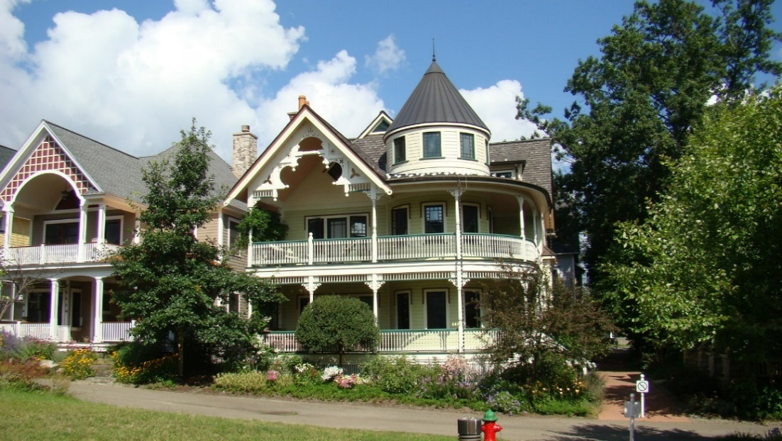

**4.5.1. History and Composition of the Garden District:** The Garden District was developed by the Chautauqua Institution beginning in the 1990s with the intent of creating a new neighborhood within the Institution that reflected many of the pedestrian scaled traditional patterns of development found within the Institution grounds.

* + 1. **Purpose and Intent** The Garden District was developed with a set of design and pattern book guidelines to assure a specific outcome of the built form. These design and pattern book guidelines continue in full force and effect. Please contact the Administrator to obtain a copy of the design and pattern book guidelines currently applicable to the Garden District sub-district.

**4.5.3. New Construction, Building Projects, and Landscaping Projects** All New Construction, Building Projects, and Landscaping Projects within the Garden District sub-district shall comply with all requirements of the design and pattern book guidelines for the Garden District, as now existing or hereafter modified or amended, and such of these Regulations, including, without limitation, those contained in Article 4.4. hereof, as may apply by their terms or are not otherwise inconsistent with such design and pattern book guidelines.

**4.5.4. Fire Pits, Open Fires or Exterior Fireplaces** Wood burning fire pits, campfires, exterior wood burning fireplaces, and open fires of any kind are prohibited in this District. Natural gas/propane fire features may be allowed following review & approval by the Administrator. These features shall not be located less than 10’ from structures, trees/plantings or other flammable material and shall not be located on any streetside or community walkway side of the house.

**4.5.5** **Swimming Pools, Hot Tubs, Outdoor Spas, other Outdoor Bathing Accessories (Including Portable/Temporary Units)**- Prohibited without approval from the Architectural Review Board following application for a Compliance Certificate. These elements are considered “Structures” under these Regulations and are required to follow all building limitations and requirements. Criteria for reviewing these requests will include, but not be limited to, proximity and possible impact to neighbors and the community, community walks/roadways, proximity and possible impact to Chautauqua Institution activities, perceived safety and aesthetic impact.

* 1. **MILLER PARK / LAKEFRONT DISTRICT**

This Article 4.6. shall apply to Buildings, Structures, Accessory Structures, Land, and Lots located in the Miller Park / Lakefront district, and to Building Projects and New Construction relating thereto.

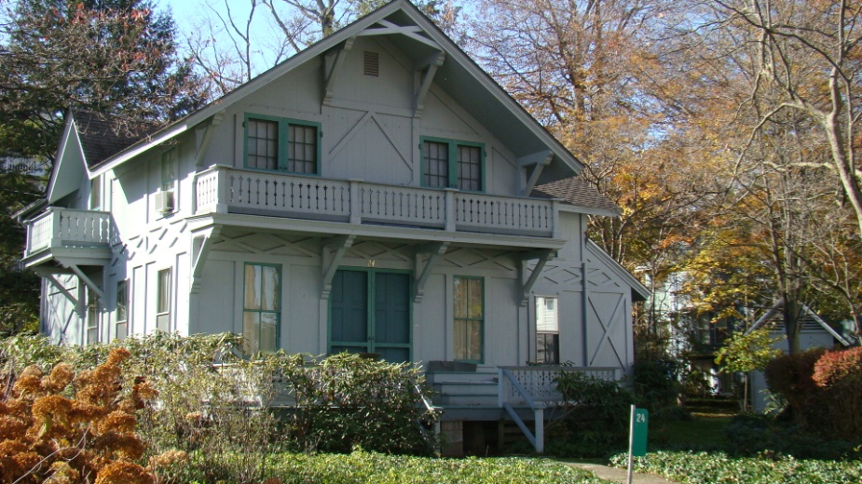

Typical Structure in the Miller Park / Lakefront District

* + 1. **History and Composition of Miller Park / Lakefront** This district surrounds Miller Park, where the first assemblies occurred, and is one of the most historic areas of Single-Family Homes within the Chautauqua Institution. The district contains historic and architecturally significant Buildings, some of which have been individually included on historic registries. This district derives its character from the minimal Setbacks and extremely small Yards. Its Green Space is derived from the surrounding park area and waterfront promenade, which provide a feeling of openness. The narrow homes that address the park display the vernacular tent platform appearance of the Institution’s earliest Structures. Larger homes face the lakefront and exhibit a variety of scales and architectural styles.
    2. **Purpose and Intent** The purpose of the Miller Park / Lakefront guidelines is to protect the character created by the diminutive scale of Structures in this district and the unique backdrop that those Structures create along the edge of the waterfront and Miller Park. Emphasis is placed on preserving existing Buildings that reflect this context rather than on Demolition and New Construction. However, when New Construction is utilized, the Regulations encourage development that is consistent with the existing historic context and development pattern. Private parking is highly discouraged.
    3. **Maximum Lot Size, Intensity, and ISR**

|  |  |  |
| --- | --- | --- |
| MINIMUM LOT SIZE, MAXIMUM INTENSITY & MAXIMUM ISR | | |
| **Regulation** | | **Neighborhood Traditional** |
| Minimum Lot Width | | 40 feet |
| Minimum Lot Area | | 2,000 Square Feet |
| Maximum FAR | | 1.0 (See exemptions below) |
| Maximum ISR | |  |
|  | Single Lot | Single Lots: 75% total site area including all surfaces of driveways, parking lots, walkways, window wells, patios etc. 25% of site area must remain green and pervious |
| Multiple Lots | Multiple Lots: 65% total site area including all surfaces of driveways, parking lots, walkways, window wells, patios etc. 35% of site area must remain green and pervious |

* + 1. **FAR Exemptions** 
       1. Any floor area located within a finished Basement that has a finished first floor height no greater than 36 inches off of the average established natural grade level of the ground adjoining the Building and does not have window wells facing the primary street shall not be included in the FAR calculation.
       2. Any finished attic space that is compliant with all height, Setback, tower, turret, and dormer Regulations and that is less than 65% of the at grade footprint of the Building shall not be included in the FAR calculation.
       3. Garage space is not exempt from FAR calculations.
    2. **Maximum Building Height**

|  |  |  |
| --- | --- | --- |
| MAXIMUM BUILDING HEIGHT | | |
| **Building Height** | **Eave Line** | **Highest Point of Roof** |
|  | 18’ | 24’ |
| Refer to Article 2 for definitions and diagrams regarding the measurement of Building Height and to Article 5.14.9. for the exemptions to Building Heights for chimneys and Ancillary Equipment. For additional information, refer to the diagrams contained in Article 4.11. The Administrator shall have the authority to allow de minimis variances in height that may exceed these maximums if the variance is less than 8”. | | |

* + 1. **Building Setbacks**

|  |  |  |  |
| --- | --- | --- | --- |
| **MINIMUM BUILDING SETBACKS** | | | |
| Building Setbacks. Please refer to the Official Map to determine if there are pre-existing, required Setbacks applicable to a particular Lot. The Official Map is located in the office of the Administrator | | Reconstruction, Rehabilitation, Renovation, or Restoration of Existing Structure | Additions and New Construction |
| Front Yard | Stoop Steps | 0’ | 0’** |
| First and Second Floor Open Porch | 0’ | 0’** |
| Building up to 24 feet of height | existing* | 6’** |
| Building Above 24 feet of height  (requires Variance) | existing* | 10’** |
| Street Side Yard | Zero side below 18’/above 18’ | existing* | 3’/5’** |
| 10 foot side, below 18’/above 18’ | existing* | 10’/12’** |
| Not specified below 18’/above 18’ | existing* | 5’/7’** |
| Interior Side Yard | Zero Side, below 18’/above 18’ | existing* | 3’/5’** |
| 10 foot side, below 18’/above 18’ | existing* | 10’/12’** |
| Not specified, below 18’/above 18’ | existing* | 5’/7’** |
| Rear Yard | Zero rear, below 18’/above 18’ | existing* | 0’/4’** |
| 10 foot side, below 18’/above 18’ | existing* | 10’/14’** |
| Not Specified, below 18’/above 18’ | existing* | 5’/9’** |
| * Many Structures within the Institution have preexisting or previously approved encroachments that render the Structure a Legally Existing Nonconforming Structure within the meaning of these Regulations. Those encroachments are recognized and allowed to remain. Expansion of such an encroachment can be requested of and granted by the Administrator under the minor encroachment provisions set forth below or by the ARB if either (a) the Administrator denies such request or (b) the requested expansion exceeds the minor encroachment criteria and the expansion meets the criteria established for Variances. Such encroachments do not carry forward in the case of a Demolition (other than an Investigative Demolition) followed by New Construction or if a Building is relocated on a Lot as part of a Building Project. Minor encroachments into normally prescribed Setbacks may be allowed to accommodate an Addition to align with the side of the existing Structure, provided: (a) the total floor area of the encroaching portion of an Addition shall not exceed 50 square feet; (b) no portion of the encroachment shall exceed 34 feet in height; and (c) the Encroachment Into The Setback is not greater than 8 inches.  ** No portion of any Structure, with the exception of overhangs, shall come within 10 feet of a neighboring Structure  For additional information, refer to the diagrams contained in Article 4.11. | | | |

* + 1. **Roof Lines and Slopes** The required Setbacks provided for in Article 4.6.6. increase for Buildings with a wall or walls above 18 feet in height (except for the provisions associated with towers and turrets provided herein). At 18 feet, or below, a cornice line shall be provided and the roofline shall begin. The roof slope shall not exceed 45 degrees (12:12 pitch). The roof peak shall not exceed the maximum height of 24 feet. If a sloped roof is not characteristic of the design style, the wall shall be accentuated with a cornice line at or below 18 feet in height. Any portion of a wall exceeding 18 feet in height shall be set back at as specified in the Minimum Building Setbacks chart contained in Article 4.6.6. For additional information, refer to the diagrams contained in Article 4.11.
       1. **Towers and Turrets** A tower or a turret may exceed the 24 foot height requirement but must utilize the additional Setbacks required for heights above 18 feet. The walls of a tower or turret shall not exceed 10 feet in any one horizontal dimension. For a tower or turret with a nonstraight (rounded) wall, this dimension shall be calculated using the smallest rectangle that will enclose the horizontal wall of the tower or turret. For additional information, refer to the diagrams contained in Article 4.11.
       2. **Dormers** The vertical plane of a dormer must comply with the additional setback requirements for height above 18 feet. The width of the dormer wall or, in the case of multiple dormers, the total width of all of the dormer walls shall not exceed 50% of the roof width, or 20 feet of width, whichever is less. Dormers shall be compatible with the chosen architectural style. For additional information, refer to the diagrams contained in Article 4.11.
    2. **General Design Criteria** All Building Projects shall comply with the Secretary of Interior Standards for the Treatment of Historic Properties, which are contained in Article 4.12., based on the Building Project’s methodology.
    3. **Pedestrian Connections**
       1. All Building Projects and New Construction shall provide for Structures to have a front porch with a minimum functional depth of 4 feet in the case of an existing Building and 6 feet in the case of New Construction.
       2. All Building Projects and New Construction shall provide for all Buildings to be connected to the sidewalk or street edge by a minimum of a 24” wide impervious or semi-pervious walkway.
       3. All Building Projects and New Construction shall provide for any Multi-Family Dwelling or Accessory Unit to be connected to the sidewalk or street edge by a minimum of a 24” wide impervious or semi-pervious walkway and shall otherwise meet all applicable design standards for such uses, including those outlined within the Accessory Unit criteria.
    4. **Building Form** 
       1. When an existing Building is altered through the creation of an Addition, then the overall form of the Building shall be retained and utilized in the creation of the Addition.
       2. When an existing Building is altered through the creation of an Addition, then the existing floor height off of the average established natural grade level of the ground adjoining the Building shall be maintained for both the existing Building and the Addition; provided, however, in the case of a new Basement or new Accessory Unit located in a Basement, the requirements of these Regulations applicable to Accessory Units, including Article 5.1. hereof, shall apply to such Basement or Accessory Unit.
       3. New Construction shall be built to have the appearance of a house raised above the average established natural grade level of the ground adjoining the Building by 16 inches. The appearance of slab on grade construction is prohibited.
       4. New Construction shall create a Building having a width-to-height ratio not greater than 1:1. Any New Construction that seeks to create a Building with a width-to-height ratio greater than 1:1 shall require a Variance from the ARB. The request for such a Variance shall be determined based on the criteria established in Article 6.10. and, if granted, shall require that the to-be-constructed Building feature architectural Fenestration (such as pilasters, arcades, building line and roof line off-sets, materials and other appropriate architectural features) to create a bay system that divides the designed Building into identifiable segments each of which has a maximum width-to-height ratio of 1:1.
    5. **Exterior Wall Composition** 
       1. When in the context of a Building Project an existing Building is altered, then the overall exterior wall composition shall be retained. For the avoidance of doubt, when in the context of a Building Project an existing Building is expanded, then the overall exterior wall composition of the existing Building shall be utilized in the Addition.
       2. In the context of both a Building Project and New Construction, doors, windows and other appropriate Fenestration shall be incorporated into all sides of a Building. There shall be no blank façades. For multi-Story Buildings, no portion of a façade corresponding to the height between two floors shall contain a blank area greater than 12 feet in width.
       3. In the context of both a Building Project and New Construction, at least 30 percent of primary and secondary street façades shall consist of Fenestration. At least 20 percent of interior side and rear façades shall have Fenestration. At least two-thirds of the Fenestration shall be transparent (i.e., window glass). One-third may consist of trim work, shutters, brackets and other architectural features. Entry doors shall be counted toward Fenestration if side panel or decorative windows are provided. Garage doors do not count toward Fenestration.
       4. Where in the context of both a Building Project and New Construction, a Structure is situated on a corner Lot, a through Lot, or on a Lot that, by the nature of the site layout, results in a façade of the Structure being clearly visible from a right-of-way, then the Structure shall be designed with full architectural treatment on all sides visible from rights-of-way. Full architectural treatment shall include roof design, wall materials, architectural trim, and door and window openings. Construction materials and detailing should be similar throughout the Structure even though the Structure will have primary and secondary façades.
    6. **Garages**
       1. Garages are highly discouraged in the Miller Park / Lakefront district and in the context of a Building Project or New Construction require a Variance from the ARB. The request for such a Variance shall be determined based on the criteria established in Article 6.10.
       2. If the ARB grants a Variance for a Garage, then the Garage shall be limited to a single width door, shall not face either Miller Park or the lakefront, have a non-obtrusive and aesthetically appropriate Garage door, and comply with any additional conditions set by the ARB as part of its approval.

**4.6.13. Fire Pits, Open Fires or Exterior Fireplaces** Fire pits, campfires, exterior fireplaces, and open fires of any kind are prohibited in this District.

**4.6.14.** **Swimming Pools, Hot Tubs, Outdoor Spas, other Outdoor Bathing Accessories (Including Portable/Temporary Units)**- Prohibited without approval from the Architectural Review Board following application for a Compliance Certificate. These elements are considered “Structures” under these Regulations and are required to follow all building limitations and requirements. Criteria for reviewing these requests will include, but not be limited to, proximity and possible impact to neighbors and the community, community walks/roadways, proximity and possible impact to Chautauqua Institution activities, perceived safety and aesthetic impact.

* 1. **NEIGHBORHOOD SUBURBAN DISTRICT**

This Article 4.7. shall apply to Buildings, Structures, Accessory Structures, Land, and Lots located in the Neighborhood Suburban district, and to Building Projects and New Construction relating thereto.

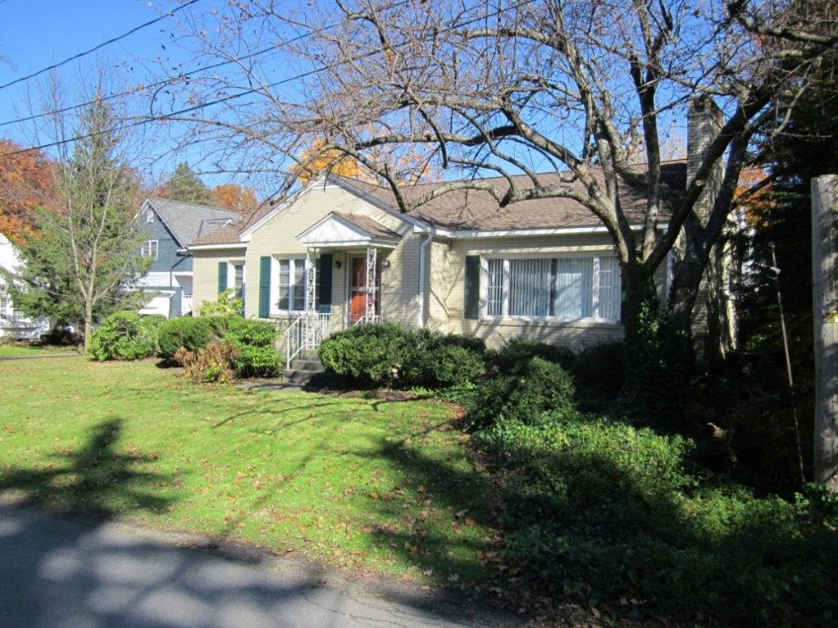

Typical Structure in the Neighborhood Suburban District

* + 1. **History and Composition of Neighborhood Suburban District** Generally, homes built in the Neighborhood Suburban district were constructed after World War II. Many of the homes were designed in the suburban styles popular at the times. Homes build earlier in the period are typically somewhat smaller, single-Story, less ornamented, and located toward the center of the Lot, with homes built later tending to be two Stories. The Neighborhood Suburban district includes a variety of Lots, most of them significantly larger than those found in the earlier development pattern of the Intuition. The larger Lots provide for a much lusher and greener landscaped setting. This district also contains a variety of home sizes, including small cottages to substantially larger homes.
    2. **Purpose and Intent** The purpose of the Neighborhood Suburban guidelines is to protect and enhance the character of the neighborhoods that are more typical of American post-World War II development than are other districts within the Chautauqua Institution. The Regulations recognize the variety of Building design styles present within this district and set out to preserve this development pattern. The Regulations encourage development that is consistent with the existing context, density, and development patterns. The Regulations encourage the connection of inside space with the public domain through the use of porches as secondary living space to reinforce the communal nature of the district. Private parking should be appropriately concealed to reinforce the open, lower density nature of the district.

The aesthetic concerns of individual properties and Buildings are important in the Neighborhood Suburban district. Buildings should be well designed and compatible in scale and proportion to their Lots and appropriate for their particular neighborhood setting. With more Open Space around and between Buildings, attractive landscaping is a greater part of the visual environment in this district than it may be in more densely built districts.

* + 1. **Maximum Lot Size, Intensity, and IRS**

|  |  |  |
| --- | --- | --- |
| MINIMUM LOT SIZE, MAXIMUM INTENSITY& MAXIMUM ISR | | |
| **Regulation** | | **Neighborhood Suburban** |
| Minimum Lot Width | | 60 Feet |
| Minimum Lot Area | | 6,000 Square Feet |
| Maximum FAR | | 0.5 (See exemptions below) |
| Maximum ISR | |  |
|  | Single Lot | Single Lots: 50% total site area including all surfaces of driveways, parking lots, walkways, window wells, patios etc. 50% of site area must remain green and pervious |
| Multiple Lots | Multiple Lots: 40% total site area including all surfaces of driveways, parking lots, walkways, window wells, patios etc. 60% of site area must remain green and pervious |

* + 1. **FAR Exemptions** 
       1. Any floor area located within a finished Basement area that has a finished first floor height no greater than 36 inches off of the average established natural grade level of the ground adjoining the Building and does not have window wells facing the primary street shall not be included in the FAR calculation.
       2. Any finished attic space that is compliant with all height, Setback, tower, turret, and dormer Regulations and that is less than 65% of the at-grade footprint of the Building shall not be included in the FAR calculation.
       3. Garage space is not exempt from FAR calculations.
    2. **Maximum Building Height**

|  |  |  |
| --- | --- | --- |
| **MAXIMUM BUILDING HEIGHT** | | |
| **Building Height** | **Eave Line** | **Highest Point of Roof** |
|  | 24’ | 36’ |
| Refer to Article 2 for definitions and diagrams regarding the measurement of Building Height to Article 5.14.9. for the exemptions to Building Heights for chimneys and Ancillary Equipment. For additional information, refer to the diagrams contained in Article 4.11. The Administrator shall have the authority to allow de minimis variances in height that may exceed these maximums if the variance is less than 8”. | | |

* + 1. **Building Setbacks**

|  |  |  |  |
| --- | --- | --- | --- |
| MINIMUM BUILDING SETBACKS | | | |
| Building Setbacks. Please refer to the Official Map to determine if there are pre-existing, required Setbacks applicable to a particular Lot. The Official Map is located in the office of the Administrator | | Reconstruction, Rehabilitation, Renovation, or Restoration of Existing Structure | Additions and New Construction |
| Front Yard | Stoop Steps | existing* | 0’** |
| First and Second Floor Open Porch | existing* | 0’** |
| Building up to 24 feet of height | existing* | 10’** |
| Building above 24 feet of height (requires Variance) | existing* | 16’** |
| Street Side Yard | Zero side below 24’/above 24’ | existing* | 3’/5’** |
| 10 foot side, below 24’/above 24’ | existing* | 10’/12’** |
| Not specified below 24’/above 24’ | existing* | 5’/7’** |
| Interior Side Yard | Zero Side, below 24’/above 24’ | existing* | 3’/5’** |
| 10 foot side, below 24’/above 24’ | existing* | 10’/12** |
| Not specified, below 24’/above 24’ | existing* | 5’/7’** |
| Rear Yard | Zero rear, below 24’/above 24 | existing* | 0’/4’** |
| 10 foot side, below 24’/above 24’ | existing* | 10’/14’** |
| Not Specified, below 24’/above 24’ | existing* | 5’/9’** |
| * Many Structures within the Institution have preexisting or previously approved encroachments that render the Structure a Legally Existing Nonconforming Structure within the meaning of these Regulations. Those encroachments are recognized and allowed to remain. Expansion of such an encroachment can be requested of and granted by the Administrator under the minor encroachment provisions set forth below or by the ARB if either (a) the Administrator denies such request or (b) the requested expansion exceeds the minor encroachment criteria and the expansion meets the criteria established for Variances. Such encroachments do not carry forward in the case of a Demolition (other than an Investigative Demolition) followed by New Construction or if a Building is relocated on a Lot as part of a Building Project. Minor encroachments into normally prescribed Setbacks may be allowed to accommodate an Addition to align with the side of the existing Structure, provided: (a) the total floor area of the encroaching portion of an Addition shall not exceed 50 square feet; (b) no portion of the encroachment shall exceed 24 feet in height; and (c) the Encroachment into The Setback is not greater than 8 inches.  **No portion of any Structure, with the exception of overhangs, shall come within 10 feet of a neighboring Structure  For additional information, refer to the diagrams contained in Article 4.11. | | | |

* + 1. **Roof Lines and Slopes** The required Setbacks provided for in Article 4.7.6. increase for Buildings with a wall or walls above 24 feet in height (except for the provisions associated with towers and turrets provided herein). At 24 feet, or below, a cornice line shall be provided and the roofline shall begin. The roof slope shall not exceed 45 degrees (12:12 pitch). The roof peak shall not exceed the maximum height of 36 feet. If a sloped roof is not characteristic of the design style, the wall shall be accentuated with a cornice line at or below 24 feet in height. Any portion of a wall exceeding 24 feet in height shall be set back at as specified in the Minimum Building Setbacks chart contained in Article 4.7.6. For additional information, refer to the diagrams contained in Article 4.11.
       1. **Towers and Turrets** A tower or a turret may exceed the 24 foot height requirement but must utilize the additional Setbacks required for heights above 24 feet. The walls of a tower or turret shall not exceed 16 feet in any one horizontal dimension. For a tower or turret with a nonstraight (rounded) wall, this dimension shall be calculated using the smallest rectangle that will enclose the horizontal wall of the tower or turret. For additional information, refer to the diagrams contained in Article 4.11.
       2. **Dormers** The vertical plane of a dormer must comply with the additional setback requirements for height above 24 feet. The width of the dormer wall or, in the case of multiple dormers, the total width of all of the dormer walls shall not exceed 50% of the roof width, or 20 feet of width, whichever is less. Dormers shall be compatible with the chosen architectural style. For additional information, refer to the diagrams contained in Article 4.11.
    2. **General Design Criteria** All Building Projects shall comply with the Secretary of Interior Standards for the Treatment of Historic Properties, which are contained in Article 4.12., based on the Building Project’s methodology.
    3. **Pedestrian Connections**
       1. Although not required, where feasible, all Building Projects and New Construction shall provide for Structures to have a front porch with a minimum functional depth of 4 feet in the case of an existing Building and 6 feet in the case of New Construction.
       2. All Building Projects and New Construction shall provide for all Buildings to be connected to the sidewalk or street edge by a minimum of a 36” wide impervious or semi-pervious walkway.
       3. All Building Projects and New Construction shall provide for any Multi-Family Dwelling or Accessory Unit to be connected to the sidewalk or street edge by a minimum of a 36” wide impervious or semi-pervious walkway and shall otherwise meet all applicable design standards for such uses, including those outlined within the Accessory Unit criteria.
    4. **Building Form** 
       1. When an existing Building is altered through the creation of an Addition, then the overall form of the Building shall be retained and utilized in the creation of the Addition.
       2. When an existing Building is altered through the creation of an Addition, then the existing floor height off of the average established natural grade level of the ground adjoining the Building shall be maintained for both the existing Building and the Addition; provided, however, in the case of a new Basement or new Accessory Unit located in a Basement, the requirements of these Regulations applicable to Accessory Units, including Article 5.1. hereof, shall apply to such Basement or Accessory Unit.
       3. New Construction shall be built to have the appearance of a house raised above the average established natural grade level of the ground adjoining the Building by 16 inches. The appearance of slab on grade construction is prohibited.
       4. New Construction shall create a Building having a width-to-height ratio not greater than 1:2. Any New Construction that seeks to create a Building with a width-to-height ratio greater than 1:2 shall require a Variance from the ARB. The request for such a Variance shall be determined based on the criteria established in Article 6.10. and, if granted, shall require that the to-be-constructed Building feature architectural Fenestration (such as pilasters, arcades, building line and roof line off-sets, materials and other appropriate architectural features) to create a bay system that divides the designed Building into identifiable segments each of which has a maximum width-to-height ratio of 1:2.
    5. **Exterior Wall Composition** 
       1. When in the context of a Building Project an existing Building is altered, then the overall exterior wall composition shall be retained. For the avoidance of doubt, when in the context of a Building Project an existing Building is expanded, then the overall exterior wall composition of the existing Building shall be utilized in the Addition.
       2. In the context of both a Building Project and New Construction, doors, windows and other appropriate Fenestration shall be incorporated into all sides of a Building. There shall be no blank façades. For multi-Story Buildings, no portion of a façade corresponding to the height between two floors shall contain a blank area greater than 12 feet in width.

* + - 1. In the context of both a Building Project and New Construction, at least 30 percent of primary and secondary street façades shall consist of Fenestration. At least 20 percent of interior side and rear façades shall have Fenestration. At least two-thirds of the Fenestration shall be transparent (i.e., window glass). One-third may consist of trim work, shutters, brackets and other architectural features. Entry doors shall be counted toward Fenestration if side panel or decorative windows are provided. Garage doors do not count toward Fenestration.
      2. Where in the context of both a Building Project and New Construction, a Structure is situated on a corner Lot, a through Lot, or on a Lot that, by the nature of the site layout, results in a façade of the Structure being clearly visible from a right-of-way, then the Structure shall be designed with full architectural treatment on all sides visible from rights-of-way. Full architectural treatment shall include roof design, wall materials, architectural trim, and door and window openings. Construction materials and detailing should be similar throughout the Structure even though the Structure will have primary and secondary façades.
    1. **Garages** In the Neighborhood Suburban district, in the context of New Construction of, and Building Projects involving, a Single-Family Home, then a Garage shall be limited to two enclosed Parking Spaces, shall face away from the street where practical, and shall be set back from the line of the front of the Building. In all other instances, a Garage in the Neighborhood Suburban district shall require a Variance from the ARB. The request for such a Variance shall be determined based on the criteria established in Article 6.10.

**4.7.13. Fire Pits, Open Fires or Exterior Fireplaces** Wood burning fire pits, campfires, exterior wood burning fireplaces, and open fires of any kind are prohibited in this District. Natural gas/propane fire features may be allowed following review & approval by the Administrator. These features shall not be located less than 10’ from structures, trees/plantings or other flammable material and shall not be located on any streetside or community walkway side of the house.

**4.7.14.** **Swimming Pools, Hot Tubs, Outdoor Spas, other Outdoor Bathing Accessories (Including Portable/Temporary Units)**- Prohibited without approval from the Architectural Review Board following application for a Compliance Certificate. These elements are considered “Structures” under these Regulations and are required to follow all building limitations and requirements. Criteria for reviewing these requests will include, but not be limited to, proximity and possible impact to neighbors and the community, community walks/roadways, proximity and possible impact to Chautauqua Institution activities, perceived safety and aesthetic impact.

* 1. **HIGHLANDS SUB-DISTRICT**

This Article 4.8. shall apply to Buildings, Structures, Accessory Structures, Land, and Lots located in the Highlands sub-district of the Neighborhood Suburban district, and to Building Projects and New Construction relating thereto. To the extent that the provisions and requirements of Article 4.7. of these Regulations are not inconsistent with the provisions and requirements of this Article 4.8., then the provisions and requirements of Article 4.7. shall also apply to Buildings, Structures, Accessory Structures, Land, and Lots located in the Highlands sub-district of the Neighborhood Suburban district, and to Building Projects and New Construction relating thereto.

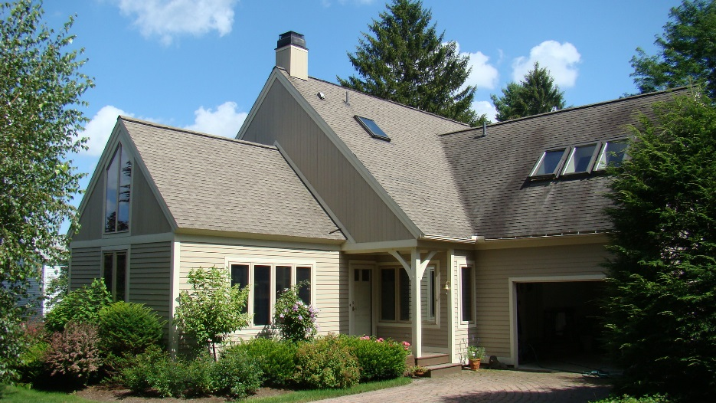

* + 1. **History Of the Highlands** The Highlands sub-district was developed by the Institution to accommodate increased demand for on-grounds, Single-Family Homes.
    2. **Purpose and Intent** The Highlands sub-district was developed with the intent of assuring a specific outcome of the built form by, among other things, specifying and relying on a detailed schedule of minimum Setbacks, Building Heights (referred to in the schedule as “Maximum Height”), Lot Coverage (referred to in the schedule as “Maximum Coverage”), and Open Space requirements. These requirements continue in full force and effect.
    3. **New Construction, Building Projects, and Landscaping Projects** All New Construction, Building Projects, and Landscaping Projects within the Highlands sub-district shall comply with all requirements for the Highlands sub-district set forth in Article 4.8.4 hereof.

**4.8.4. Fire Pits, Open Fires or Exterior Fireplaces** Wood burning fire pits, campfires, exterior wood burning fireplaces, and open fires of any kind are prohibited in this District. Natural gas/propane fire features may be allowed following review & approval by the Administrator. These features shall not be located less than 10’ from structures, trees/plantings or other flammable material and shall not be located on any streetside or community walkway side of the house.

**4.8.5.** **Swimming Pools, Hot Tubs, Outdoor Spas, other Outdoor Bathing Accessories (Including Portable/Temporary Units)**- Prohibited without approval from the Architectural Review Board following application for a Compliance Certificate. These elements are considered “Structures” under these Regulations and are required to follow all building limitations and requirements. Criteria for reviewing these requests will include, but not be limited to, proximity and possible impact to neighbors and the community, community walks/roadways, proximity and possible impact to Chautauqua Institution activities, perceived safety and aesthetic impact.

* + 1. **Building Yard and Bulk**

|  |  |  |  |  |  |  |  |
| --- | --- | --- | --- | --- | --- | --- | --- |
| **Schedule of Lot, Yard, and Bulk Details for Highlands District** | | | | | | | |
|  | | | | | | | |
|  | **Minimum Setbacks** | | | | **Maximum Height** | **Maximum Coverage %** | **Open Space %** |
| **Lot #** | **Left Side** | **Right Side** | **Front** | **Back** |
| 1901 | N/A | N/A | N/A | N/A | N/A | N/A | N/A |
| 1902 | N/A | N/A | N/A | N/A | N/A | N/A | N/A |
| 1903 | 7.5’ | 7.5’ | 5.0’ | 15.0’ | 30’ | 33 | 50 |
| 1904 | 7.5’ | 7.5’ | 5.0’ | 15.0’ | 30’ | 33 | 50 |
| 1905 | 7.5’ | 7.5’ | 5.0’ | 15.0’ | 30’ | 33 | 50 |
| 1906 | 7.5’ | 7.5’ | 5.0’ | 5.0 | 30’ | 40 | 50 |
| 1907 | 7.5’ | 7.5’ | 5.0’ | 10.0’ | 30’ | 40 | 50 |
| 1908 | 7.5’ | 5.0’ | 5.0’ | 10.0’ | 30’ | 40 | 50 |
| 1909 | 5.0’ | 7.5’ | 5.0’ | 10.0’ | 30’ | 40 | 50 |
| 1910 | 7.5’ | 5.0’ | 5.0’ | 10.0’ | 30’ | 45 | 50 |
| 1911 | 5.0’ | 7.5’ | 5.0’ | 10.0’ | 30’ | 45 | 50 |
| 1912 | 5.0’ | 7.5’ | 5.0’ | 10.0’ | 30’ | 45 | 50 |
| 1913 | 5.0’ | 7.5’ | 5.0’ | 10.0’ | 30’ | 45 | 50 |
| 1914 | 7.5’ | 7.5’ | 5.0’ | 10.0’ | 30’ | 45 | 50 |
| 1915 | 7.5’ | 5.0’ | 5.0’ | 10.0’ | 30’ | 45 | 50 |
| 1916 | 7.5’ | 7.5’ | 5.0’ | 10.0’ | 30’ | 40 | 50 |
| 1917 | 7.5’ | 7.5’ | 5.0’ | 10.0’ | 30’ | 45 | 50 |
| 1918 | 7.5’ | 7.5’ | 5.0’ | 10.0’ | 30’ | 40 | 50 |
| 1919 | 7.5’ | 7.5’ | 5.0’ | 5.0’ | 30’ | 40 | 50 |
| 1920 | 7.5’ | 7.5’ | 5.0’ | 5.0’ | 30’ | 40 | 50 |
| 1921 | 7.5’ | 2.0’ | 5.0’ | 10.0’ | 30’ | 40 | 50 |
| 1922 | 7.5’ | 7.5’ | 5.0’ | 10.0’ | 30’ | 40 | 50 |
| 1923 | 7.5’ | 7.5’ | 5.0’ | 10.0’ | 30’ | 40 | 50 |
| 1924 | 7.5’ | 10.0’ | 5.0’ | 10.0’ | 30’ | 33 | 50 |
| 1925 | 7.5’ | 10.0’ | 5.0’ | 15.0’ | 30’ | 33 | 50 |
| 1926 | 7.5’ | 10.0’ | 5.0’ | 10.0’ | 30’ | 33 | 50 |
| 1927 | 7.5’ | 10.0’ | 5.0’ | 15.0’ | 30’ | 45 | 50 |
| 1928 | 5.0’ | 10.0’ | 5.0’ | 5.0 | 30’ | 33 | 50 |
| 1929 | 10.0’ | 7.5’ | 5.0’ | 15.0’ | 30’ | 33 | 50 |
| 1930 | 7.5’ | 5.0’ | 5.0’ | 10.0’ | 30’ | 33 | 50 |
| 1931 | 7.5’ | 5.0’ | 5.0’ | 15.0’ | 30’ | 33 | 50 |

* 1. **WOODLANDS SUB-DISTRICT**

This Article 4.9. shall apply to Buildings, Structures, Accessory Structures, Land, and Lots located in the Woodlands sub-district of the Neighborhood Suburban district, and to Building Projects and New Construction relating thereto. To the extent that the provisions and requirements of Article 4.7. of these Regulations are not inconsistent with the provisions and requirements of this Article 4.9., then the provisions and requirements of Article 4.7. shall also apply to Buildings, Structures, Accessory Structures, Land, and Lots located in the Woodlands sub-district of the Neighborhood Suburban district, and to Building Projects and New Construction relating thereto.

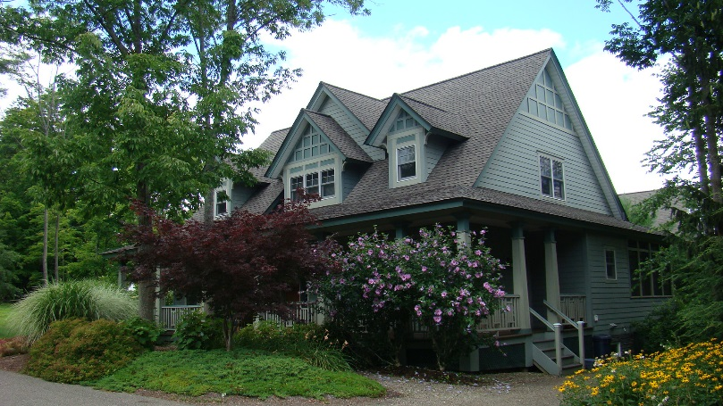

* + 1. **History Of the Woodlands** The Woodlands sub-district was developed by the Institution to accommodate increased demand for on-grounds, Single-Family Homes.
    2. **Purpose and Intent** The Woodlands sub-district was developed with the intent of assuring a specific outcome of the built form by, among other things, specifying and relying on a detailed schedule of Lot Areas (referred to in the schedule as “Lot Size”), Building Footprint (referred to in the schedule as “Bldg. Envelope”), Lot Coverage (referred to in the schedule as “Maximum Coverage”), Building Height (referred to in the schedule as Maximum Height”), and maximum floor area or enclosed space. These requirements continue in full force and effect.
    3. **New Construction, Building Projects, and Landscaping Projects** All New Construction, Building Projects, and Landscaping Projects within the Woodlands sub-district shall comply with all requirements for the Woodlands sub-district set forth in Article 4.9.4. hereof.

**4.9.4. Fire Pits, Open Fires or Exterior Fireplaces** Wood burning fire pits, campfires, exterior wood burning fireplaces, and open fires of any kind are prohibited in this District. Natural gas/propane fire features may be allowed following review & approval by the Administrator. These features shall not be located less than 10’ from structures, trees/plantings or other flammable material and shall not be located on any streetside or community walkway side of the house.

**4.9.5.** **Swimming Pools, Hot Tubs, Outdoor Spas, other Outdoor Bathing Accessories (Including Portable/Temporary Units)**- Prohibited without approval from the Architectural Review Board following application for a Compliance Certificate. These elements are considered “Structures” under these Regulations and are required to follow all building limitations and requirements. Criteria for reviewing these requests will include, but not be limited to, proximity and possible impact to neighbors and the community, community walks/roadways, proximity and possible impact to Chautauqua Institution activities, perceived safety and aesthetic impact.

* + 1. **Building Yard and Bulk**

|  |  |  |  |  |  |
| --- | --- | --- | --- | --- | --- |
| **Schedule of Lot, Yard, and Bulk Details for Woodlands District** | | | | | |
| **Lot #** | **Lot Size**  **in sq. ft.** | **Bldg. Envelope**  **in sq. ft.** | **Maximum Coverage**  **for Entire Lot in sq. ft.** | **Maximum**  **Height** | **Maximum**  **Enclosed Space in sq. ft.** |
| 1 | 10,809 | 2,250 | 3,700 | 30 feet | 3,000 |
| 2 | 8,114 | 2,250 | 3,350 | 30 feet | 3,000 |
| 3 | 9,642 | 2,500 | 3,400 | 30 feet | 3,000 |
| 4 | 9,199 | 3,000 | 3,679 | 30 feet | 3,000 |
| 5 | 8,835 | 2,700 | 3,700 | 30 feet | 3,000 |
| 6 | 6,902 | 2,250 | 2,650 | 30 feet | 3,000 |
| 7 | 10,800 | 2,130 | 3,550 | 30 feet | 3,000 |
| 8 | 13,019 | 2,250 | 3,700 | 30 feet | 3,000 |
| 9 | 12,977 | 2,070 | 3,850 | 30 feet | 3,000 |
| 10 | 6,620 | 2,010 | 3,400 | 30 feet | 3,000 |
| 11 | 13,120 | 2,220 | 3,400 | 30 feet | 3,000 |
| 12 | 20,945 | 3,600 | 4,400 | 30 feet | 3,600 |
| 13 | 17,822 | 3,000 | 4,400 | 30 feet | 3,600 |
|  | | | | | |
| The official site plan for the Woodlands District identified certain trees that must be retained. Driveway access to Lot 1 required the removal of several designated trees that were identified in the site planning process. Maximum Lot Coverage includes the Building, any porches or decks, and any impervious, at-grade improvements such as driveways, patios, etc. Maximum Enclosed Space includes habitable and uninhabitable space (such as a Garage) on the first and second (roof structure) levels of the home. It does not include any Basement or cellar space. Basements must be at a height appropriate to existing grade and may not be built up and then filled around. No Structures may be built outside the Building envelope. | | | | | |

* 1. **MULTI-FAMILY SUBURBAN DISTRICT**

This Article 4.10. shall apply to Buildings, Structures, Accessory Structures, Land, and Lots located in the Multi-Family Suburban district, and to Building Projects and New Construction relating thereto.

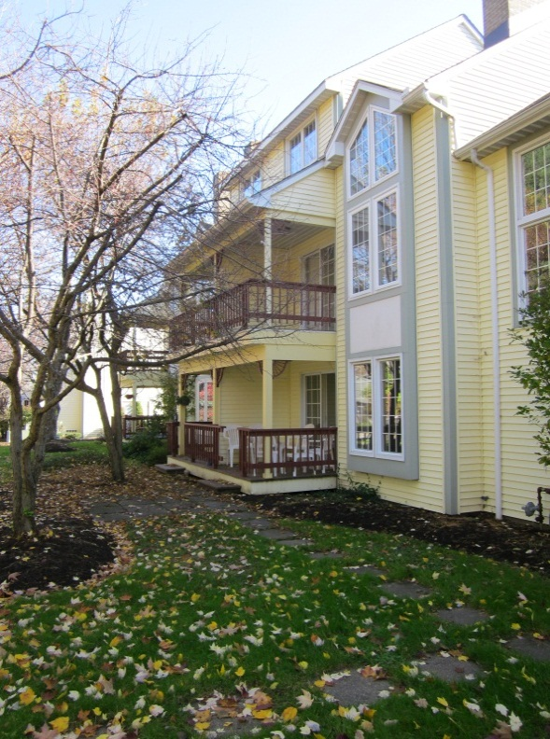

Typical Structure in the Multi-Family Suburban District

* + 1. **History and Composition of Multi-Family Suburban District** Several Multi-Family Dwellings were created at both the north end and the south end of the Institution grounds in the early 1980s. These Structures are largely atypical of Buildings found in other districts in the Institution and, therefore, have quite different Regulations. It is recognized that this district will largely stay intact and that the Multi-Family Dwellings located therein likely will not be substantially altered over time but, instead, will be maintained.
    2. **Purpose and Intent** The purpose of the Multi-Family Suburban guidelines is to recognize and provide for the unique character of the existing development pattern found in this particular district. The guidelines do not intend to direct future redevelopment within the district or any part thereof.
    3. **Maximum Lot Size, Intensity, and ISR**

|  |  |
| --- | --- |
| **MINIMUM LOT SIZE, MAXIMUM INTENSITY & MAXIMUM ISR** | |
| **Regulation** | **Multi-Family Suburban** |
| Minimum Lot Width | 400 Feet |
| Minimum Lot Area | 2 Acres |
| Maximum FAR | 0.5, with no exemptions |
| Maximum ISR | 50% total site area including all surfaces of driveways, parking lots, walkways, window wells, patios etc. 50% of site area must remain green and pervious |

* + 1. **Maximum Building Height**

|  |  |  |
| --- | --- | --- |
| **MAXIMUM BUILDING HEIGHT** | | |
| **Building Height** | **Eave Line** | **Highest Point of Roof** |
|  | 24’ | 36’ |
| Refer to Article 2 for definitions and diagrams regarding the measurement of Building Height and to Article 5.14.9. for the exemptions to Building Heights for chimneys and Ancillary Equipment. For additional information, refer to the diagrams contained in Article 4.11. The Administrator shall have the authority to allow de minimis variances in height that may exceed these maximums if the variance is less than 8”. | | |

* + 1. **Building Setbacks**

|  |  |  |  |
| --- | --- | --- | --- |
| **MINIMUM BUILDING SETBACKS** | | | |
| Building Setbacks. Please refer to the Official Map to determine if there are pre-existing, required Setbacks applicable to a particular Lot. The Official Map is located in the office of the Administrator | | Reconstruction, Rehabilitation, Renovation, or Restoration of Existing Structure** | Additions and New Construction** |
| Front Yard | First and Second Floor Open Porch | existing* | 15’ |
| Building up to 24 feet of height | existing* | 24’ |
| Building above 24 feet of height (requires Variance) | existing* | 30’ |
| Street Side Yard | Building below 24’/above 24’ | existing* | 24’/30’ |
| Interior Side Yard | Building, below 24’/above 24’ | existing* | 24’/30’ |
| Rear Yard | Building, below 24’/above 24’ | existing* | 24’/30’ |
|  |  |  |  |
| * Many Structures within the Institution have preexisting or previously approved encroachments that render the Structure a Legally Existing Nonconforming Structure within the meaning of these Regulations. Those encroachments are recognized and allowed to remain. Expansion of such an encroachment can be requested of and granted by the Administrator under the minor encroachment provisions set forth below or by the ARB if either (a) the Administrator denies such request or (b) the requested expansion exceeds the minor encroachment criteria and the expansion meets the criteria established for Variances. Such encroachments do not carry forward in the case of a Demolition (other than an Investigative Demolition) followed by New Construction or if a Building is relocated on a Lot as part of a Building Project. Minor encroachments into normally prescribed Setbacks may be allowed to accommodate an Addition to align with the side of the existing Structure, provided: (a) the total floor area of the encroaching portion of an Addition shall not exceed 50 square feet; (b) no portion of the encroachment shall exceed 24 feet in height; and (c) the Encroachment into The Setback is not greater than 8 inches.  ** In the case of either a Building Project or New Construction, and notwithstanding anything to the contrary contained in these Regulations, multiple Structures within the same development site used as Multi-Family Dwellings must be separated by a minimum of 20 feet between Structures. | | | |

* + 1. **Site Layout and Orientation** All Building Projects and New Construction shall place parking areas on interior portions of the site and shall screen the parking areas from visibility from the public roadways or rights of way.
    2. **Pedestrian Connections** All Building Projects and New Construction shall provide for all Buildings to be connected to the sidewalk or street edge by a minimum of a 48” wide sidewalk.
    3. **Garages**  In the context of Building Projects and New Construction, Garages shall face internally on to the site and shall not have direct access from the public roadway system.

**4.10.9. Fire Pits, Open Fires or Exterior Fireplaces** Wood burning fire pits, campfires, exterior wood burning fireplaces, and open fires of any kind are prohibited in this District. Natural gas/propane fire features may be allowed following review & approval by the Administrator. These features shall not be located less than 10’ from structures, trees/plantings or other flammable material and shall not be located on any streetside or community walkway side of the house.

**4.10.10.**  **Swimming Pools, Hot Tubs, Outdoor Spas, other Outdoor Bathing Accessories (Including Portable/Temporary Units)**- Prohibited without approval from the Architectural Review Board following application for a Compliance Certificate. These elements are considered “Structures” under these Regulations and are required to follow all building limitations and requirements. Criteria for reviewing these requests will include, but not be limited to, proximity and possible impact to neighbors and the community, community walks/roadways, proximity and possible impact to Chautauqua Institution activities, perceived safety and aesthetic impact.

* 1. **GRAPHIC EXAMPLES**
     1. **Roof Lines**  Please refer to Articles 4.3.5., 4.4.5., 4.6.5., 4.7.5. and 4.10.4. for maximum permitted Building Heights at both the eave line and the highest point of the roof.

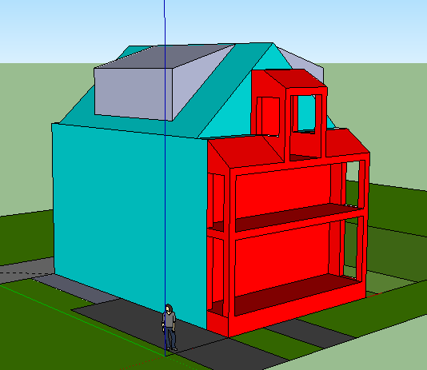

Peak of the Roof is the tallest point of the roof crest as outlined in the chart above

Eave line is where the eave line begins and where the roof shall start to slope back

|  |  |  |
| --- | --- | --- |
| District | Eave Line | Peak of Roof |
| Mixed Use Core | 34 Feet | 46 Feet |
| Neighborhood Traditional | 24 Feet | 36 Feet |
| Garden District Sub-District | See Pattern Book | |
| Neighborhood Suburban | 24 Feet | 36 Feet |
| Highlands Sub-District | See Highlands Building Yard and Bulk Chart | |
| Woodlands Sub-District | See Woodlands Building Yard and Bulk Chart | |
| Suburban Multi-Family | 24 Feet | 36 Feet |

* + 1. **Types of Roof Shapes**

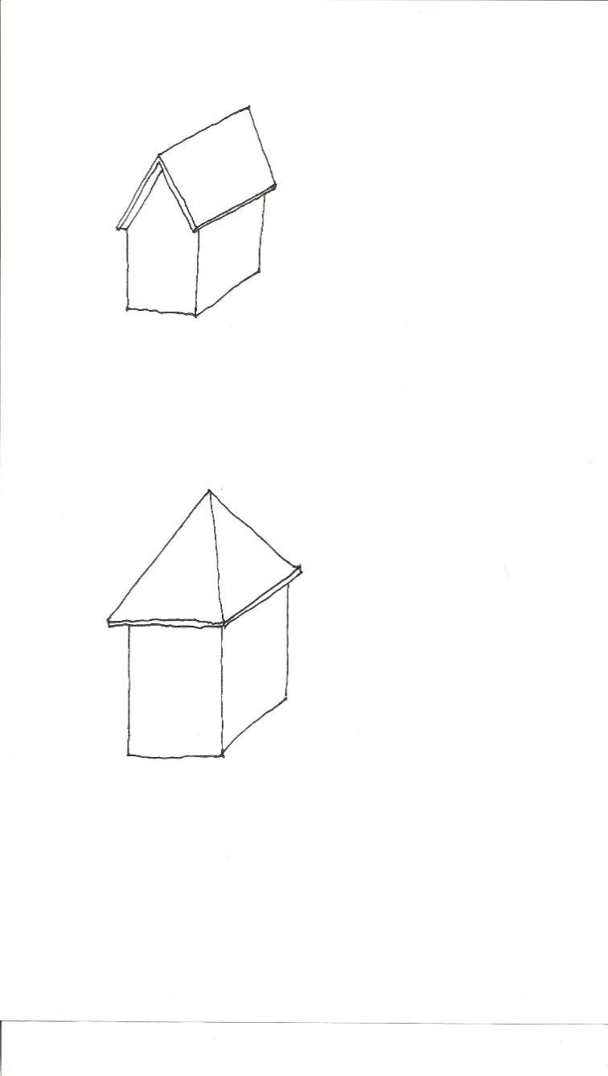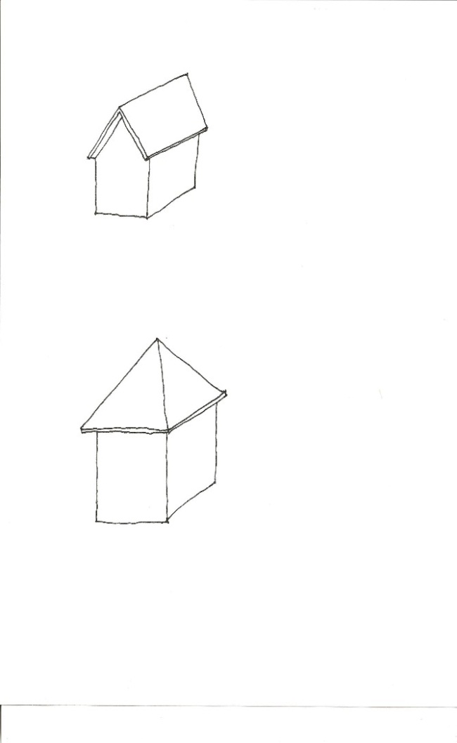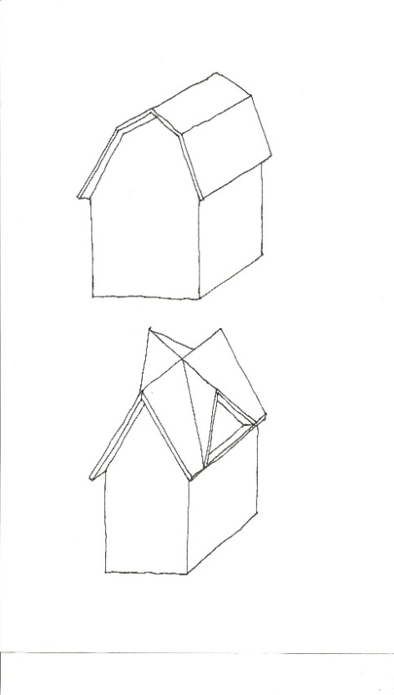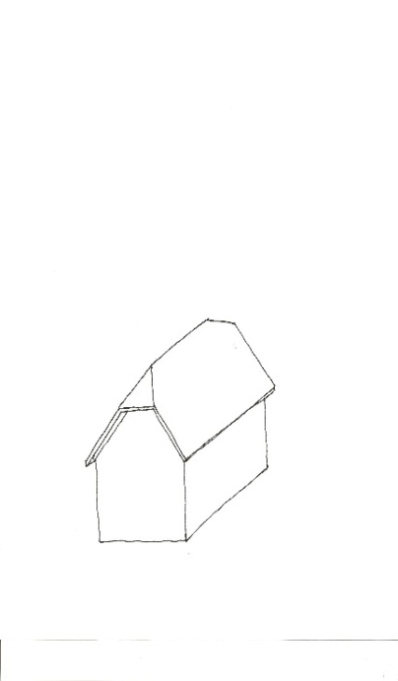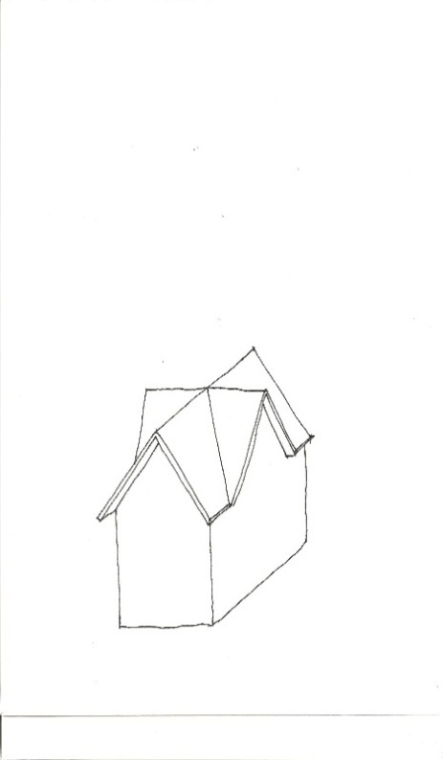

Hipped

Gable

Gambrel

Clipped Gable

Cross Gabel

* + 1. **Dormers**

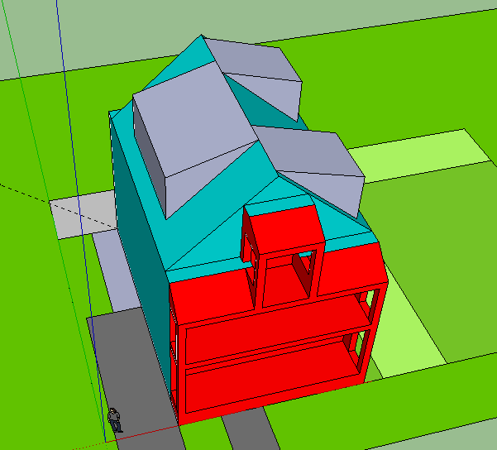

A single dormer covering 50% of the linear roof edge

Two dormers covering 50% of the linear roof edge

* + - 1. **Dormer Setbacks**

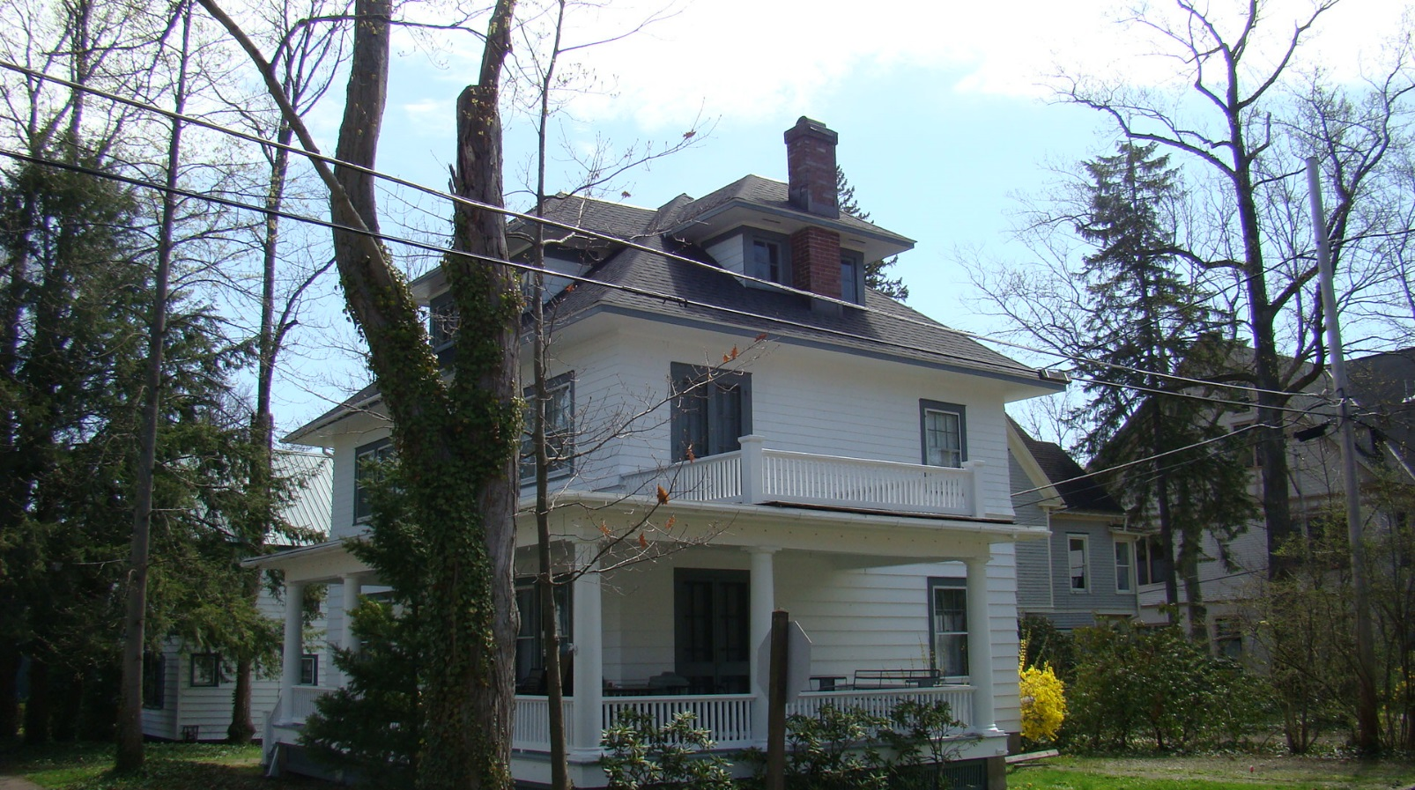

Note how the wall plane of the Dormer is set back an additional two feet from the wall plane of the main building. This reduces the massiveness and bulk of the roofline and allows additional light and air to circulate into neighboring properties.

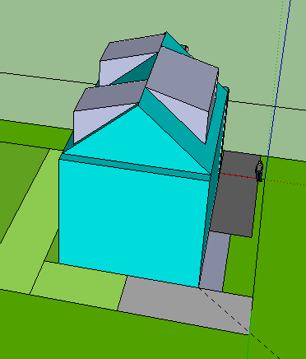

Areas for bike storage, trash cans etc. located in Side or Rear Yards.

* + 1. **Yard Requirements**
    2. **Porch Design**

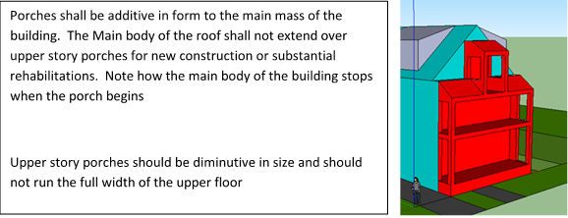

* + 1. **Towers and Turrets**

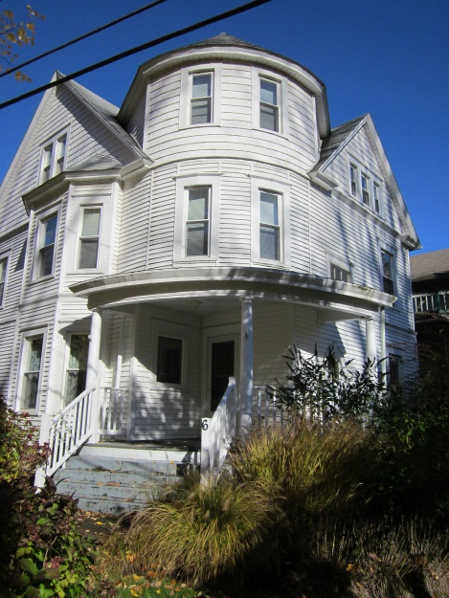

Towers and turrets may exceed the required stepping back of the roof plane if they meet the sizing requirements located within the district’s Regulations.

* + 1. **Fenestration and Blank Walls**

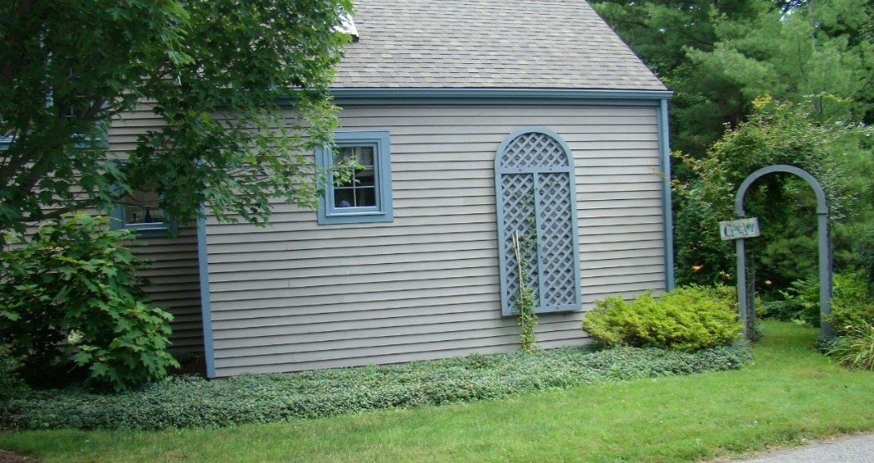

Blank walls are walls with limited amount of architectural fenestration and are not allowed. The use of this garden trellis attached to the wall is a creative way of solving this issue.

* + 1. **Entries to Accessory Units**

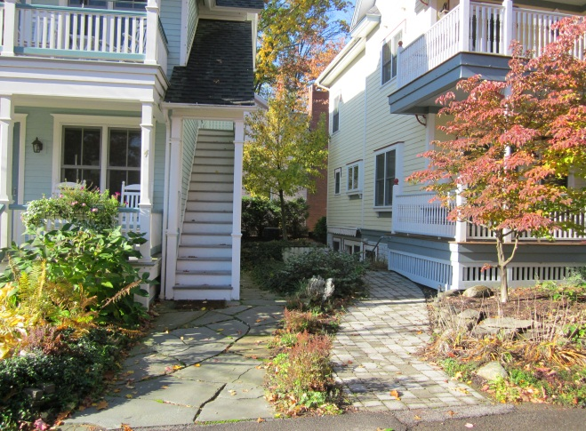

These two entries to Accessory Units are clearly identified from the street. They are connected to the street with paved sidewalks and are secondary to the primary entrances

* + 1. **Storage Areas, Sheds**

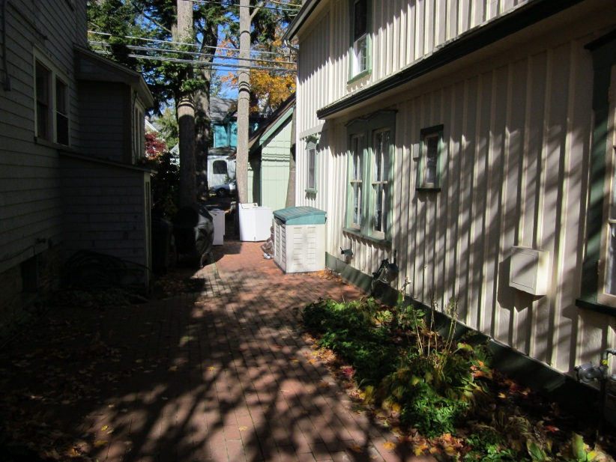

This shed is located to the side of a property, and has been painted to complement the color scheme of the house

* + 1. **Screening of Mechanical Equipment**

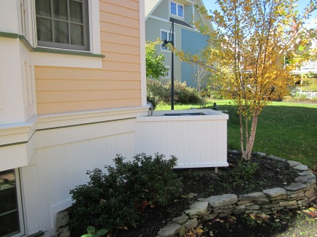

The air conditioning unit is screened form sight by materials that resemble the foundation skirting

* 1. **THE SECRETARY OF THE INTERIOR'S STANDARDS FOR THE TREATMENT OF HISTORIC PROPERTIES, 1995**
     1. **Standards for Preservation**
        1. A property will be used as it was historically or be given a new use that maximizes the retention of distinctive materials, features, spaces, and spatial relationships. Where a treatment and use have not been identified, a property will be protected and, if necessary, stabilized until additional work may be undertaken.
        2. The historic character of a property will be retained and preserved. The replacement of intact or repairable historic materials or alteration of features, spaces, and spatial relationships that characterize a property will be avoided.
        3. Each property will be recognized as a physical record of its time, place, and use. Work needed to stabilize, consolidate, and conserve existing historic materials and features will be physically and visually compatible, identifiable upon close inspection, and properly documented for future research.
        4. Changes to a property that have acquired historic significance in their own right will be retained and preserved.
        5. Distinctive materials, features, finishes, and construction techniques or examples of craftsmanship that characterize a property will be preserved.
        6. The existing condition of historic features will be evaluated to determine the appropriate level of intervention needed. Where the severity of deterioration requires repair or limited replacement of a distinctive feature, the new material will match the old in composition, design, color, and texture.
        7. Chemical or physical treatments, if appropriate, will be undertaken using the gentlest means possible. Treatments that cause damage to historic materials will not be used.
        8. Archeological resources will be protected and preserved in place. If such resources must be disturbed, mitigation measures will be undertaken.
     2. **Standards for Reconstruction**
        1. Reconstruction will be used to depict vanished or nonsurviving portions of a property when documentary and physical evidence is available to permit accurate reconstruction with minimal conjecture, and such reconstruction is essential to the public understanding of the property.
        2. Reconstruction of a landscape, building, structure, or object in its historic location will be preceded by a thorough archeological investigation to identify and evaluate those features and artifacts which are essential to an accurate reconstruction. If such resources must be disturbed, mitigation measures will be undertaken.
        3. Reconstruction will include measures to preserve any remaining historic materials, features, and spatial relationships.
        4. Reconstruction will be based on the accurate duplication of historic features and elements substantiated by documentary or physical evidence rather than on conjectural designs or the availability of different features from other historic properties. A reconstructed property will re-create the appearance of the nonsurviving historic property in materials, design, color, and texture.
        5. A reconstruction will be clearly identified as a contemporary re-creation.
        6. Designs that were never executed historically will not be constructed.
     3. **Standards for Rehabilitation**
        1. A property will be used as it was historically or be given a new use that requires minimal change to its distinctive materials, features, spaces, and spatial relationships.
        2. The historic character of a property will be retained and preserved. The removal of distinctive materials or alteration of features, spaces, and spatial relationships that characterize a property will be avoided.
        3. Each property will be recognized as a physical record of its time, place, and use. Changes that create a false sense of historical development, such as adding conjectural features or elements from other historic properties, will not be undertaken.
        4. Changes to a property that have acquired historic significance in their own right will be retained and preserved.
        5. Distinctive materials, features, finishes, and construction techniques or examples of craftsmanship that characterize a property will be preserved.
        6. Deteriorated historic features will be repaired rather than replaced. Where the severity of deterioration requires replacement of a distinctive feature, the new feature will match the old in design, color, texture, and, where possible, materials. Replacement of missing features will be substantiated by documentary and physical evidence.
        7. Chemical or physical treatments, if appropriate, will be undertaken using the gentlest means possible. Treatments that cause damage to historic materials will not be used.
        8. Archeological resources will be protected and preserved in place. If such resources must be disturbed, mitigation measures will be undertaken.
        9. New additions, exterior alterations, or related new construction will not destroy historic materials, features, and spatial relationships that characterize the property. The new work will be differentiated from the old and will be compatible with the historic materials, features, size, scale and proportion, and massing to protect the integrity of the property and its environment.

* + - 1. New additions and adjacent or related new construction will be undertaken in such a manner that, if removed in the future, the essential form and integrity of the historic property and its environment would be unimpaired.
    1. **Standards for Restoration**
       1. A property will be used as it was historically or be given a new use which reflects the property's restoration period.
       2. Materials and features from the restoration period will be retained and preserved. The removal of materials or alteration of features, spaces, and spatial relationships that characterize the period will not be undertaken.
       3. Each property will be recognized as a physical record of its time, place, and use. Work needed to stabilize, consolidate and conserve materials and features from the restoration period will be physically and visually compatible, identifiable upon close inspection, and properly documented for future research.
       4. Materials, features, spaces, and finishes that characterize other historical periods will be documented prior to their alteration or removal.
       5. Distinctive materials, features, finishes, and construction techniques or examples of craftsmanship that characterize the restoration period will be preserved.
       6. Deteriorated features from the restoration period will be repaired rather than replaced. Where the severity of deterioration requires replacement of a distinctive feature, the new feature will match the old in design, color, texture, and, where possible, materials.
       7. Replacement of missing features from the restoration period will be substantiated by documentary and physical evidence. A false sense of history will not be created by adding conjectural features, features from other properties, or by combining features that never existed together historically.
       8. Chemical or physical treatments, if appropriate, will be undertaken using the gentlest means possible. Treatments that cause damage to historic materials will not be used.
       9. Archeological resources affected by a project will be protected and preserved in place. If such resources must be disturbed, mitigation measures will be undertaken.
       10. Designs that were never executed historically will not be constructed.

**ARTICLE 5**

**SUPPLEMENTAL REGULATIONS**

This Article 5 provides additional regulations and requirements that typically will apply in the context of New Construction and Building Projects in all districts and sub-districts of the Chautauqua Institution. The Article also provides additional regulations and requirements that will apply in all districts and sub-districts of the Chautauqua Institution in certain limited instances other than New Construction and Building Projects. It is the intent of these additional regulations and requirements to protect the unique conditions that exist within the districts and sub-districts on the grounds of the Chautauqua Institution because of the close proximity of housing, the density of the Buildings, and the presence of small, pedestrian oriented streets.

* 1. **ACCESSORY UNITS**
     1. **Applicability** This Article 5.1. applies to New Construction and Building Projects on or after the effective date of these Regulations that involve the installation or alteration of an Accessory Unit.
     2. **Purpose and Intent** Some Single-Family Homes in the Chautauqua Institution contain a separate apartment. These Accessory Units are secondary, ancillary, and clearly subordinate to the principal Single-Family Home. Common forms of Accessory Units include a Basement apartment, a separate apartment in the attic space of a Single-Family Home, and in some cases an area within the living space of the home. These Accessory Units have become more desirable over time as property owners use these Accessory Units to generate revenue to offset the cost of housing, to provide additional living space for multi-generational families, and to provide an opportunity for affordable housing accommodations.

A Single-Family Home with an Accessory Unit differs significantly from a Multi-Family Dwelling because the outward appearance of the Structure typically remains that of a Single-Family Home. The Accessory Unit is clearly secondary, ancillary, and subordinate to the use of the primary Structure as a Single-Family Home. Appropriately guiding the form of development is important in maintaining the character and the viability of traditional, Single-Family Home neighborhoods. Protecting the patterns of development requires the establishment of applicable standards and compliance with these standards.

* + 1. **Establishment** The establishment or alteration of an Accessory Unit through New Construction or a Building Project shall be subject to the following requirements:
       1. No Single-Family Home shall have more than one Accessory Unit.
       2. An Accessory Unit must be physically attached to the principal Single-Family Home and shall not be freestanding.
    2. **Minimum Development Standards** The establishment or alteration of an Accessory Unit through New Construction or a Building Project also shall be subject to the following additional requirements: 
       1. The Lot Area shall be at least 2,000 square feet.
       2. A Lot containing an Accessory Unit shall not be subdivided to separate the Accessory Unit from the principal Building.
       3. An Accessory Unit shall remain in single ownership with the principal Building and the property shall not be turned into a Multi-Family Dwelling. Any property proposed for such a conversion shall be deemed a change of use and shall be required to follow all rules and Regulations as they apply to Multi-Family Dwellings, if allowed under the Use Matrix.
    3. **Building and Design Requirements:** The following additional requirements shall apply to the establishment or alteration of an Accessory Unit through New Construction or a Building Project:
       1. An Accessory Unit shall be no smaller than 250 square feet, and no larger than 40% of the overall square footage of the Building.
       2. An Accessory Unit must contain its own cooking and bathroom facilities.
       3. A Single-Family Home with an Accessory Unit shall have an overall appearance of a Single-Family Home, and the Building shall not have the appearance of a duplex or other Multi-Family Dwelling.
       4. If a Basement is added to create an Accessory Unit, it shall be done with the minimum disruption to the character and scale of the Building and the overall street context. Without limiting the generality of the foregoing, a Building shall be raised no more than 18” to accommodate the new Basement and the new finished floor Elevation shall not exceed 36” above the average established natural grade level of the ground adjoining the Building.
       5. For New Construction, the Finished Floor Height of the first floor shall be within 12 inches of the Finished Floor Height of the two homes adjacent to the new Building; provided, however, on sloped sites the heights of adjacent homes will be averaged and the new Building’s Finished Floor Height shall be no more than 36” above the average established natural grade level of the ground adjoining the Building.
       6. The appearance of the Building’s original porch and porch skirting shall be maintained and no windows or window wells shall be visible along the front façade of the Building.
       7. The Accessory Unit shall have a separate entryway. The entry should be secondary to the primary Building entry but be clearly accessible from the front of the property.
       8. Except as may otherwise be provided for herein, the entry door for an Accessory Unit shall be connected to the sidewalk or street edge by a minimum of a 24” wide impervious or semi-pervious walkway.
       9. An Accessory Unit shall not create additional parking on the site.
       10. On site accommodations shall be made for additional trash receptacles, bike or scooter parking and anything deemed necessary because of the Accessory Unit, all of which shall be located to conform to the Regulations.
  1. **ANCILLARY EQUIPMENT**
     1. **Applicability** This Article 5.2. applies to the installation of Ancillary Equipment on or after the effective date of these Regulations, whether pursuant to New Construction, a Building Project or otherwise and, where the context so requires, applies to the use of Ancillary Equipment whether installed prior to or after the effective date of these Regulations.
     2. **Purpose and Intent** Ancillary Equipment that requires an exterior operating system can significantly impact the visual aesthetics and quiet enjoyment of a property and its surrounding area. Care must be taken to design the placement of such Ancillary Equipment to ensure that it appropriately blends into the Structure or is sufficiently screened from public view. The Regulations apply to existing residential technologies (such as satellite dishes) and also emerging or future technologies (such as solar and geothermal heating and cooling systems) as they become more cost-effective and more readily available. The same thoughtful consideration should be given to the placement of ramps and lifts that facilitate handicap access.
     3. **Design Criteria**
        1. **Sound Tolerances**
           1. Except as expressly set forth hereinafter, Ancillary Equipment shall not generate sound greater than 60 dB as measured five (5) feet from the unit or the exterior discharge.
           2. Window-style air conditioning equipment shall not generate sound greater than 65 dB as measured five (5) feet from the unit.
           3. Residential power generation equipment, whether gas, solar, geo-thermal or wind, shall not generate sound greater than 75 dB as measured five (5) feet from the unit.
           4. Testing of generators is not allowed during the Summer Assembly Season.
        2. **Location Buffering and Screening**
           1. No Ancillary Equipment shall be installed in the Front Yard or Street Side Yard of a Building or located on the front façade or front roof of a Building.
           2. Location of Ancillary Equipment should consider neighboring bedroom windows and living space.
           3. When multiple items of Ancillary Equipment are present, roof top locations or interior mechanical rooms shall be used in New Construction or a Building Project unless impractical.
           4. All Ancillary Equipment located in Side Yards or located on the Building shall be screened from the public street, and such screening shall be effective twelve (12) months of the year.
           5. In the context of New Construction, Building Projects, and post-effective date installation, generators shall be located within the Structure or in a mechanical box with proper baffling and venting.
           6. The post-effective date installation of window-style air conditioning units is not recommended when such units will be visible from the street.
           7. In the context of New Construction or a Building Project, the use of traditional window-style air conditioners is strongly discouraged and shall require a Variance from the ARB. The request for such a Variance shall be determined based on the criteria established in Article 6.10. and, if granted, may carry such conditions as the ARB may elect to impose.

* + - * 1. Television antennas and any other type of obsolete Ancillary Equipment shall be removed as part of any Building Project and or substantial Maintenance.
      1. **Ramps, Lifts, and Fire Escapes**
         1. Ramps, lifts, and other forms of access to facilitate handicap accessibility or delivery to a Building that are installed after the effective date of these Regulations shall, where possible, be incorporated into existing access Structures (such as porches and walkways) and situated to the side or rear of the Structure.
         2. The materials and design of all ramps, lifts, and other forms of access that are installed after the effective date of these Regulations shall be compatible with the architectural design of the principal Structure and shall conform to the Regulations for walkways, porches and Setbacks. Exposed metal ramps are prohibited except in temporary situations (less than 12 months) following written authorization from the Administrator.
         3. All lifts, ramps and fire escapes that are installed after the effective date of these Regulations shall be situated to the side or rear of the Structure and painted or stained to minimize visual impact.
  1. **BASEMENT ENTRY WELLS AND WINDOW WELLS**
     1. **Applicability** This Article 5.3. applies to New Construction and Building Projects on or after the effective date of these Regulations that involve the creation or relocation of wells that provide access or natural light to below-grade space located in Basements of Structures, including Accessory Units, spaces used for storage or utilities, or any other type of occupied or unoccupied space.
     2. **Purpose and Intent** The Buildings in the Chautauqua Institution, especially in the older areas, typically did not have the visual appearance of occupied Basements. With the addition of Basement space and the need for light, ventilation and egress, wells and stairs have been added to some Buildings. To preserve the character and historic appearance, limitations have been placed on the allowable locations for Basement entry wells and window wells.
     3. **Design Criteria**
        1. Window wells and Basement entry wells created or relocated on or after the effective date of these Regulations, whether through New Construction, a Building Project or otherwise, shall be located in the Interior Side Yard and/or the Rear Yard and shall be a minimum of 5 feet from any property line.
        2. A Variance from the ARB is required if a window well or a Basement entry well that is created or relocated on or after the effective date of these Regulations is to face a Front Yard or a Street Side Yard. The request for such a Variance shall be determined based on the criteria established in Article 6.10. and, if granted, shall require that the tops of the windows not be visible from the street (whether by placing windows below grade or requiring adequate plantings to conceal the windows) and may carry such other conditions as the ARB may elect to impose.
        3. Basement entries installed after the effective date of these Regulations shall be designed to minimize the appearance of multiple residential units. Without limiting the generality of the foregoing, Basement access stairs should be installed internally where feasible and, where not feasible, exterior Basement access stairs shall be placed to the side or rear of the property.
  2. **COMBINING LOTS**
     1. **Applicability** This Article 5.4. applies when on or after the effective date of these Regulations two separate Lots in common ownership are combined to allow for a larger Building site, a Building Project proposes to join two Buildings together, or New Construction or a Building Project proposes to cross a Lot line separating two Lots in common ownership. The reference map we use to identify lot configurations is the 1939 Official Map of Chautauqua Institution (not the current Chautauqua County maps). For areas outside of the coverage of the 1939 map, other official Chautauqua Institution maps and surveys on file will be used.
     2. **Purpose and Intent** The development pattern in the Chautauqua Institution is unique and requires that special attention to detail be maintained. It is important that the design of a new or combined Structure continues to reinforce the contextual pattern of the neighborhood when two separate Lots in common ownership are combined to allow for a larger Building site, when a Building Project proposes to join two Buildings together, or when New Construction or a Building Project proposes to cross a Lot line separating two Lots in common ownership.
     3. **ARB Review** A Variance from the ARB is required when New Construction or a Building Project proposes to combine two separate Lots in common ownership to allow for a larger Building site, when a Building Project proposes to join two Buildings together, or when New Construction or a Building Project proposes to cross a Lot line separating two Lots in common ownership. The request for such a Variance shall be determined based on the criteria established in Article 6.10.
  3. **EXTERIOR LIGHTING**
     1. **Applicability** This Article 5.5. applies to the installation or alteration of any exterior lighting fixture on or after the effective date of these Regulations, whether pursuant to New Construction, a Building Project, a Landscaping Project or otherwise, but not as part of routine Maintenance.
     2. **Purpose and Intent** When designed properly, exterior lighting enhances the ambiance of the environment and provides safety and security on a property. When not designed properly, exterior lighting can create glare and light trespass because of the small Lots and close proximity of Structures. It is important that light be appropriately utilized in a way that is respectful to neighboring properties.
        1. Exterior lighting shall provide the minimum intensity level necessary to service driveways, walkways, entrances, porches and decks.

* + - 1. Security style lights are highly discouraged, and bright, glaring lights shall not be used.
      2. Lighting shall be directed in a fashion that does not adversely impact adjoining properties.
      3. Exterior lighting should utilize “dark-sky” devices.
      4. Lamps and fixtures with exposed light sources are discouraged, and the source of light should be shielded so that it does not create glare and is not visible above a horizontal line at the height of the light.
      5. Bollard style and path lights are encouraged.
      6. Dimmers are encouraged for exterior lights to control and reduce light levels, and timers are encouraged for exterior lights to control the time when the lights automatically turn off at night.
      7. Lamp color shall not exceed 3,000K (2,700K preferred).
  1. **EXTERIOR PAINTING**
     1. **Applicability** This Article 5.6., together with the provisions of Article 8.1.2., apply to exterior painting of a Building or Structure on or after the effective date of these Regulations, whether as part of New Construction, a Building Project or routine Maintenance activity.
     2. **Purpose and Intent** Exterior Painting as part of routine Maintenance shall not require a Compliance Certificate. However, to assure the aesthetic character of the Chautauqua Institution, the following Regulations apply to exterior painting of a Building or Structure:
        1. Buildings shall be painted in an architecturally compatible method highlighting the body of the Building and its trim and details.
        2. All sides of a Structure shall be painted using the same color scheme.
        3. Polka dots, stripes and other similar non architectural paint schemes are not allowed.
  2. **FENCES, GARDEN WALLS, AND RETAINING WALLS**
     1. **Applicability** This Article 5.7. applies to the installation or alteration of any fence, garden wall, or retaining wall on or after the effective date of these Regulations, whether pursuant to New Construction, a Building Project, Landscaping Project or otherwise, but not as part of routine Maintenance.
     2. **Purpose and Intent** The typical landscape in the Chautauqua Institution has an open, visual connection between properties. This openness encourages and reinforces interaction among neighbors and visitors in the spirit of shared community. The openness is also important for fire safety because of the close proximity of Buildings, especially in the older neighborhoods of the Chautauqua Institution.
     3. **Design Criteria** 
        1. All fences and garden walls shall be located on private property.
        2. No fence or garden wall shall exceed two (2) feet in height unless a greater height is required by the New York State Building Code. A Variance from the ARB is required prior to installation of any fence or garden wall that is required by the New York State Building Code to be more than two feet high. The request for such a Variance shall be determined based on the criteria established in Article 6.10. If the Variance is granted, then the approved fence or garden wall shall exceed two feet in height by the minimum amount needed to meet the requirements of the New York State Building Code in the particular case and the ARB may condition installation of the approved fence or garden wall on additional design and placement criteria.
        3. Solid fences are prohibited and all fences shall have a minimum of 20% transparency through spacing of pickets or other openings; provided, however, that such transparency may be obstructed through the use of Landscaping (such as a climbing vine or adjacent plantings) without violating this requirement.
        4. All wooden or composite fences shall be painted or stained to complement the primary Building on the property, and treated wood fences shall not be left in an unpainted or unstained state.
        5. All fences and garden walls shall be decorative in nature and shall be compatible with the style of the primary Building on the property.
        6. Garden walls may be solid and may have a decorative and distinctive cap.
        7. Retaining walls may be located on private property. With written permission from the Administrator, retaining walls installed as part of a Landscaping Project may also be located on Chautauqua Institution property for the sole purpose of accommodating changes in the grade. Such Retaining Walls installed as part of New Construction or a Building Project require a Variance from the ARB. The request for such a Variance shall be determined based on the criteria established in Article 6.10. and, if granted, may carry such conditions as the ARB may elect to impose.

* + - 1. Retaining walls shall be the minimum height necessary to contain the sloping ground and shall not exceed two (2) feet high. If a greater slope is to be contained, then multiple retaining walls shall be used and the Lot or site shall be terraced to follow the natural contours of the slope.
  1. **HARDSCAPE ON PRIVATE PROPERTY AND ON ADJACENT**

**INSTITUTION PROPERTY**

* + 1. **Applicability** This Article 5.8. applies to the installation or alteration of any Hardscape (whether on private property or on adjacent Chautauqua Institution property utilized for access to private property) on or after the effective date of these Regulations, whether pursuant to New Construction, a Building Project, a Landscaping Project or otherwise, but not as part of routine Maintenance.
    2. **Purpose and Intent** Hardscape improvements such as sidewalks, patio areas and other Impervious Surfaces are regulated to maintain the Green Space that is characteristic of the Chautauqua Institution’s diminutive streetscapes. By so doing, protection is afforded to the character and ambience of the Chautauqua Institution.

**5.8.2.1. Hardscaping, furnishings, artistic elements, and accessories On Street-sides, Community Walkway-sides, and Community Gathering Space-sides** Hardscape improvements such as sidewalks, patio areas, fire pits, fireplaces, benches, furnishings, accessories, artistic elements, and other Impervious Surfaces are prohibited between the house/structure and streets, community walkways, and community gathering spaces without specific written authorization from the Administrator and shall be determined on a case-by-case basis. Architectural drawings, specifications, photo images and full descriptions of the proposed installations shall be submitted to the Administrator for review.

* + 1. **Design Criteria:**
       1. All properties shall be compliant with the ISR in each district. All proposed projects that include hardscape shall complete the ISR worksheet (available from the Operations Office or Website) and submit it along with the Application materials.

A screenshot of a cell phone

Description generated with very high confidence

* + - 1. Areas of property that are owned by the Chautauqua Institution and that are crossed by driveways and walkways to connect private properties to the paved street shall have a maximum ISR of 0.35 for interior Lots and 0.25 for corner Lots.
      2. For purpose of the ISR calculation, the following Building elements and materials shall be considered to have the following percentages of their areas counted toward impervious coverage:
         1. Buildings, Structures, porches, steps, stoops, window wells, Basement stairwells, concrete paving, asphalt paving, mechanical equipment at grade level, and stepping stones shall be calculated to be 100% impervious; open raised decks that allow water to drain through and contain permeable surface underneath shall be calculated to be 10% impervious.
         2. Brick, pavers and flagstone surfaces set in a bed of gravel or sand shall be calculated to be 90% impervious; Brick, pavers and flagstone surfaces set in a drainage bed per the following diagram can be calculated to be 10% impervious.

A close up of a piece of paper

Description generated with high confidence

**Typical Semi-Permeable Hardscape Application**

Polymeric or binding sand is not permitted in any semi-permeable application. Surfaces that are designed as semi-permeable must be properly maintained to avoid future concerns with water runoff. Property owners are responsible for maintaining these hardscape surfaces to retain the permeability rating.

All new hardscape including driveways (with adjacent required greenspace as specified in Article 5 of these regulations), walkways and patios that abut Chautauqua Institution property or a neighboring property must be constructed with this Semi-Permeable design. When installing near a neighboring property or structure, there must be an underdrain or other method to ensure that water collected in the subbase material does not flow toward the neighboring property. All hardscape proposed to cross onto Institution property must also be constructed with this design and must be pre-approved in writing by the Vice President of Campus Planning and Operations.

* + - * 1. Compacted Gravel areas shall be calculated to be 90% impervious while crushed or washed stone areas with minimal fine materials are calculated to be 10% impervious. The Administrator shall determine the level of permeability allowed based on conditions and proposed materials.;
        2. Porous pavement and other materials shall be calculated to be impervious in a percentage as identified by the manufacturer or calculated using sound engineering principles.
  1. **LANDSCAPING PROJECTS**
     1. **Applicability** This Article 5.9. applies to all New Construction, Building Projects, and Landscaping Projects on or after the effective date of these Regulations, including, without limitation, Landscaping Projects that accompany and are a component part of New Construction or Building Projects.
     2. **Purpose and Intent** The Chautauqua Institution has many small Lots that are significantly covered with Impervious Surfaces that block the natural absorption of rain water into the ground. Slight changes in grade, in plant materials, and in the amount of Impervious Surface can have a significant impact on adjacent properties and the amount of storm water flowing into Chautauqua Lake or onto a neighboring property. Storm water can be managed by integrating into New Construction, Building Projects, and Landscaping Projects an appropriate plan that begins with conceptual layout and grading and continues through installation and long-term Maintenance. The process of storm water management is intended to minimize the release of surface water, to protect stream channels from erosion, silt, debris, fertilizers and other pollutants, and to prevent damage to existing downstream properties. The New York State Storm Water Management Design Manual and its ancillary publications should serve as a primary resource for acceptable storm water management practices.
     3. **Design Criteria**
        1. Any Landscaping Project undertaken by a private property owner to Chautauqua Institution property or right of way shall first be reviewed and approved by the Administrator, including, without limitation, any change of landscaping materials, alteration to the amount of Impervious Surface, and any change of surface materials.
        2. In approving any application for New Construction, for a Building Project, or for a Landscaping Project, the Administrator or ARB, as the case may be, may condition its approval on the Administrator’s receipt from the property owner and contractor of a detailed and comprehensive drainage and storm water management plan prepared by an engineer, contractor, consultant, or other professional and the Administrator’s approval of such plan.
        3. If the topography or grade of a site is altered, then the drainage and storm water management plan must provide for on-site retention of water compliant with New York State Building Code requirements.
        4. Without limiting the generality of the foregoing, no Landscaping Project shall permit storm water runoff onto neighboring properties, into public streets or rights of way, or onto public sidewalks.
        5. The Administrator, in determining whether or not to approve the drainage and storm water management plan, shall have the power as part of the approval process to require that such plan include and provide for the implementation of the following:
           1. To manage storm water runoff from private property to prevent sediment or other pollution to be carried into the Chautauqua Institution’s storm sewers, property or roadways or onto the property of others;
           2. If the plan involves the direction or redirection of some or all storm water runoff from the site, to require the property owner to obtain from any adjacent property owner(s) such easements or consents as may be necessary or appropriate concerning the flow of water, including the consent of the Chautauqua Institution for the flow of water onto its property and roadways;
           3. For the soil of cut and fill slopes not to be left exposed following completion of the New Construction, Building Project, or Landscaping Project;
           4. For natural or existing drainage patterns for surface waters not to be changed on any Lot in a way that could adversely affect any other Lot, whether adjacent or otherwise;
           5. For site grading and drainage to be done with the goal of minimum disruption of the Lot;
           6. Prior to pre-construction site grading, for the top layer of organic matter or topsoil to shall be scraped away from the Building site area and stockpiled (on the Lot or elsewhere) for later use in the finished site grading;
           7. For excess excavated material or material unsuitable for filling or grading operations, miscellaneous refuse, and similar other items to be removed from the site and disposed of off-site in compliance with local codes and ordinances;
           8. With the consent of the Chautauqua Institution, for the use of underground pipes to channel water;
           9. To prohibit the discharge of storm water, surface water, ground water, roof run-off, and/or sub-surface drainage water into any sanitary sewer and to provide, in the event of noncompliance, for the abatement of any violation and for the cost of the abatement to be charged to the owner of the property;
           10. Basement drains, sump pump drains, gutter downspouts and any other surface drains (such as foundation drains or French drains) are to be piped directly to dry wells, subgrade storage tanks, or seepage pits on the owner’s property (or CI property with prior written permission). Discharge or overflow from these private collection systems may be piped to the underground community storm sewer system following receipt of written authorization from the Vice President of Campus Planning and Operations and shall not to be discharged to the street or to other above-ground locations; and
           11. For the locations of underground storage tanks, drywells, and similar devices to be located so as to avoid damage to trees, not to be located where a tree would normally be required or appropriately planted, and/or placed under driveways, walkways, and patio areas to maintain the maximum amount of Green Space and protect the ability to plant shade trees.
           12. Any new subgrade stormwater retention system installed as a part of New Construction and Building Projects shall be designed and stamped by a professional capable and qualified for such design, submitted and approved by the Administrator prior to installation.
        6. Topography or grade of a site shall not be altered to affect Building Height calculations.
        7. If Impervious Surface is added to a Lot, it shall be compliant with the requirements in the district and with the Hardscape requirements in Article 5.
        8. Projects that propose to add additional Impervious Surface to a Lot above the allowable ISR shall either remove other areas of Impervious Surface from the Lot so as to be compliant or shall seek a Variance from the ARB. The request for such a Variance shall be determined based on the criteria established in Article 6.10. and, if granted, may carry such conditions as the ARB may elect to impose.
  2. **PARKING AND STORAGE OF BICYCLES AND PERSONAL MOBILITY**

**DEVICES**

* + 1. **Applicability** This Article 5.10. shall apply to New Construction and Building Projects on or after the effective date of these Regulations. Bicycles also are addressed in Article IX of the Rules and Regulations of Chautauqua Institution.
    2. **Purpose and Intent** Bicycles and other forms of personal mobility devices, such as motorized scooters, can provide a wider choice of transportation options in the Chautauqua Institution. While they can significantly improve mobility, they can create visual clutter and they can be dangerous if temporarily parked or stored in locations that impede public access.
    3. **Design Criteria** In considering whether to approve an application for New Construction or for a Building Project, the Administrator or the ARB, as the case may be, may condition such approval on the creation of a parking or storage area for bicycles and personal mobility devices that is behind the front porch line of the Building and not in the Street Side Yard.
  1. **PARKING AND STORAGE OF PRIVATE MOTOR VEHICLES**
     1. **Applicability** This Article 5.11. applies to all New Construction and Building Projects on or after the effective date of these Regulations that include a request for a private Parking Space and to all Building Projects on or after the effective date of these Regulations that include a request for alteration of an existing Parking Space. Parking of motor vehicles also is addressed in Article VI of the Rules and Regulations of Chautauqua Institution.
     2. **Purpose and Intent:** The on-grounds use of private automobiles in the Chautauqua Institution, particularly during the Summer Assembly Season, is regarded as a privilege. The preferred method of transportation, particularly during the Summer Assembly Season, is by foot, bicycle or licensed personal mobility device, such as a battery powered scooter utilized by handicapped individuals. The use of private motor vehicles is restricted during the Summer Assembly Season to travel between the gates of the Chautauqua Institution and a residence, for the purpose of loading and unloading people and personal items. The Chautauqua Institution intends that all newly approved private Parking Spaces on the grounds be adequately designed in terms of size and location to reduce or eliminate to the extent practicable the visibility of the Parking Space itself and of the automobiles located thereon.
     3. **Criteria for New or Altered Private Parking Spaces**
        1. Any newly approved or altered Parking Space must be located entirely on private property and approved by the Administrator (or his designee) or by the ARB, as the case may be.
        2. To the extent that any newly approved or to-be-altered Parking Space is to be located adjacent to an existing Parking Space on an adjacent Lot, to a Structure (including a retaining wall or fence), or to a property line, then, to the extent adequate space exists and design is practical, the newly approved or to-be-altered Parking Space shall be set back at least 18” from the Structure or property line as the case may be. This 18” strip shall be landscaped with vegetation.
        3. All newly approved driveways and newly approved Parking Spaces and all to-be-altered driveways and to-be-altered Parking Spaces shall be designed to minimize any change in the natural or existing grade of the surface of the Lot. This includes significant cutting or filling the site by more than 12” to accommodate Parking Spaces.
        4. The creation or alteration of a driveway under the canopy of one or more trees that are larger than 5” in diameter (measured at a height of 4.5 feet above the ground) and that are located on Chautauqua Institution property requires the written approval of the Administrator or the ARB, as the case may be, which approval shall not be granted if the proposed action is likely to significantly and adversely affect the health and longevity of the tree(s).
        5. Where a driveway crosses a drainage swale, then a drainage pipe shall be installed at the expense of the property owner at an elevation that conforms to the master drainage plan.
        6. Any new or altered driveway or Parking Space shall be constructed of semi-permeable or porous material and shall conform to the requirements for ISR and Hardscape.
        7. Private parking is not allowed ~~as a stand-along use on private property in any district or sub-district of the Chautauqua Institution and, instead, must be associated with and be contiguous to an existing primary use of a Building, Structure, or Accessory Structure and must be accessory to that primary use.~~  On stand alone physicality separated from the lot which has a Primary Residential House on it.
        8. Any newly approved Parking Space and, to the extent practical, any to-be-altered Parking Space, must have a minimum size of 8’-6” by 20”-0”. The Space must be entirely located behind the front porch line of the primary Building or Structure on the Lot and not extend beyond the rear line of the Building or Structure (except as allowed in district specific regulations below).
     4. **Specific Requirements for New or Altered Private Parking Spaces in each District and Sub-District**
        1. **Mixed Use Core District** Driveways and Parking Spaces shall be single width and align with the side of the Building. The Parking Space must be configured to permit the vehicle, when parked, to be completely behind the front porch line. Garages are not allowed. A maximum of one Parking Space may exist on a Lot. Creation of and/or reconstruction of Parking lots for multiple vehicles must receive prior review and authorization by the Administrator.
        2. **Neighborhood Traditional District**  Driveways and Parking Spaces shall be located behind the Building and/or at the side of the Building, in which case the driveway and Parking Space shall align with the rear and/or the side of the Building. The Parking Space shall be configured to permit the vehicle, when parked, to be completely behind the side plane of the Building (if parked in the rear of the Building) or completely behind the front porch line (if parked on the side of the Building). A maximum of two Parking Spaces may exist on a Lot, unless the Building has a Garage, in which case a maximum of one Parking Space (in addition to those contained within the Garage) may exist on the Lot. Creation of and/or reconstruction of Parking lots for multiple vehicles must receive prior review and authorization by the Administrator.
        3. **Garden District** Driveways, Parking Spaces, and Parking Pads shall be located as specified in the design and pattern book guidelines applicable to the Garden District sub-district and in the Rules and Regulations of Chautauqua Institution, both as modified and amended from time to time. Creation of and/or reconstruction of Parking lots for multiple vehicles must receive prior review and authorization by the Administrator.
        4. **Miller Park / Lakefront District** Driveways and Parking Spaces shall be single width. Driveways and Parking Spaces shall be located behind the Building and/or at the side of the Building, in which case the driveway and Parking Space shall align with the rear and/or the side of the Building. The Parking Space shall be configured to permit the vehicle, when parked, to be completely behind the side plane of the Building (if parked in the rear of the Building) or completely behind the front porch line (if parked on the side of the Building). No new Garages are allowed in the Miller Park / Lakefront District without a Variance from the ARB. The request for such a Variance shall be determined based on the criteria established in Article 6.10. A maximum of one Parking Space may exist on a Lot unless the Building has an existing Garage, in which case no additional Parking Spaces may exist on the Lot in addition to those contained in the existing Garage. Creation of and/or reconstruction of Parking lots for multiple vehicles must receive prior review and authorization by the Administrator.
        5. **Neighborhood Suburban District** Driveways and Parking Spaces shall be located behind the Building and/or at the side of the Building, in which case the driveway and Parking Space shall align with the rear and/or the side of the Building. The Parking Space shall be configured to permit the vehicle, when parked, to be completely behind the side plane of the Building (if parked in the rear of the Building) or completely behind the front porch line (if parked on the side of the Building). A maximum of two Parking Spaces may exist on a Lot, unless the Building has a Garage, in which case a maximum of one Parking Space (in addition to those contained within the Garage) may exist on the Lot. Creation of and/or reconstruction of Parking lots for multiple vehicles must receive prior review and authorization by the Administrator.
        6. **Highlands Sub-District** All residences shall be designed to include a Garage with parking capacity for at least one (1) vehicle. Driveways and exterior Parking Spaces shall be located behind the Building and/or at the side of the Building, in which case the driveways and Parking Spaces shall align with the rear and/or the side of the Building. The Parking Spaces shall be configured to permit the vehicle, when parked, to be completely behind the side plane of the Building (if parked in the rear of the Building) or completely behind the front porch line (if parked on the side of the Building). A maximum of two Parking Spaces may exist on a Lot, in addition to those contained within the Garage. Driveways and exterior Parking Spaces shall not be located within five (5) feet of a side or rear property line. Creation of and/or reconstruction of Parking lots for multiple vehicles must receive prior review and authorization by the Administrator.
        7. **Woodlands Sub-District** Residences may be designed to include a Garage with parking capacity for at least one (1) vehicle. Driveways and exterior Parking Spaces shall be located behind the Building and/or at the side of the Building, in which case the driveways and Parking Spaces shall align with the rear and/or the side of the Building. The Parking Spaces shall be configured to permit the vehicle, when parked, to be completely behind the side plane of the Building (if parked in the rear of the Building) or completely behind the front porch line (if parked on the side of the Building). A maximum of one Parking Space may exist on a Lot, in addition to those contained within the Garage. Driveways and exterior Parking Spaces shall not be located within five (5) feet of a side or rear property line. Creation of and/or reconstruction of Parking lots for multiple vehicles must receive prior review and authorization by the Administrator.
        8. **Multi-Family Suburban District** A maximum of one Parking Space per residential unit may exist. Parking Spaces shall be assigned to a residential unit. The assigned Parking Space shall be located in the particular parking lot that is assigned to or associated with the Multi-Family Dwelling in which the residential unit is located. Vehicles operated by the resident of a particular residential unit must be parked only in the Parking Space assigned to that unit. Creation of and/or reconstruction of Parking lots for multiple vehicles must receive prior review and authorization by the Administrator.

**5.11.5** **Bicycle, Scooter, Mobility Device Parking Spaces/Areas** Bicycle, Scooter, and Mobility Device parking areas shall not be created between the plane of a house on any side and a community street or walkway.

* 1. **OUTDOOR STORAGE** 
     1. **Applicability** This Article 5.12. shall apply to all New Construction and Building Projects on or after the effective date of these Regulations.
     2. **Purpose and Intent** The outdoor storage and location of items, including, without limitation, recreational equipment, boats and related watercraft, garbage and recycling containers, grills, gardening equipment and tools, can have a significant visual impact in a community with small Lots. The outdoor storage of such items can create visual clutter and can be dangerous if the items are stored or located in areas that impede public access, particular in times of emergency. The storage of garbage and recycling containers present particular issues arising from the need to keep such containers both clean and sanitary and secured from disturbance by wildlife.
     3. **Design Criteria** In considering whether to approve an application for New Construction or for a Building Project, the Administrator or the ARB, as the case may be, may condition such approval on the creation of an area (either internal or external to the Building) or Accessory Structure for the storage and location of such items; provided, however, any such external area or Accessory Structure shall be located in the Rear Yard or in a Side Yard behind the front porch line of the Building and, to the extent practical, screened from the street.
  2. **TREE REQUIREMENTS AND PROTECTIONS**
     1. **Applicability** This Article 5.13. applies to all New Construction, Building Projects, and Landscaping Projects on or after the effective date of these Regulations, including, without limitation, Landscaping Projects that accompany and are a component part of New Construction or Building Projects.
     2. **Purpose and Intent** Proper tree care and management programs are important to the health, longevity, sustainability, and beauty of the Chautauqua Institution’s grounds and the Green Space contained therein. It is the responsibility of all property owners to plan, preserve, protect, maintain, and replace trees. Additionally, all property owners are encouraged to adopt tree maintenance programs for the trees between their property and the street in a manner as approved by the Chautauqua Institution.
     3. **Tree Preservation Plan**
        1. The application for New Construction, a Building Project, or a Landscaping Project shall be accompanied by a tree preservation plan prepared by a certified professional tree service or arborist registered with the Chautauqua Institution, which plan shall identify the trees on the Lot that will be preserved, shall provide a plan for their protection during and after the construction or project, shall identify the trees on the Lot or on adjacent Chautauqua Institution property that will be removed, and shall provide for a replacement plan for all such removed trees that is consistent with this Article 5.13.

.

* + - 1. Any trees that are to be removed (whether on the Lot or on adjacent Chautauqua Institution property) as part of the New Construction, Building Project, or Landscaping Project shall be removed only after compliance with the requirements of this Article 5.13.
    1. **Protection of Trees**
       1. As part of the New Construction, Building Project, or Landscaping Project, all trees on the Lot and on the adjacent property owned by the Chautauqua Institution shall be protected and shall be replaced at the property owner’s expense if damage or death occurs to a tree within 5 years after the conclusion and as the result of the New Construction, Building Project, or Landscaping Project or the related construction activity.
       2. The protection of trees shall include the protection of tree roots from disturbance. Each tree has a critical root zone that varies by species and site conditions. The International Society of Arboriculture defines critical root zone as an area equal to a one foot radius from the base of the tree’s trunk for each inch of the tree’s diameter at 4.5 feet above grade. (Example: a tree with a 20 inch diameter at 4.5 feet above grade would have a critical root zone that forms a circle with a 20 foot radius beyond the trunk of the tree. The total critical root zone, including the trunk, for which protection would be needed would be a circle around the tree having a diameter of approximately 42 feet.) Encroachment or penetration of the critical root zone during the New Construction, Building Project, or Landscaping Project shall require the prior approval of the Administrator.
    2. **Minimum Tree Requirement per Property** All Lots should have at least one qualifying tree per 2,000 square feet of Lot Area. A qualifying tree shall be of a species that will grow to at least fifty (50) feet high when mature. In addition to shade trees, ornamental trees are highly encouraged but, for purpose of this requirement, shall not be substituted for qualifying trees.

In the context of New Construction, Building Projects, and Landscaping Projects, including, without limitation, Landscaping Projects that accompany and are a component part of New Construction or Building Projects, at least one qualifying tree per 2,000 square feet of Lot Area shall be required by the ARB or the Administrator, as the case may be.

* + 1. **Removal of Trees on Private Property**
       1. Prior to the removal of any trees in excess of 5” in diameter, measured at a height of 4.5 feet above the ground, from any Lot, the property owner shall notify the Administrator of the intention to remove the tree and seek acknowledgement of this action by submitting an Application for Compliance Certificate. Upon acknowledgement, the Administrator will issue a Compliance Certificate which must be posted in public view by the applicant. Tree removal shall be done by a certified professional tree service.
       2. Any tree that is removed shall be replaced by the property owner on the same Lot with a new qualifying tree that shall be of a species that will grow to at least fifty (50) feet high when mature. If the Administrator determines that there is not a suitable location on the Lot for a replacement tree, a tree may be planted on Chautauqua Institution property adjacent to the Lot, or at another location.
       3. A replacement tree shall be at least 3” in diameter measured at 4.5 feet above the ground when it is planted.
       4. The Administrator may waive the need for a replacement tree if there is sufficient tree canopy on the site or for other reasons in the best interest of the Chautauqua Institution.
    2. **Removal of Trees on Institution Property**
       1. A property owner can request from the Administrator the removal of a tree from Chautauqua Institution property or right of way. This is done by submitting an Application for Compliance Certificate. Upon approval, the Administrator will issue a Compliance Certificate which must be posted in public view by the applicant. Standard review fee applies for tree removal requests.
       2. If permission is granted by the Administrator to remove a tree from Chautauqua Institution property, any tree that is removed must be replaced at the expense of the property owner on the adjacent private Lot or on Chautauqua Institution property with a new qualifying tree that shall be of a species that will grow to at least fifty (50) feet high when mature. Tree removal shall be done by a certified professional tree service.
       3. The Administrator may waive the need for a replacement tree if there is sufficient tree canopy on the site or for other reasons in the best interest of the Chautauqua Institution. If the Administrator determines that there is not a suitable location on the Lot or on the adjacent Chautauqua Institution property for a replacement tree, then the replacement tree may be planted on Chautauqua Institution property at another location.
  1. **MISCELLANEOUS PROVISIONS**

**5.14.1. Minimum Size-Related Requirements** Minimum Lot Area, Lot Width, and other similar size-related requirements exist within certain of the districts and sub-districts and shall be met for a Lot in that particular district and sub-district to be buildable.

**5.14.2. No Subdivision of Lots** Larger Lots shall not be subdivided if, by so doing, a Lot is created that is smaller in Lot Area or in Lot Width than the minimum Lot Area or Lot Width prescribed for the district or sub-district in which the Lot is located or that otherwise violates any other size-related requirement for the district or sub-district in which the Lot is located.

**5.14.3. Building Lots** Lots that are smaller in Lot Area or in Lot Width than the minimum Lot Area or Lot Width prescribed for the district or sub-district in which the Lot is located, or that otherwise violates any other size-related requirement in the district or sub-district in which the Lot is located, may be built upon only if the Lot was originally platted and identified in its existing, unaltered form on the Official Map of Chautauqua Institution.

**5.14.4. De Minimis Discrepancy** A Structure shall not constitute either a Nonconforming Structure or a Legally Existing Nonconforming Structure if its only nonconformity is a de minimis position discrepancy on the Lot of six inches (6”) or less in the case of a Single-Family Home and three inches (3”) or less for all other Structures and if such discrepancy has existed continuously since November 9, 1985.

**5.14.5. Encroachments**  Encroachments onto a neighbor’s property are considered a civil matter and shall be addressed by the respective property owners.

**5.14.6. License to Encroach** Property owners may request a license to encroach onto Chautauqua Institution property or into a Chautauqua Institution right of way. As specified in Article XIII of the Rules and Regulations of Chautauqua Institution, the license is granted (or denied) by the President of the Chautauqua Institution on recommendation of the ARB.

**5.14.7. Width to Height Ratio** Certain of the design standards contained in these Regulations include a width to height ratio for Buildings. Where a proposed Building exceeds the width to height ratio, architectural Fenestration may be required to create a bay system that reduces the width to height ratio. This may be achieved through the use of pilasters, arcades, building line and roof line off-sets, materials and other architectural features. Examples of the width to height ratio are as follows:



Bay Spacing is 3:1 (width: height)



Bay Spacing is 1:1 (width: height)

**5.14.8. Roof Overhang** A roof overhang, which is the architectural extension of the roof plane beyond the wall plane of the Structure, may encroach over a Setback a maximum of 18 inches from the wall plane of the Structure.

**5.14.9** **Awnings** **Used as Front Porch Covers** Awning (fixed or retractable) installation on the front of a house being used to cover a front porch are considered a structure and require a Compliance Certificate prior to installation. These awnings on the front of a house used as a cover for a front porch may encroach upon Chautauqua Institution right-of-ways by a maximum of 24” with prior authorization from the Administrator. Awnings shall not be within 10’ of a neighboring structure and shall not encroach over setbacks or private property lines.

**5.14.10. Building Height Exemptions** Chimneys no greater than 10 square feet can exceed the maximum Building Height by up to 8 feet. Ancillary Equipment may exceed the maximum Building Height by up to 5 feet provided that it is completely screened from view.

**5.14.11. FAR Exemptions** Exemptions to the calculation for FAR are indicated for each district other than the Multi-Family Suburban district. These exemptions are meant to incentivize development within each district that reinforces the character of the district. A Variance to FAR shall only be sought when it is impractical or overly burdensome to meet the ratio through use of the exemption criteria outlined within each district.

**5.14.12. Computation of Stories** In computing the number of Stories in a Building, the Basement shall not be included unless the finished floor of the first floor is more than 36” above the average established natural grade level of the ground adjoining the Building.

**5.14.13. Attics** Attics of Buildings that exceed a Half Story, as defined in these Regulations, shall be considered as a Story.

**5.14.14. Yard Features** A required Yard shall be open, unobstructed and free of Structures (other than Accessory Structures permitted in these Regulations) except for allowable projections on Buildings, walks, landscaping, trees, shrubbery, and other allowable Yard or site features.

**5.14.15. Winter Curtain** Open Porches may be wrapped or encased with a “winter curtain” or other protective barrier at any time other than during the Summer Assembly Season.

**5.14.16. Carports / Vehicle Storage Units** Prefabricated or site-built car ports or vehicle coverage and storage structures of any kind shall not be permitted without ARB approval except as follows:

Temporary, removable structures meeting safety, NYS Building Code, and ALU Regulations may be approved for installation no earlier than October 15th and shall be fully removed no later than April 15th upon formal application to, and approval from the Administrator of Architectural and Land Use Regulations. Determination of parameters for approval shall include, but not be limited to:

Perceived safety;

Impact on neighboring properties;

Aesthetics;

Impact upon vegetation;

Drainage impact on surrounding lands;

No carports or vehicle storage units shall exist within 10’ of a neighboring structure.

**5.14.17. Tents / Fixed Awnings / Retractable Awnings -** Tents, retractable and/or permanent and/or temporary awnings require review and approval by the Administrator of Architectural and Land Use Regulations prior to installation. Temporary tents (5 days maximum) and retractable awnings may be approved by the administrator based upon the following parameters:

Perceived safety;

Impact on neighboring properties;

Aesthetics;

Impact upon vegetation;

Drainage impact on surrounding lands.

No tents or awnings of any kind, or car ports or vehicle storage units shall exist within 10’ of a neighboring structure.

Long-term or permanent tents (more than 5 days) require ARB approval.

**5.14.17.1. Fixed Awning Design –** Approved fixed awnings on the front (address) side of the property may extend up to 24” over a Chautauqua Institution property line if approved by the Administrator of Architectural and Land Use Regulations. All awnings, including retractable or temporary awnings must otherwise meet all regulations and setbacks and must be approved by the Administrator prior to installation. No awning shall come within 10’ of a neighboring structure. **NOTE**: Existing awnings in place prior to the activation of these Regulations shall request approval for their existing awning by submitting an application for a Compliance Certificate to the Administrator.

**5.14.17.2. Retractable Awning Design** Approved retractable awings on the front (address) side of he property may extend up to 24” over a Chautauqua Institution property line if approved by the Administrator of the Architectural and Land Use Regulations. All awnings, including Retractable or Temporary awnings must otherwise meet all regulations and setbacks. Must also be approved by the Administrator prior to installation. No Retractable awning shall come within 5’ of neighboring structure. No water or snow shall be permitted to drain onto neighboring property. Retractable awnings shall be Fully Retracted When Not In Use and must be supervised when open. These awnings shall be Fully Retracted when house is unoccupied.

**5.14.18. Landscape accessories (including Railings, Sculptures, Artwork, Benches, Boulders and all other “placed” Lawn and Landscape elements) -** shall not be placed anywhere upon Chautauqua Institution property, in right-of-ways, on roadways, or on walkways without prior written authorization of the Administrator of Architectural and Land Use Regulations. Existing placed elements are NOT grandfathered and require written authorization to remain in place. Chautauqua Institution’s Administrator of Architectural & Land Use Regulations reserves the right to require un-approved accessories and landscape elements to be removed. Criteria for approval of these installations shall be based upon a review by the Administrator and Executive Staff of Chautauqua Institution.

**5.14.18.1 Landscape Artwork, including Sculptures and other various artistic elements –** creative, thoughtful artistic expression on private property is encouraged at Chautauqua Institution. Installing permanent or moveable artwork on private property (signs and flags are regulated under the Rules and Regulations of Chautauqua Institution), including sculptures and other various artistic elements should be done in a manner that does not overwhelm the natural and architectural beauty of Chautauqua. The total, cumulative area of artistic elements placed upon private property shall not exceed 1% of the total area of the site and shall be enforceable by the Administrator of Architectural & Land Use Regulations. Also refer to 5.8.4 for restrictions between houses and streets, walkways and community gathering spaces.

**ARTICLE 6**

**REVIEW PROCESSES AND COMPLIANCE CERTIFICATES**

* 1. **GENERAL PROVISIONS**

The following provisions have been adopted to guide and control the planning, development, redevelopment, subdividing and use of all of the Lands, Buildings, Structures and Accessory Structures within the boundaries of the Chautauqua Institution, and shall apply to all of the Lands, Buildings, Structures and Accessory Structures within the boundaries of the Chautauqua Institution, other than Lands, Buildings, Structures and Accessory Structures while owned or controlled by the Chautauqua Institution.

* + 1. **Requirement of Compliance Certificate** No Building, Structure or Accessory Structure shall be constructed, repaired, replaced, renovated, restored, expanded or structurally altered, nor shall any change in grade for any Yard or Lot be made, nor shall any New Construction, Building Project or Landscaping Project be undertaken without the prior approval or the Administrator of the ARB, as the case may be, and the issuance of a Compliance Certificate; provided, however, neither such prior approval nor the issuance of a Compliance Certificate shall be required if the project is exempted from such requirements in the Compliance Process Matrix or elsewhere in these Regulations. The Compliance Certificate, or a legible true and correct copy thereof, shall be posted on the Lot at which the construction or project shall be undertaken.
    2. **Use of Land and Structures** No Building, Structure, Accessory Structure or Land shall be used in a manner or for a purpose that does not comply with the Regulations established for the district or sub-district in which it is located, except as allowed by Variance or Special Exception granted by the ARB or as exempted in the Regulations, including, without limitation, the provisions regarding Grandfathered Uses, Nonconforming Uses, and Legally Existing Nonconforming Uses.
    3. **Lot Requirements** The requirements of the Regulations for minimum Yard sizes and other areas of Open Space for any Lot shall be met within the boundaries of the Lot and shall not be met by reason of the Lot’s proximity with any other Lot or Land. No Lot or Yard shall be reduced in dimension or area below the requirements of the Regulations. All newly created Lots or Yards shall meet the requirements of the Regulations.
    4. **Frontage Requirement** No Building, Structure or Accessory Structure shall be constructed, repaired, replaced, renovated, restored, expanded or structurally altered, nor shall any New Construction, Building Project or Landscaping Project be undertaken, unless the Building, Structure, or Accessory Structure is located on a Lot having frontage on a street designated as such by the Chautauqua Institution or having access to a street or a right-of-way approved by the Chautauqua Institution.

Except in the case of currently existing Nonconforming Structures and Legally Existing Nonconforming Structures, no Building, Structure or Accessory Structure shall extend beyond its Lot or encroach into a street or right of way or onto any adjoining property.

* + 1. **Primacy of Institution Operations** No Building, Structure, Accessory Structure or Lot shall be used in a manner that will interfere with or adversely affect the facilities, programs or operations of the Chautauqua Institution, whether during the Summer Assembly Season or otherwise.
    2. **Exterior Architecture Features** No Building, Structure, or Accessory Structure shall be constructed, repaired, replaced, renovated, restored, expanded or structurally altered, nor shall any New Construction, Building Project or Landscaping Project be undertaken, unless the exterior architectural features of the Building, Structure, or Accessory Structure observable from adjacent streets or walkways meet the Regulations.
  1. **COMPLIANCE CERTIFICATE**

The prior approval of the Administrator or the ARB, as the case may be, and the issuance of a Compliance Certificate, shall be required for all construction, repair, replacement, Demolition, Renovation, Restoration, expansion or structural alteration of any Building, Structure or Accessory Structure, other than Maintenance, but including New Construction, a Building Project and a Landscaping Project, all as indicated and provided for in the Compliance Process Matrix.

* + 1. **Applicant Status** For all projects that require a Compliance Certificate, the Applicant shall submit an application to the Administrator. For a contract vendee of a Lot, Building, Structure or Accessory Structure to qualify and be recognized as an Applicant, it must attach to the application (a) a copy of the fully executed contract for the purchase of the Lot, Building, Structure or Accessory Structure and (b) the current owner’s written consent to the submission of the application by the contract vendee.
    2. **Routine Maintenance** Neither an application to the Administrator nor a Compliance Certificate is required for general and routine Maintenance of property.
  1. **COMPLIANCE PROCESS MATRIX**

The Compliance Process Matrix has been developed to assist Applicants in determining the scope of work of any proposed project, including any New Construction, Building Project and Landscaping Project, and any Administrator and/or ARB approvals required for such a project. The Compliance Process Matrix does not address approvals and permits, if any, required from the Town of Chautauqua for any project, and an Applicant should contact the Town of Chautauqua for further information regarding any such approvals and permits.

|  |  |  |  |
| --- | --- | --- | --- |
| **CHAUTAUQUA INSTITUTION COMPLIANCE PROCESS MATRIX** | | | |
| ACTION | REVIEWING AUTHORITY | | |
| NO APPLICATION OR COMPLIANCE CERTIFICATE REQUIRED  (CONSIDERED MAINTENANCE) | REVIEW AND APPROVAL BY THE ADMINISTRATOR FOLLOWED BY ISSUANCE OF A COMPLIANCE CERTIFICATE.  *Provided no Variance to any regulation or criteria is requested or required. | REVIEW AND APPROVAL BY THE ARB FOLLOWED BY ISSUANCE OF A COMPLIANCE CERTIFICATE BY THE ADMINISTRATOR.  *When a Variance to any regulation or criteria is requested or required. |
| NEW CONSTRUCTION AND BUILDING PROJECTS, INCLUDING ADDITIONS, RECONSTRUCTIONS, REHABILITATIONS, RENOVATIONS, RESTORATIONS, AND SUBSTANTIAL REHABILITATIONS, BUT EXCLUDING REVIEW AND APPROVAL OF POST-DEMOLITION STRUCTURES AND RELATED LANDSCAPING | | | |
| COMPLIANT WITH ALL REQUIREMENTS |  | X |  |
| MINOR ENCROACHMENT ONLY |  | X |  |
| VARIANCE OR SPECIAL EXCEPTION REQUESTED OR REQUIRED |  |  | X |
| DEMOLITIONS, INCLUDING REVIEW AND APPROVAL OF POST-DEMOLITION STRUCTURES AND RELATED LANDSCAPING | | | |
| ACCESSORY STRUCTURE |  |  | X |
| PRIMARY STRUCTURE |  |  | X |
| MINOR PARTIAL DEMOLITION TO ACCOMMODATE COMPLIANT NEW CONSTRUCTION |  | X* | X* |
| INVESTIGATIVE DEMOLITION |  | X |  |
| BUILDING CODE/FIRE CODE COMPLIANCE AND RELATED ISSUES OF SAFETY AFTER A FIRE OR OTHER CASUALTY |  | X |  |
| DRIVEWAYS AND PARKING LOTS | | | |
| ADDING A DRIVEWAY OR PARKING LOT |  | X* | X* |
| CHANGE OF MATERIAL |  | X |  |
| REMOVAL OF DRIVEWAY OR PARKING LOT |  | X |  |
| USE OF IMPERVIOUS MATERIALS |  | X* | X* |
| PARKING AREAS FOR BIKES, SCOOTERS, MOBILITY DEVICES |  | X* | X* |
| FOUNDATIONS | | | |
| REPAIR IN KIND |  | X |  |
| ADDITION OF A FOUNDATION, BUT WITH THE SAME FIRST-FLOOR ELEVATION |  | X* | X* |
| ADDITION OF A FOUNDATION, BUT WITH A CHANGE OF FIRST-FLOOR ELEVATION |  | X* | X* |
| ADDITION OF A BASEMENT |  | X* | X* |
| ALTERATION OR CHANGE OF WINDOWS | | | |
| SAME LOCATION, MATERIAL, AND DESIGN |  | X |  |
| DIFFERENT LOCATION, MATERIAL OR DESIGN WHEN COMPLIANT WITH THE SELECTED ARCHITECTURAL STYLE OF THE PROJECT |  | X |  |
| DIFFERENT LOCATION, MATERIAL OR DESIGN WHEN NOT COMPLIANT WITH THE SELECTED ARCHITECTURAL STYLE OF THE PROJECT |  |  | X |
| MUNTINS ON EXTERIOR OF GLASS |  | X |  |
| MUNTINS ONLY ON INTERIOR OF GLASS |  |  | X |
| USE OF VINYL WINDOWS |  | X* | X* |
| PORCHES / BALCONIES / DECKS / PATIOS / PERGOLAS | | | |
| COMPLIANT WITH ALL REQUIREMENTS |  | X |  |
| VARIANCE REQUESTED OR REQUIRED |  |  | X |
| SITE FEATURES / LANDSCAPING | | | |
| SHEDS |  | X* | X* |
| FENCES / GARDEN WALLS / RETAINING WALLS |  | X* | X* |
| POOLS / SPAS |  | X* | X* |
| CHANGE OF PLANT MATERIAL | X |  |  |
| CHANGE OF GRADE |  | X* | X* |
| INSTALLATION OF ACCESSORIES/ART/FURNISHINGS BETWEEN HOUSE AND COMMUNITY STREETS/WALKS/GATHERING SPACES |  | X* | X* |
| USE OF IMPERVIOUS MATERIALS |  | X* | X* |
|  |  |  |  |
| WOOD BURNING FIRE PITS |  |  | X |
| GAS/PROPANE FIRE FEATURES |  | X | X |
| CANVAS COVERINGS AND AWNINGS | | | |
| CANVAS COVERINGS–DURING SEASON IN PLAC |  |  | X |
| CANVAS COVERING-OFF SEASON |  | X |  |
| FIXED AWNINGS |  |  |  |
| COMPLIANT W/REGULATIONS |  | X |  |
| VARIANCE REQUIRED |  |  | X |
| RETRACTABLE AWINGS |  |  |  |
| COMPLIANT W/REGULATIONS |  | X |  |
| VARIANCE REQUIRED |  |  | X |
| TENTS/CARPORTS |  |  |  |
| TEMPORARY |  | X* | X* |
| PERMANENT |  | X* | X* |
| CLEANING | | | |
| PRESSURE WASHING | X |  |  |
| CHEMICAL REMOVAL | X |  |  |
| SANDBLASTING |  | X |  |
| INTERIOR MAINTENANCE | | | |
| CARPET/FLOORING | X |  |  |
| WALL FINISHES | X |  |  |
| PAINTING | X |  |  |
| INTERIOR ALTERATIONS | | | |
| NONSTRUCTURAL CHANGES | X |  |  |
| STRUCTURAL CHANGES |  | X |  |
| KITCHEN BATH ALTERATIONS OR APPLIANCE CHANGES | X |  |  |
| MECHANICAL SYSTEMS | | | |
| INTERIOR MECHANICAL SYSTEMS ONLY | X |  |  |
| SOME (OR ALL) EXTERIOR MECHANICAL SYSTEMS |  | X |  |
| AC WINDOW UNITS |  | X |  |
| AC CONDENSER |  | X |  |
| GENERATOR |  | X* | X* |
| SOLAR PANELS AND EQUIPMENT |  | X* | X* |
| WIND TURBINE AND EQUIPMENT |  | X* | X* |
| SATELLITE DISHES AND EQUIPMENT |  | X* | X* |
| PAINTING | | | |
| EXTERIOR | X |  |  |
| ROOF | | | |
| SAME OR CHANGE OF MATERIAL |  | X |  |
| METAL OR ALTERNATIVE MATERIAL |  | X* | X* |
| SKYLIGHT REPAIR, REPLACEMENT OR NEW INSTALLATION |  | X | X |
| REPAIR OR REPLACEMENT OF EXISTING GUTTERS/DOWNSPOUTS |  | X |  |
| INSTALLATION OF NEW GUTTER/DOWNSPOUT SYSTEMS (REQUIRES STORMWATER PLAN) |  | X |  |
| INSTALLATION OF ANY NEW ROOF MOUNTED ACCESSORY EQUIPMENT (IF ALLOWED BY THE RULES AND REGULATIONS) |  | X |  |
| SHUTTERS | | | |
| REPAIR/REPLACE WITH SAME SIZE, MATERIAL, OR DESIGN | X |  |  |
| REPAIR/REPLACE WITH DIFFERENT SIZE, MATERIAL, OR DESIGN |  | X |  |
| NEW |  | X |  |

* + 1. **Interpretation of Compliance Matrix** The Applicant shall apply to the Administrator and seek a Compliance Certificate for any project that, in whole or in part, is not specifically identified on the Compliance Process Matrix as not requiring such a Compliance Certificate and is, instead, considered routine Maintenance. The Administrator shall determine whether or not the application requires review and approval by the ARB or whether the application is within his power to review and approve. If the Administrator determines that the application is within his power to review and approve and if the Administrator denies the application or approves the application and issues a Compliance Certificate with conditions, then the Applicant may appeal the Administrator’s decision to the ARB in the manner set forth herein.
    2. **Notice of Issued Certificate of Compliance** Notice of the issuance of a Compliance Certificate by the Administrator shall be promptly posted on the website of the Chautauqua Institution; provided, however, the failure to promptly post notice of any such Compliance Certificate shall not invalidate such certificate or any Investigative Demolition, Building Project, New Construction, or Landscape Project undertaken in reliance thereon. The Applicant is encouraged, but not required, promptly to provide a copy of the issued Compliance Certificate by first-class mail to those individuals to whom Public Notice would have been given had the application otherwise required that Public Notice be given.
    3. **Power of Administrator** Without limiting the generality of the foregoing Article 6.3.1. or the specificity of the Compliance Process Matrix, the Administrator has the power to review applications and issue Compliance Certificates for New Construction, Building Projects, and Landscaping Projects that meet and are wholly compliant with the requirements of the Regulations. The Administrator also shall have the power to review applications and issue Compliance Certificates relating to Investigative Demolition.
    4. **ARB Review** Without limiting the generality of the foregoing Article 6.3.1. or the specificity of the Compliance Process Matrix, the ARB shall review applications and direct the Administrator to issue or deny Compliance Certificates for New Construction, Building Projects, and Landscaping Projects that do not meet and are not wholly compliant with the requirements of the Regulations and for which a Variance or Special Exception is requested or required. The ARB also shall review applications relating to requests for Demolition, other than Investigative Demolition. As provided for in greater detail herein, the ARB also shall hear and determine appeals from decisions of the Administrator.
    5. **Conditional Approvals** Without limiting the generality of the foregoing Article 6.3.1. or the specificity of the Compliance Process Matrix, both the Administrator and the ARB may condition their approval of applications and the issuance of a Compliance Certificate.
  1. **APPLICATION**

An applicant seeking the approval of the Administrator or the ARB, as the case may be, for a project, including New Construction, a Building Project, or a Landscaping Project, and the issuance of a Compliance Certificate, shall submit a completed official application to the Administrator. Informal digital applications via e-mail may be submitted for information only and may not be recorded as received until the hard copy is received. The application shall be submitted on the prescribed application form, as modified and amended from time to time, which can be obtained on request from the office of the Administrator. Prior to final action on the application by the Administrator or the ARB, as the case may be, and the issuance of a Compliance Certificate, the application shall be complete and shall include such of the following information as, in the particular circumstances of each case and in the reasonable judgment of the Administrator or the ARB, as the case may be, appropriate and necessary for a full and complete understanding of the proposed project and any Variances or Special Exceptions requested in connection therewith. The Administrator or the ARB, as the case may be, prior to taking final action on any application, may require the submission of such other and additional information as he or it may deem appropriate under the particular circumstances of the case.

* + - 1. **Standard Application Requirements**

For a Compliance Certificate for New Construction, a Building Project or a Landscaping Project, the application, signed by the Property Owner /Applicant and Contractor, shall be accompanied by one (1) set of the following (see list below):

OR

For ARB review for New Construction, a Building Project or a Landscaping Project, A complete formal submission of the application, signed by the Property Owner /Applicant, shall be accompanied by Payment, one (1) original large format set (seven (7) 11x17 max sets, after administrator approves application for ARB), AND a PDF file, of the following:

(a) scaled, dimensional drawings of the project (minimum 1/8” = 1’-0”);

(b) an official STAMPED survey of the Lot WITH Professional Surveyors’ Stamp affixed, showing (i) Lot dimensions, (ii) Lot orientation, (iii) the location, size, and material description of all existing and all proposed Structures, walkways, drives, retaining walls, garden walls, fences, patios, decks, Ancillary Equipment (including air conditioning units and compressors and generators), and other site amenities (including locations for garbage and recycling containers) in relation to the street, to other Buildings and Structures (both in terms of height profiles and land footprints), and to Lot and Setback lines, (iv) pre- and post-project contours in one foot increments, and (v) the location of existing trees, bushes, vegetation and other plants both on the Lot and in the adjacent right of way, with the designation of any trees that are proposed to be removed or that will be within ten (10) feet of any construction or excavation. (vi) dimensions to neighboring property lines and structures; (vii) North Arrow.

(c) site plan (to the extent not shown on the official survey provided for in clause (b) above);

(d) floor plans for each floor or Story, including any Basement or proposed Basement;

1. All drawings shall clearly identify and annotate requested variances in contrasting colors, shading, hatching, varying line weights, or other means of **clearly identifying the variance being requested (NOTE: It is the responsibility of the property owner or owner’s representative to accurately identify and annotate all required variances based upon the Architectural and Land Use Regulations.** Failure to identify variances by the owner or owner’s representative may disqualify a project from being scheduled in time for the next ARB meeting);

2. Allowable buildable Area delineations shall be clearly shown on all drawings including plans and elevations;

(e) roof plan;

(f) front, rear, and side elevations identifying materials, dimensions, heights, exterior lighting locations, light color (based on the Kelvin scale) and types of windows and doors; exterior lighting locations and description of materials including color temperature;

(g) details of door and window types (to the extent not provided for in clause (f) above), steps, railings, driveways, and walkways;

(h) streetscapes (elevations showing Building form inrelation to Neighboring Structure and dimension to Neighboring Structure) showing both the existing Structure and the post-project proposed Structure;

1. landscaping plans and details;
2. Stormwater pollution prevention plans and drainage plans meeting local code enforcement requirements;
3. Photographs showing affected areas of the project and photos of adjacent properties including the subject property and adjacent structures;

(l) such additional documents, drawings, or information as the Administrator may reasonably request.

The Administrator may in his sole and absolute discretion accept an application as complete without requiring the submission of one or more of the foregoing items based on the Administrator’s evaluation of the nature, extent, and complexity of the proposed New Construction, Building Project, or Landscaping Project; provided, however, the Administrator’s decision to proceed on that basis shall not be binding on the ARB in those instances in which ARB review or approval of an application are required (whether by reason of appeal of the Administrator’s decision or otherwise) and the ARB in its discretion may require submission of any one or more of the omitted items as a condition to its review or approval of an application.

* + 1. **Basic Diagrams** For New Construction or a Building Project, including a Building Project that includes only minor alterations to windows, doors, porches, dormers or the like (but no Additions or structural changes to the Building), or for replacements thereof, the application shall contain basic diagrams drawn to scale showing both the existing and the proposed alterations/replacements.
    2. **Elevations and Scale Drawings** For New Construction or a Building Project, the application shall contain such information as will demonstrate compliance with the requirements of these Regulations, including Article 4 and Article 5 hereof, which information shall include, but not be limited to, scale drawings of all exterior Elevations with dimensions showing both the Building Height and the Building Footprint, pre- and post-project FAR and ISR calculations, explanatory sections, details of door and window types, porch steps and railings, details of Building finishes, baseline grade and elevation calculations for the Lot, and an indication of finished floor and ceiling levels.
    3. **Additional Drawings and Information** The application shall also contain such additional drawings, information and diagrams as may reasonably be requested by the Administrator or the ARB to ensure compliance with these Regulations, including, without limitation, streetscapes.
    4. **Certificate Regarding Variances and Special Exception** The application shall contain the written, signed certification of the Applicant that either (a) certifies that the proposed project requires no Variance or Special Exception from these Regulations or (b) specifies the Variances and Special Exceptions from these Regulations required for the proposed project and certifies that, other than the specified Variances and Special Exceptions, the proposed project requires no other Variance or Special Exception from these Regulations.
    5. **Certification of Completeness** Prior to the issuance of a Compliance Certificate by the Administrator, the Applicant shall certify in writing to the Administrator that all documents delivered by or on behalf of the Applicant to the Administrator and the ARB in connection with the application are identical to those that have been submitted to the Town of Chautauqua in connection with its building permit review, and the Applicant subsequent to the issuance of the Compliance Certificate shall deliver to the Administrator from time to time such supplemental or additional documents as shall be needed to ensure continued compliance with this requirement.
    6. **Condition Precedent to Construction** Work on New Construction, a Building Project, a Landscaping Project or Demolition shall not be commenced until the required Compliance Certificate has been issued by the Administrator.
    7. **Need for Supplemental Approval** No changes shall be made in the scope or nature of the New Construction, Building Project, Landscaping Project, or Demolition that deviate materially from the project as previously approved by the Administrator or the ARB without the prior written approval of the Administrator obtained after a supplemental written application from the Applicant. The Administrator shall determine whether or not the supplemental written application requires review and approval by the ARB or whether the supplemental written application is within his power to review and approve. If the Administrator determines that the supplemental written application is within his power to review and approve and if the Administrator denies that application or approves that application with conditions, then the Applicant may appeal the Administrator’s decision to the ARB in the manner set forth herein.
    8. **Other Permits** The requirement of a Compliance Certificate is in addition to and not in substitution for required building, demolition (and other) permits issued by appropriate governmental authorities having jurisdiction over the subject matter of any Compliance Certificate.Notwithstanding the issuance of a Compliance Certificate subsequent to the approval of an application by either the Administrator or the ARB, it remains the responsibility of the Applicant and the Applicant’s contractor and other agents to comply fully and completely with all relevant requirements of the rules, regulations, and codes of New York State, the Town of Chautauqua, and all other governmental authorities having jurisdiction over the subject matter of the Compliance Certificate.
  1. **ACTION BY ADMINISTRATOR**

Upon the Administrator’s receipt of an application from the Applicant, the Administrator shall review the application for completeness and, if the submitted application is incomplete, then Administrator shall notify the Applicant of the incomplete nature of the application and advise the Applicant as to the additional information and materials that need to be submitted to make the application complete. No application may proceed for review by the Administrator nor may an application be scheduled for review by the ARB unless and until the Administrator has determined that the application is complete. Upon review of a completed application:

* + 1. **No Compliance Certificate Required** The Administrator may determine that no Compliance Certificate is required for the particular project.
    2. **Compliance Certificate Required/Application Granted** The Administrator may determine that a Compliance Certificate is required for the particular project, determine that the requirements of the Regulations are met, determine that the nature of the project does not require ARB review or approval, and proceed to issue a Compliance Certificate, with or without conditions. In the event the Administrator issues a Compliance Certificate with conditions, such Compliance Certificate shall not become effective until the Applicant in writing accepts and agrees to abide by such conditions.
    3. **Compliance Certificate Required/Application Denied** The Administrator may determine that a Compliance Certificate is required for the particular project, determine that the requirements of the Regulations are not met, determine that the nature of the project does not require ARB review or approval, and proceed to deny a Compliance Certificate.
    4. **ARB Review Required** The Administrator may determine that a Compliance Certificate is required for the particular project, determine that the nature of the project requires ARB review or approval, and proceed to schedule the application for review by the ARB at the next regularly scheduled meeting of the ARB that will permit Public Notice to be timely given by the Applicant as required herein.
    5. **Optional ARB Review** The Administrator may determine that a Compliance Certificate is required for the particular project and may in his sole and absolute discretion elect to decline to consider the application and, instead, refer the application to the ARB for decision notwithstanding that the project may not strictly require ARB review or approval under the Compliance Process Matrix. In the case of such a decision, the Applicant shall provide Public Notice of the application as required by Article 6.14. of these Regulations and the Administrator shall proceed to schedule the application for review by the ARB at the next regularly scheduled meeting of the ARB that will permit Public Notice to be timely given.
    6. **Option for Informal Discussion** The Administrator may determine that a Compliance Certificate is required for the particular project, determine that the nature of the project requires ARB review or approval, determine that the requirements of the Regulations are not met and that the ARB’s approval of the project is unlikely, and advise the Applicant of the Administrator’s conclusion and suggest that, rather than schedule the application for review by the ARB, the Applicant seek an informal discussion with the ARB regarding the project at the ARB’s next regularly scheduled meeting.
  1. **APPEAL OF THE ADMINISTRATOR’S DECISION TO THE ARB**
     1. **Appeal of Administrator’s Decision** An Applicant may appeal the Administrator’s decision to the ARB. It shall do so by delivering to the Administrator a written request for appeal within ten days of the Administrator’s original decision.
     2. **Requirement for Public Notice** The Applicant shall give Public Notice of its appeal and of the ARB meeting at which such appeal will be heard to the persons, at the time, and in the manner set forth in Article 6.14. hereof. The Applicant’s appeal shall be put on the agenda for the next regularly scheduled meeting of the ARB following the Administrator’s receipt of the written request for appeal if the required Public Notice of the appeal and meeting can be timely given. Alternatively, or at the request of the Applicant, the appeal will be placed on the agenda for a later regularly scheduled meeting of the ARB to facilitate or ensure that Public Notice of the appeal and related ARB meeting can be timely given as required by Article 6.14. hereof.
     3. **De Novo Review** Upon appeal of the Administrator’s decision by the Applicant, the ARB shall engage in a de novo review of the application and may affirm or reverse, in whole or in part, the Administrator’s decision. Should the ARB reverse, in whole or in part, the Administrator’s decision, then it shall have the power to direct the Administrator to grant a Compliance Certificate with or without conditions. If the ARB directs the Administrator to grant a Compliance Certificate with conditions, then such Compliance Certificate shall not become effective until the applicant in writing accepts and agrees to abide by such conditions.
     4. **Limited Review and Remand** The ARB’s review of the Administrator’s decision shall be scheduled for the next regularly scheduled meeting of the ARB that will permit Public Notice to be timely given by the Applicant as required herein and, with the exception of oral presentations from the Applicant and comments from the community, shall be limited to the application and supporting documents and information previously submitted by the Applicant to the Administrator. In the event the Applicant desires to supplement its application with additional documents and information not previously submitted to the Administrator at the time of his original decision, then the ARB shall decline to hear the appeal on the merits and, instead, shall remand the matter to the Administrator to reconsider his decision in light of the Applicant’s additional submission.
  2. **ESTABLISHMENT OF THE ARB** 
     1. **The ARB** To provide for the determination of appeals from decisions of the Administrator and to hear and determine applications relating to New Construction, Building Projects, Landscaping Projects, Demolition, Variances, Special Exceptions and other matters that, under the Compliance Process Matrix and these Regulations are allocated to the ARB for decision, and to perform and carry out its duties and responsibilities hereunder, the Board of Trustees by the adoption of its By-Laws established the Architectural Review Board. Section 4.2 of those By-Laws provides, among other things, that the membership of the ARB shall consist of a Chair and four other persons appointed by the Chair of the Board of Trustees and approved by the Board of Trustees, for such term of years as the Board of Trustees shall by resolution determine; that at least two members of the ARB shall, at all times, be members of the Board of Trustees; that the Chair of the ARB shall be a member of the Board of Trustees; and that a quorum of the ARB shall consist of not less than three members, with all matters being decided by the affirmative vote of not less than three members. The initial consideration by the ARB of an application may be heard at the meetings of the ARB that may be attendant to the regularly scheduled in-person meetings of the Board of Trustees in February, May, July, August, and November. However, the ARB has the option to change or eliminate meeting schedules at the discretion of the ARB chairperson. For good cause shown, other meetings of the ARB may be scheduled at the discretion of the Chair of the ARB. A property owner may schedule an informal discussion with the ARB regarding a proposed application during any meeting of the ARB, but no action will be taken by the ARB on the proposed application at such a meeting. The number of cases reviewed at each ARB meeting may be limited by the chairperson due to time constraints or other unforeseen factors. However, the opportunity to review deferred cases shall be offered to the applicant within a reasonable time following regularly scheduled ARB meetings, including Special Meetings or the next regularly scheduled meeting.
     2. **Goal and Process** The goal of the ARB is to balance an individual property owner’s right of private use of Land and Buildings, while respecting the rights of others and maintaining the character and historic significance of the community. The Regulations have been compiled with the intent of balancing the interests of individual rights and community interests, and providing sufficient support for both.Within this balance, an Applicant is strongly encouraged to meet the requirements of the Regulations. When meeting the requirements is not feasible, the Applicant may apply to the ARB for a Variance or a Special Exception. The Applicant shall have the responsibility and burden to make the case why approval of the application and noncompliance with the requirements of the Regulations are appropriate in the particular facts and circumstances of the case.Prior to submitting an application for a Variance or a Special Exception to the ARB, an Applicant is encouraged to discuss the proposed project with the Administrator and to participate in an informal discussion with the ARB. Such discussions may allow the Applicant, the Applicant’s design professional, and the Administrator and ARB to discuss the proposed project and the proposed Variance or Special Exception at an early stage such that the need for nonconformity might be avoided or, alternatively, the application process might be streamlined or enhanced.
  3. **ACTIONS OF THE ARB**
     1. **ARB’s Decision**  After the ARB has reviewed the completed application and all material and information submitted in connection with an application, heard presentations from the Applicant or its representative, received comments from members of the community present at the meeting, and considered any written correspondence received in advance of the meeting from members of the community, then, after such public discussion as the ARB deems necessary and appropriate under the particular circumstances of the application, the ARB shall take one of the following actions**:**
        1. The ARB may approve the application and direct the Administrator to issue a Compliance Certificate.
        2. The ARB may approve the application, but with conditions, and direct the Administrator to issue a Compliance Certificate. In the event the ARB grants the application with conditions, then the Administrator shall issue a Compliance Certificate that reflects such conditions, and such Compliance Certificate shall not become effective until the Applicant in writing accepts and agrees to abide by such conditions.
           1. Conditions accepted by the Applicant shall become a part of the approved application. The Applicant may decline to accept the conditions, in which case the application will be deemed denied by the ARB, subject to the right of the Applicant to appeal the denial to the Executive Committee of the Board of Trustees as provided for herein.
           2. Any conditions imposed by the ARB shall be consistent with an intent to balance an applicant’s right to use privately owned Land and Buildings and the rights of others in the community, all while seeking to maintaining the character and historic significance of the grounds of the Chautauqua Institution.
           3. Failure to implement fully any conditions imposed on the Compliance Certificate (either during or after the completion of the project) shall void the approval of the application, the Compliance Certificate, and any Variance, Special Exception or Demolition otherwise permitted thereby; and the Chautauqua Institution, acting through either the Administrator or the ARB and pursuant to the powers contained in the deeds of conveyance relating to the property, shall implement and assess such remedy for noncompliance as is reasonable under the particular facts and circumstances of the application, which in the case of a monetary assessment shall constitute a personal obligation of the Applicant and a lien on the property enforceable pursuant to the laws of New York State.
        3. The ARB may deny the application and direct the Administrator not to grant a Compliance Certificate.
           1. A denied application may be modified and resubmitted as a new application.
           2. A denied application that is not modified and resubmitted may be appealed to the Executive Committee of the Board of Trustees.
     2. **Deferment or Postponement** Requests by an Applicant for the postponement of action by the ARB on an application may be granted at the discretion of the ARB. If postponement of action by the ARB is sought only until the next regularly scheduled meeting of the ARB, then it shall be granted routinely by the ARB, notice of the postponed hearing shall be announced publicly and on the record by the ARB at the meeting at which the application was to have been heard (and at any further postponed meeting), and no additional Public Notice of the postponed meeting need be given by the Applicant. In the event action on any pending application is postponed for more than two consecutive meetings, then the application shall be deemed withdrawn without prejudice to the Applicant’s right to refile the application again in the future. Public Notice of any refiled application shall be required as provided for herein.
     3. **Attendance By The Applicant** The Applicant or an authorized representative of the Applicant must be present for the ARB to consider any application. If the Applicant or an authorized representative is not present, then the application will be continued to the next regularly scheduled ARB meeting. Notice of the continued hearing shall be announced publicly and on the record by the ARB at the meeting at which the application was to have been heard, and no additional Public Notice of the continued meeting need be given by the Applicant. If the Applicant or an authorized representative is not present at the next regularly scheduled ARB meeting, then the application will be deemed denied without prejudice to the Applicant’s right to refile the application again in the future. Public Notice of any refiled application shall be required as provided for herein.
     4. **Continuation of a Hearing** The ARB may on its own motion continue the hearing of an application to a subsequent meeting of the ARB. Notice of the continued hearing shall be announced publicly and on the record by the ARB at the meeting at which the application was to have been heard (and at any further continued meeting), and no additional Public Notice of the continued meeting need be given by the Applicant.
     5. **Special Consultants**
        1. The ARB may decide that a special consultant is necessary or desirable to provide professional assistance, advice and/or information to the ARB in respect of a particular application. A special consultant may be an individual or entity.
        2. The ARB may continue the hearing of an application pursuant to Article 6.8.4. if the ARB determines that a special consultant is necessary or desirable.
        3. The ARB may require that the expense of obtaining a special consultant shall be paid by the Applicant. In such instances, the special consultant shall be selected by mutual agreement of the ARB and the Applicant.
        4. The ARB may engage a special consultant at no expense to the Applicant. In such instances, the selection of the special consultant will be made solely by the ARB.
  4. **APPEAL OF THE ARB’S DECISION**

The Applicant or an owner of property within one hundred and fifty (150) feet of the property that is the subject of an application may appeal a decision of the ARB to the Executive Committee of the Board of Trustees.

* + 1. **Timing** Any appeal to the Executive Committee of the Board of Trustees must be submitted in writing to the Chair of the Board of Trustees within ten (10) days from the date of the ARB’s decision.
    2. **Limited Review** Except as provided for in Article 6.9.3., any appeal to the Executive Committee of the Board of Trustees must concern only the procedures that the ARB followed (or failed to follow) with respect to its decision.
    3. **Possible Substantive Review** Notwithstanding Article 6.9.2., an appeal to the Executive Committee of the Board of Trustees may also be based on the substantive aspects of the ARB’s decision provided the appealing party alleges and, as part of the appeal can demonstrate clearly and convincingly, that the ARB’s decision was the result of manifest error in the application of one or more substantive provisions of these Regulations or otherwise the result of a willful disregard of one or more substantive provisions of these Regulations.
    4. **Possible Actions** The Executive Committee of the Board of Trustees shall have the power to review, modify, affirm, or reverse, with or without conditions, and subject to Article 6.9.5. with or without a hearing, any decision of the ARB. It also may remand to the ARB any decision of the ARB for further review and consideration. If the decision of the Executive Committee of the Board of Trustees has the effect of granting the application with conditions, then the Administrator shall issue a Compliance Certificate that reflects such conditions. Such Compliance Certificate shall not become effective until the Applicant in writing accepts and agrees to abide by such conditions, and the provisions of Articles 6.8.1.2.1. through 6.8.1.2.3. shall apply in full force and effect to such conditions. If the Applicant fails to accept the conditions imposed by the Executive Committee of the Board of Trustees, then the application shall be deemed denied.
    5. **Denial/Hearing** The Executive Committee of the Board of Trustees also shall have the power to deny the appeal of the ARB’s decision, with or without a hearing; provided, however, the Executive Committee of the Board of Trustees shall hold a hearing (either in person or by telephone or video conference or other similar means) on the appeal if the appealing party alleges that the ARB’s decision was the result of manifest error in the application of one or more substantive provisions of these Regulations or otherwise the result of a willful disregard of one or more substantive provisions of these Regulations.
    6. **Notice and Opportunity to Submit Response** If an appeal is filed by any party other than the Applicant, the Applicant shall be notified of the appeal and shall be given 15 days from the date of the notice to the Applicant to file a response with the Chair of the Board of Trustees. Any hearing shall consist solely of a review by the Executive Committee of written submissions from the parties, a brief (not to exceed 15 minute) statement by each party to the appeal (with individuals on the same side of an issue to share such allotment of time), a review of the materials and record before the ARB, and a period of questions from the Executive Committee. Time parameters shall be set in the sole discretion of the Executive Committee. Any trustee of the Chautauqua Institution serving both on the Executive Committee and the ARB shall recuse himself or herself from the appeal, but shall be available to respond to questions, if any, from the remaining members of the Executive Committee. The Executive Committee shall memorialize its decision in a writing delivered to the parties within a reasonable time after to conclusion of the hearing.
  1. **VARIANCES**

The ARB shall have the power to grant Variances from the requirements of these Regulations including, without limitation, in those instances in which compliance with the Regulations otherwise is mandated through the use of the words shall or must.

* + 1. **Relevant Factors** In deciding whether or not to grant such a Variance, and while no single factor shall be dispositive, the ARB shall consider to the extent applicable:
       1. Whether the requested Variance will impose any material detriment to the health, safety or welfare of any member of the Chautauqua community;
       2. Whether the requested Variance will impose any material detriment to the character of the district, neighborhood, or grounds of the Chautauqua Institution;
       3. Whether the requested Variance will materially impair the intent and purpose of the district or these Regulations;

* + - 1. Whether the requested Variance will adversely affect the physical or environmental conditions in the district, neighborhood, or grounds of the Chautauqua Institution;
      2. Whether the requested Variance will produce an undesirable change in the character of the district, neighborhood, or grounds of the Chautauqua Institution;
      3. Whether the requested Variance will adversely impact nearby properties;
      4. Whether the requested Variance will produce a benefit to the Applicant or others that exceeds any detriment to the character of the district, neighborhood, or grounds of the Chautauqua Institution, any adverse impact to nearly properties, or any detriment to the health, safety or welfare of the members of the Chautauqua community;
      5. Whether the requested Variance will produce a benefit to the Applicant or others that can be achieved by some method that is feasible for the Applicant to pursue and that does not require a Variance;
      6. Whether the need for the requested Variance was self-created;
      7. Whether the requested Variance is substantial;
      8. Whether the requested Variance is the minimum necessary to achieve the desired results;
      9. Whether the requested Variance will allow the retention of the existing Structure and any Additions to be in keeping with the scale, character and design of the existing Structure and the character of the existing district and neighborhood;
      10. Whether the requested Variance will eliminate or mitigate any hardship related to the property in question that is unique and does not apply to a substantial portion of the Buildings or Structures in the district;
      11. Whether the requested Variance will further the Institution’s policy to support efforts of Denominational Houses to provide additional affordable housing within their facilities;
      12. Whether, as demonstrated by competent evidence, without the requested Variance the Applicant cannot make an appropriate use of the Building, Structure, or Lot (including a possible alternative use to that proposed in the application) at a reasonable cost; and
      13. Whether the same or similar Variances have been granted or denied in the past under circumstances similar to that presented by the application.
  1. **DEMOLITION**
     1. **Philosophy** These Regulations highly discourage Demolition, other than Investigative Demolition, of Buildings, Structures and Accessory Structures, as all such Structures contribute historic and architectural significance to the Chautauqua Historic Landmark. Rather, these Regulations encourage an Applicant to consider other available options prior to submitting a Demolition application. In particular, the Regulations encourage an Applicant, prior to submitting a Demolition application, to consider whether and to what extent the Structure – if rehabilitated, renovated or restored – might better continue an existing relationship with neighboring Structures and better contribute as a Historic Property to the Chautauqua Historic Landmark and the ambiance of the Chautauqua Institution.

Chautauqua has developed over time in a way that each Building plays a role in the overall character of the community. The Mixed-Use Core, the Neighborhood Traditional, and the Miller Park / Lakefront districts of Chautauqua represent the highest concentration of historically significant architecture in Chautauqua. Demolition is particularly discouraged in these districts.

Mid-century Buildings and Buildings that contain a mixture of architectural styles should not be readily considered opportunities for Demolition. Buildings that have been built more recently and those Buildings that have been modified over time also tell part of the story of Chautauqua and also are part of the history of the Institution.

Over time, parts of some Buildings may have significantly deteriorated. Elements such as Open Porches may have been significantly modified, enclosed, or expanded. In some cases, Demolition and Reconstruction of these elements may be a practical approach to maintaining the overall Building.

It is the Applicant’s responsibility and burden to provide information to support an application for Demolition. An Applicant should balance a need for Demolition versus a desire for Demolition. Renovation of existing Buildings and the incorporation of new features into existing Buildings are generally considered to be more beneficial to the community than Demolition of existing Structures and replacement with new Structures. In some cases, it may be in the Applicant’s best interests to seek another property that more easily accommodates the Applicant’s needs rather than proceed with a Demolition application.

Upon Complete Demolition or Substantial Demolition of a Building, any proposed New Construction shall meet all requirements of the Regulations. Partial Demolition of a Structure that leaves a relatively small portion of a Structure in place shall for this purpose be deemed Complete Demolition by the ARB, particularly where prior to the Demolition the remaining portion of the Structure contained an encroachment or otherwise give rise to the Structure’s status as either a Nonconforming Structure or a Legally Existing Nonconforming Structure.

* + 1. **Demolition Process and Relevant Factors**  No Building, Structure, or Accessory Structure shall be demolished, in whole or in part, and no Demolition of any Building, Structure, or Accessory Structure, or any portion thereof, shall occur prior to the issuance of a Compliance Certificate. The Compliance Certificate, or a legible true and correct copy thereof, shall be posted on the Lot at which the Demolition shall be undertaken.

The Administrator shall have the power to issue a Compliance Certificate for Partial Demolition, Substantial Demolition or Complete Demolition as follows:

1. For limited, spot Investigative Demolition to assist the architect, contractor or engineer in determining how to proceed with Rehabilitation
2. If the Building, Structure, Accessory Structure or portion thereof has been rendered unusable by reason of fire or other casualty and, as a result thereof, has either (a) suffered Substantial Structural Damage or (b) been directed to be demolished by the Town of Chautauqua for building code and fire code compliance purposes~~.~~ or (c) the administrator and ARB chairperson determine that partial demolition is the most reasonable course of action due to convincing evidence discovered during the construction process.
3. For the in-kind replacement of specific building elements such as porches; stairs; decorative or structural members; roofing materials and roof structures; dormers, select, limited demolition required to accommodate a fully compliant addition; demolition necessary to remedy significant discovered site deterioration/rot/corrosion conditions during the course of approved construction; or any other individual component may be approved by the administrator; upon the condition that (a) No variance is required; (b) the replacement design (including details such as spindles, railings & trim) remains substantially similar in character as determined by the Administrator. New York code required modifications are permitted as part of an approved replacement if appropriate design to convey the original historic construction is also present. Basement demolition within a setback may be approved by the administrator if the replacement basement elements are not visibly changed from the original footprint and the new elements do not cross a property line or create a problem with adjacent properties.
4. For Connective Demolition when an addition requires removing part of an existing structure to make internal connections to the addition where the portion of demolition will not be visible once the addition is connected to the existing structure.

The Administrator shall not issue a Compliance Certificate for Demolition for any other reason without the approval of the ARB.

The ARB shall have the power to direct the Administrator to issue a Compliance Certificate for any form of Demolition. In making its decision whether to direct that a Compliance Certificate be issued for Partial Demolition, Substantial Demolition, or Complete Demolition, the ARB must find that one or more of the following conditions exist:

* + - 1. The Building, Structure, or Accessory Structure, or portion thereof, has been rendered unusable by reason of fire or other casualty and, as a result thereof, has either (a) suffered Substantial Structural Damage or (b) been directed to be demolished by the Town of Chautauqua for building code and fire code compliance purposes;
      2. The structural integrity of the Building, Structure, or Accessory Structure, or portion thereof, is impaired to the point that Rehabilitation of the Building, Structure, or Accessory Structure is Technically Infeasible;
      3. The Building, Structure or Accessory Structure, or portion thereof, has insufficient structural integrity to the point of being considered Dangerous or has suffered Substantial Structural Damage to the point that Rehabilitation is Technically Infeasible;
      4. The Building, Structure, or Accessory Structure, or portion thereof, may be functional for its current use, but cannot be adapted on a reasonable basis to another intended use;

* + - 1. A compelling public interest exists that requires Demolition; or
      2. The razing and/or removal of limited components or portions of a Building, Structure, or Accessory Structure does not, in the judgment of the ARB, significantly affect the Structure, its relationship to neighboring Structures, its contribution as a Historic Property to the Chautauqua Historic Landmark, or the ambiance of the grounds of the Chautauqua Institution.

In addition, in making its decision regarding Demolition, and while no single factor shall be dispositive, the ARB shall consider the following additional factors to the extent applicable:

* + - 1. Whether the Demolition will impose any material detriment to the health, safety or welfare of any member of the Chautauqua community;
      2. Whether the Demolition will impose any material detriment to the character of the district, neighborhood, or grounds of the Chautauqua Institution;
      3. Whether the Demolition will substantially impair the intent and purpose of the district or these Regulations;
      4. Whether the Demolition will adversely affect the physical or environmental conditions in the neighborhood, district, or grounds of the Chautauqua Institution;
      5. Whether the Demolition will produce an undesirable change in the character of the neighborhood, district, or grounds of the Chautauqua Institution;
      6. Whether the Demolition will adversely impact nearby properties;
      7. Whether the benefit to the Applicant or others from Demolition exceeds any detriment to the character of the neighborhood, district, or grounds of the Chautauqua Institution, any adverse impact to nearby properties, or any detriment to the health, safety or welfare of the members of the Chautauqua community;
      8. Whether the requested Demolition will produce a benefit to the Applicant or others that can be achieved by some method that is feasible for the Applicant to pursue and that does not require Demolition;
      9. Whether the need for the requested Demolition (full or partial) was self-created by neglect or other avoidable action or inaction by the applicant (in the case of neglect or other avoidable action or inaction leading toward partial or full demolition, the ARB shall impose a penalty equal to the lowest cost estimate of the partial or full reconstruction from three cost estimates obtained by the Administrator of Architectural and Land Use Regulations from three nearby contractors (within 100 miles of Chautauqua). These estimates shall be paid for by the property owner;



* + - 1. Whether the request is for either a Partial Demolition, a Substantial Demolition, or a Complete Demolition;
      2. Whether the requested form of Demolition is the minimum necessary to achieve the desired results;
      3. Whether Partial Demolition will allow the retention of the existing Structure and any post-Demolition Additions to be in keeping with the scale, character and design of the existing Structure and the character of the existing district and neighborhood;
      4. Whether in the case of either Substantial Demolition or Complete Demolition, the post-Demolition Structure will be in keeping with the scale, character and design of the existing Structure and the character of the existing district and neighborhood;
      5. Whether the requested Demolition will eliminate or mitigate any hardship related to the property in question that is unique and does not apply to a substantial portion of the Buildings or Structures in the district;
      6. Whether the requested Demolition will further the Institution’s policy to support efforts of Denominational Houses to provide additional affordable housing within their facilities;
      7. Whether, as demonstrated by competent financial evidence, without the requested Demolition the Applicant cannot make an appropriate use of the Building or Structure (including a possible alternative use to that proposed in the application) through a level of financial investment that, based on current market conditions, would result over time in a reasonable return on that investment; and
      8. The extent to which the Structure meets the standards for a Historic Property.
    1. **Conditions Of Approval For Demolition** Except where the Building, Structure, or Accessory Structure, or portion thereof, has been rendered unusable by reason of fire or other casualty and, as a result thereof, has been directed to be demolished by the Town of Chautauqua for building code and fire code compliance purposes, any Compliance Certificate for a Partial Demolition, a Substantial Demolition, or a Complete Demolition shall be conditional in nature, and no portion of the Building, Structure, or Accessory Structure shall be demolished until:
       1. The ARB has reviewed and approved the plan for the re-use of the property, including the replacement Structure and all New Construction, Building Projects or Landscaping Projects relating thereto, and has directed the Administrator to issue a Compliance Certificate for such New Construction, Building Projects and/or Landscaping Projects;
       2. A building permit for the construction of any replacement Structure on the property has been issued by the Town of Chautauqua; and
       3. A written history and pictorial documentation of the prior Structure has been completed by the Applicant and submitted to the Chautauqua Institution Archives.
  1. **REBUILDING OF A STRUCTURE DEMOLISHED THRU FIRE OR OTHER CASUALTY**

When a Building, Structure, or Accessory Structure, or portion thereof, has been damaged or destroyed as the result of a fire or other casualty and requires Demolition, then in certain cases it may be appropriate for nonconformities that rendered the former Structure either a Legally Existing Nonconforming Structure or a Nonconforming Structure to remain and be carried forward in the replacement Structure. In other cases, it may be inappropriate to do so.

* + 1. **Grandfathered Reconstruction** When either a Nonconforming Structure or a Legally Existing Nonconforming Structure, or portion thereof, is demolished as the result of fire or other casualty and is proposed to be reconstructed, then the nonconformities that existed in the demolished Structure can be maintained and replaced in the Reconstruction, if approved by the Town of Chautauqua, and provided that the reconstructed Structure constitutes a true Reconstruction and follows the exact same foot print, includes the same amount of square footage, and duplicates the exact size, Building Heights, shapes, forms, and architectural design of the prior Structure. Changes in building materials to better address fire and life safety codes can be made provided they replicate the aesthetic appearance of the original materials.
    2. **Termination of Nonconformities Absent Reconstruction** When either a Nonconforming Structure or a Legally Existing Nonconforming Structure, or portion thereof, is demolished as the result of fire or other casualty and the owner desires to build a Structure other than a true Reconstruction, then the site will be treated as a vacant Lot, the prior nonconformities shall terminate, and all aspects and requirements of these Regulations shall be met with regard to the New Construction.
  1. **SPECIAL EXCEPTION USES**

Upon application by an Applicant in the manner set forth in Article 6.4., the ARB shall have the power to approve a Special Exception, including, without limitation, in districts in which the Use Matrix does not expressly permit a particular use as a Special Exception, and including, without limitation, in those instances in which compliance with the Regulations otherwise is mandated through the use of the words shall or must.

* + 1. **Relevant Factors** In making its determination whether to grant the application and approve the requested Special Exception, and while no single factor shall be dispositive, the ARB shall consider the following factors to the extent applicable:
       1. Whether in the Use Matrix the Special Exception is allowed in the particular district;
       2. Whether the Special Exception is a new use for the Land, Building, Structure or Accessory Structure or an expansion, reduction or modification of an existing Special Exception;
       3. Whether the requested Special Exception will impose any material detriment to the health, safety or welfare of any member of the Chautauqua community;
       4. Whether the requested Special Exception will impose any material detriment to the character of the district, neighborhood or grounds of the Chautauqua Institution;
       5. Whether the requested Special Exception will materially impair the intent and purpose of the district or these Regulations;
       6. Whether the requested Special Exception will adversely affect the physical or environmental conditions in the district, neighborhood, or grounds of the Chautauqua Institution; and
       7. Whether the requested Special Exception will produce a benefit to the Applicant or others that exceeds any detriment to the character of the district, neighborhood, or grounds of the Chautauqua Institution, any adverse impact to nearby properties, or any detriment to the health, safety or welfare of the members of the Chautauqua community.
    2. **Treatment of Application as Request for Variance** In determining whether the foregoing standards have been met and the application should be granted or denied, the ARB may determine that an overriding public need for the Special Exception exists and that such need mitigates certain adverse impacts or effects that might arise upon approval of the Special Exception.

In determining whether to approve an application for a Special Exception in a district in which the Use Matrix does not specify the proposed use of property within a district as a Permitted Use or an Accessory Use (including, without limitation, in those instances in which the Use Matrix specifies the proposed use of property within a district as an Accessory Use but the application seeks to make the proposed use of the Land, Building, Structure, or Accessory Structure as the property’s primary use), the ARB shall treat the application as a request for a Variance.

* 1. **PUBLIC NOTICE OF MEETINGS**
     1. **Public Notice Required** Public Notice is required for all applications that come to the ARB for approval, including any appeal by an Applicant of a decision of the Administrator. Public Notice is not required for those Building Projects that are fully compliant with the Regulations, that do not require a Variance, and for which under the Compliance Process Matrix the Administrator can issue a Compliance Certificate.
     2. **Informal Discussions** No Public Notice shall be required for an informal discussion with the ARB.
     3. **Parties Entitled to Receive Notice** No application to the ARB, including any appeal by an Applicant of a decision of the Administrator, shall be presented for approval, and no action shall be taken by the ARB on any application, unless Public Notice of such application has been timely mailed to all persons listed with the Chautauqua County Property Appraiser’s Office as owning properties within one hundred fifty (150**)** feet of the property line of the property that is the subject of the application. The distance of one hundred fifty feet shall be measured perpendicularly to all points along said property line and within one hundred fifty feet radius of the corners using Chautauqua Institution’s GIS database or other method determined by the Administrator to be accurate.
     4. **Form of Notice** The form for Public Notice shall be provided by the Administrator, at the request of the Applicant.
     5. **Nature of Delivery** The Public Notice shall be mailed by the Applicant not less than thirty (30) days prior to the scheduled meeting of the ARB.The Applicant shall mail the Public Notice at its expense by first-class, priority, certified or registered U.S. mail, postage prepaid, utilizing mailing labels and U.S. Postal Service Certificate of Mailing forms provided by the Administrator.
     6. **Opportunity to Review Application** The Public Notice shall inform interested persons that they have the opportunity to review the application at the offices of Chautauqua Institution during normal business hours. The Public Notice shall also inform interested persons that the owners of property within one hundred fifty feet of the property that is the subject of the application may request a copy of the application, which shall be provided and sent by the Applicant by first-class, priority, certified or registered U.S. mail, express delivery or courier, and with proof of delivery, at the expense of the property owner who makes such a request.
     7. **Notice to Multi-Family Dwellings** If a property owner within one hundred fifty feet of the property that is the subject of the application is entitled to receive Public Notice as the result of ownership of a unit or other interest in a Multi-Family Dwelling, then the Public Notice shall also be sent by the Applicant to the Multi-Family Dwelling’s association, governing board, registered agent, or other similar person or entity not less than thirty (30) days prior to the scheduled meeting of the ARB.
     8. **Posting on Chautauqua Institution Website** Notice of the regularly scheduled meetings of the ARB may be posted on the website of the Chautauqua Institution. It is not the responsibility of the Applicant to assure such posting. The failure to post notice of any regularly scheduled meeting of the ARB on the website of the Chautauqua Institution shall not prevent such meeting of the ARB from proceeding as scheduled, and all actions taken by the ARB at such meeting shall be valid notwithstanding the failure to post notice of the meeting on the website of the Chautauqua Institution.
  2. **COMMENCEMENT OF WORK AND TIME FRAMES**
     1. **ARB Rulings** ARB rulings are considered in force for a period of twenty four (24) months. A Compliance Certificate must be issued during that period. In the case of a sale of property during that (24) month period, ARB rulings may be transferred from one property owner to another so that a new owner may complete the same project. Once the period expires without having received a Compliance Certificate, a new application must be submitted for a new review by the Administrator and /or ARB as case may be.
     2. **Commencement of Construction** Construction work on any New Construction, Building Project, or Landscaping Project for which a Compliance Certificate is required must be commenced within twelve (12) months of the date that a Compliance Certificate is issued.
     3. **Construction Not Commenced or Discontinued** If the construction work is not begun within twelve months of the date that a Compliance Certificate is issued or if construction work is discontinued for a period of more than six (6) months (excluding from the calculation the nine-week Summer Assembly Season), then the Administrator may revoke the Compliance Certificate and notify the Applicant in writing. No further construction work may occur after the revocation of a Compliance Certificate.

Any application for a renewed Compliance Certificate shall be made by the Applicant under the Regulations in effect at the time of the new application. The Chautauqua Institution may take such steps as may be necessary or desirable to complete or partially complete any commenced but uncompleted construction project to ensure the safety of the members of the Chautauqua community, particularly during the Summer Assembly Season. The cost of any such steps shall be assessed against the Applicant.

* + 1. **Completion of Construction** Once commenced, construction work must be completed within twenty-four (24) months from the date that the Compliance Certificate is issued. If the work is not completed within twenty-four months from the date that the Compliance Certificate is issued, then the Administrator may revoke the Compliance Certificate and notify the Applicant in writing. No further construction work may occur after the revocation of a Compliance Certificate. Any application for a renewed Compliance Certificate shall be made by the Applicant under the Regulations in effect at the time of the new application. The Chautauqua Institution may take such steps as may be necessary or desirable to complete or partially complete any commenced but uncompleted construction project to ensure the safety of the members of the Chautauqua community, particularly during the Summer Assembly Season. The cost of any such steps shall be assessed against the Applicant.
    2. **Noncompliance Fees** The Administrator also may assess a fee against the Applicant for construction work that either is discontinued for a period of more than six (6) months (excluding from the calculation the nine-week Summer Assembly Season) or is not completed within twenty-four months after the date that a Compliance Certificate is issued. Any monetary assessment relating to discontinued construction work shall not be more than $1,000 and not less than $250 for each day of the violation beyond the six month period, with the assessment to be paid in full before construction work may be resumed. Any monetary assessment relating to the completion of construction work within the twenty-four month period shall not be more than $1,000 and not less than $250 for each day of the violation beyond the twenty-four month period.
  1. **INFORMAL DISCUSSION WITH THE ARB**
     1. **Request by Applicant** The Applicant may request an informal discussion with the ARB regarding a proposed Demolition, New Construction, Building Project, Landscaping Project, Variance, Special Exception, or other similar matter, including a previously submitted, pending, but incomplete application to the Administrator for a Compliance Certificate.
     2. **Pending Application Preferred** The filing or pendency of an application (whether or not completed) for a Compliance Certificate with the Administrator is preferred, but not required, for an informal discussion with the ARB.
     3. **Nature of Discussion** At and during the informal discussion, the Applicant shall describe the proposed Demolition, New Construction, Building Project, Landscaping Project, Variance, Special Exception, or other similar matter, and his goals and intent in respect thereto. The ARB may provide the Applicant with guidance and informal commentary on the proposed project or other matter, but the ARB shall not take any action in respect of such project or matter. Without limiting the generality of the foregoing, the ARB shall not approve an application or project, grant a Variance, approve a Special Exception, or direct the Administrator to grant a Compliance Certificate at or during an informal discussion. Any guidance or informal commentary provided by the ARB to the Applicant are without prejudice to the ARB’s ultimate decision on the application once that application has been completed, set for hearing, and noticed to the public.

**ARTICLE 7**

**NONCONFORMING STRUCTURES, NONCONFORMING USES, LEGALLY EXISTING NONCONFORMING STRUCTURES, AND LEGALLY EXISTING NONCONFORMING USES**

* 1. **CONTINUATION OF NONCONFORMING STRUCTURES, NONCONFORMING USES, LEGALLY EXISTING NONCONFORMING STRUCTURES, AND LEGALLY EXISTING NONCONFORMING USES**
     1. **Grandfathered Nonconformities** A Nonconforming Structure or a Nonconforming Use of a Structure or a Nonconforming Use of Land that existed immediately prior to the effective date of these Regulations and that remains nonconforming under these Regulations may continue in place and to exist, subject to the authority of the Board of Trustees to set a fair and reasonable amortization schedule for the elimination of the nonconformity in the district in which the particular Structure, Land, or use exists or within the grounds of the Chautauqua Institution generally, but any such existing nonconformity shall not be enlarged, expanded, intensified, extended, or used as a justification to add other nonconformities to the Structure or Land.
     2. **Legally Existing Nonconformities** A Legally Existing Nonconforming Structure or a Legally Existing Nonconforming Use of a Structure or a Legally Existing Nonconforming Use of Land that existed immediately prior to the effective date of these Regulations and that remains nonconforming under these Regulations may continue in place and to exist, and, on application to the ARB for a Variance or Special Exception, the existing nonconformity may be enlarged, expanded, intensified, extended, or used as a justification to add other nonconformities to the Structure or Land; provided, however, that an existing intrusion of a Building, Structure, or Accessory Structure into a Setback may only be expanded vertically and shall not be expanded laterally in any direction.
     3. **Burden of Distinction** The burden of distinguishing between a Legally Existing Nonconforming Structure or a Legally Existing Nonconforming Use of a Structure or a Legally Existing Nonconforming Use of Land, on the one hand, and a Nonconforming Structure or a Nonconforming Use of a Structure or a Nonconforming Use of Land, on the other, rests with the Applicant.
     4. **Newly Created Encroachments and Nonconformities** Encroachments and nonconformities, if any, that first arise under, and because of the enactment of, these Regulations and that previously were neither encroachments nor nonconformities and were, among other things, consistent with the Setback requirements established by the Official Map, by the adoption of Regulations effective on November 9, 1985, or any prior amendment to or modification of those Regulations can be maintained in and utilized as part of all Building Projects that constitute Reconstruction, Rehabilitation, Renovation, Restoration or Substantial Rehabilitation. Such encroachments and nonconformities shall not be maintained in or utilized as part of New Construction or a Building Project approved for construction after either a Complete Demolition or Substantial Demolition of an existing Structure.
     5. **Limitation on Expansion or Alteration of Legal Nonconformity** A Legally Existing Nonconforming Use may continue in its current location and can be expanded or altered as allowed in Article 7.1.2., but shall not be introduced to Land or Structures where it does not currently exist unless the use would be permitted in the district in which such other Land or Structure is located.
  2. **MAINTENANCE AND IMPROVEMENT**
     1. **Maintenance and Nonconformities** The Chautauqua Institution requires that all Structures, including Nonconforming Structures and Structures containing a Nonconforming Use, be properly maintained. Maintenance and improvements to a Nonconforming Structure and Structures containing a Nonconforming Use shall be done without enlargement, expansion, intensification, or extension of the nonconformity.
     2. **Variance and Special Exceptions** The Chautauqua Institution requires that all Structures, including Legally Existing Nonconforming Structures and Structures containing a Legally Existing Nonconforming Use, be properly maintained. Maintenance and improvements to a Legally Existing Nonconforming Structure and Structures containing a Legally Existing Nonconforming Use shall be done without enlargement, expansion, intensification, or extension of the nonconformity unless such enlargement, expansion, intensification, or extension is approved by the ARB as a Variance or Special Exception.
  3. **CONVERSION AND TERMINATION OF NONCONFORMING STRUCTURES, NONCONFORMING USES, LEGALLY EXISTING NONCONFORMING STRUCTURES, AND LEGALLY EXISTING NONCONFORMING USES**
     1. **Termination Through Conformity** When either a Nonconforming Structure or a Legally Existing Nonconforming Structure is replaced by a conforming Structure, then the nonconformity shall be terminated and the Structure thereafter shall conform to the Regulations. The nonconformity shall not be resumed except as allowed by the Regulations, and no new nonconformity shall be created unless it is approved by the ARB as a Variance or Special Exception.
     2. **Termination Through Partial Conformity** When the portion of a Structure that gives rise to either a Nonconforming Structure or a Legally Existing Nonconforming Structure is modified, altered, or replaced such that the nonconformity is removed (in whole or in part) and that portion of the Structure becomes conforming, then that portion of the nonconformity shall be terminated, and the newly modified, altered, or replaced portion of the Structure thereafter shall conform to the Regulations. The nonconformity shall not be resumed except as allowed by the Regulations, and no new nonconformity shall be created unless it is approved by the ARB as a Variance or Special Exception.
     3. **Termination as the Result of Casualty** When a Structure that contains either a Nonconforming Use or a Legally Existing Nonconforming Use, or portion of such a Structure, is demolished as the result of fire or other casualty, then the nonconformity shall be terminated and the use of the Structure or Land thereafter shall conform to the Regulations even if the Structure is Reconstructed; provided, however, and regardless of whether or not the Structure is Reconstructed, the prior nonconformity may be resumed and/or a new nonconformity may be created if it is approved by the ARB as a Special Exception.
     4. **Termination by Change of Use** When either a Nonconforming Use or a Legally Existing Nonconforming Use is replaced by a conforming use, then the nonconformity shall be terminated and the use of the Structure or Land thereafter shall conform to the Regulations. The nonconformity shall not be resumed except as allowed by the Regulations, and no new nonconformity shall be created unless it is approved by the ARB as a Special Exception.
     5. **Previously Approved Parking** The Administrator shall approve the installation of and/or issue permits for the use of a Parking Space that constitutes a Legally Existing Nonconforming Use if, at the time of such installation and/or permitting, the Parking Space meets the requirements of the Regulations in force at the time of the Parking Space’s approval by the Administrator or the ARB, as the case may be.
     6. **Intent to Discontinue Use** The discontinuance of either a Nonconforming Use or a Legally Existing Nonconforming Use with the intention of the owner or lessee of the Structure or Land on which the use exists to terminate such use in that Structure or on such Land constitutes a termination of the nonconformity and the use of the Structure or Land thereafter shall conform to the Regulations, the nonconformity shall not be resumed except as allowed by the Regulations, and no new nonconformity shall be created unless it is approved by the ARB as a Special Exception; provided, however, the foregoing shall not apply to a Legally Existing Nonconforming Use that constitutes a Parking Space unless notice of the intent to abandon is provided to the Administrator in writing.
     7. **Termination of Use Through Discontinuance** The discontinuance of either a Nonconforming Use or a Legally Existing Nonconforming Use for a period of twenty-four (24) consecutive months without the intention of the owner or lessee of the Structure or Land on which the use exists to terminate such use in that Structure or on such Land constitutes a termination of the nonconformity and the use of the Structure or Land thereafter shall conform to the Regulations, the nonconformity shall not be resumed except as allowed by the Regulations, and no new nonconformity shall be created unless it is approved by the ARB as a Special Exception; provided, however, the foregoing shall not apply to a Legally Existing Nonconforming Use that constitutes a Parking Space where the alleged discontinuance constitutes solely the noninstallation of the previously approved Parking Space or the decision not to permit a previously installed parking space for one or more years.

**ARTICLE 8**

**CONSTRUCTION REQUIREMENTS**

The process of construction within the Chautauqua Institution is different than in most communities due to the close proximity of Structures and the prohibition of construction during the Summer Assembly Season.

* 1. **TIME OF CONSTRUCTION**
     1. **Prohibition During Summer Assembly Season** Construction, including work on New Construction and Building Projects for which a Compliance Certificate is required, is prohibited within the Chautauqua Institution during the ~~Summer Assembly Season~~ dates officially designated by Chautauqua Institution as the Assembly Season and/or from the last week of June and the end of August. unless written approval has been granted by the Administrator. This prohibition extends to and includes indoor construction work, including interior Maintenance work, if such work has the effect of either interfering with the operations of the Chautauqua Institution or the quiet enjoyment of neighboring property owners. The Administrator shall provide written approval for such work during the designated Assembly Season only for Emergency Work as defined in Article 2 and/or when the Administrator determines that the benefits to the community outweigh the detriments. Repairs shall be limited to preventing further damage or will mitigate unsafe conditions…follow-up work shall be scheduled following the designated Assembly Season. This “Emergency Work” requires an application for an Emergency Compliance Certificate which must be posted at the location of the work during the repairs.
     2. **Exterior Painting** Exterior painting of any Structure is prohibited within the Chautauqua Institution during the designated ~~Summer~~ Assembly Season unless written approval has been granted by the Administrator. The Administrator may deny approval if the work is likely to interfere with the operations of the Chautauqua Institution or the quiet enjoyment of neighboring property owners.
     3. **Landscaping Projects** Landscaping Projects are defined as any landscape work done that adds to, alters or changes existing landscape grading, materials, plantings or features. Such projects are prohibited within the Chautauqua Institution during the dates officially designated by Chautauqua Institution as the ~~Summer~~ Assembly Season unless written approval has been granted by the Administrator. The Administrator may deny approval if the work is likely to interfere with the operations of the Chautauqua Institution or the quiet enjoyment of neighboring property owners.
     4. **Routine Landscaping** Routine lawn and landscaping Maintenance is allowed within the Chautauqua Institution during the designated ~~Summer~~ Assembly Season. The use of gas powered equipment including trimmers, leaf blowers and edgers is discouraged within the Chautauqua Institution during the designated ~~Summer~~ Assembly Season and use of such equipment shall not be used at times and locations that interfere with any Institution events and/or programing.
     5. **Road Work and Paving** Road cuts and road patching are prohibited in any Chautauqua Institution street between June 1 and September 1 except by the Chautauqua Utility District or third-party utility providers to properties on the grounds of the Chautauqua Institution or upon permission of the Administrator for good cause shown. Utility providers shall provide advance notification to the Administrator prior to scheduling and conducting road cuts at ALL times unless emergences require immediate road cuts.
     6. **Hours of Construction** Throughout the year, and with the exception of the ~~Summer~~ designated Assembly Season, no construction shall occur before 7:00 AM or after 7:00 PM unless written approval has been granted by the Administrator for good cause shown.

* 1. **OWNER AND CONTRACTOR RESPONSIBILITIES AND RULES FOR**

**CONSTRUCTION**

* + 1. **Contractor License** All contractors (see 2.1.20 for definition of contractor), working within the Chautauqua Institution shall obtain a revocable license (Contractor Authorization Certificate) from the Administrator prior to commencing work. License applications shall be on a form prescribed by the Chautauqua Institution ~~and shall, at minimum, require proof of New York State Workers Compensation Insurance and liability insurance.~~ Licenses must be renewed annually and may be denied or revoked by the Administrator if the contractor violates the Regulations. Property owners wishing to complete work themselves on their own property may do so without obtaining a license but any entity working for/with them must obtain the license. Property owners performing their own construction shall follow the same Regulations required of contractors, including applications for a Compliance Certificate.
    2. **Gate Pass / Identification Card** All contractors and their employees shall obtain a contractor gate pass / identification card at the time the contractor receives its revocable license. This contractor gate pass / identification card shall be presented upon request while within the boundaries of Chautauqua Institution throughout the year. It shall be the only means of work-related access to the grounds during the Summer Assembly Season. A contractor gate pass / identification card may be revoked at any time by the Administrator and shall only allow limited access to the grounds as authorized by the Administrator.
    3. **Owner/Contractor Responsibility** The owner, as “Applicant” for Compliance Certificates, must ensure that all contractors working on their behalf are qualified based on having the proper Contractor License before start of work. The property owner and contractor are responsible for ensuring that all construction complies with the Regulations, including any approvals and Compliance Certificate relating to such construction, for having adequate insurance, and for confining the construction work to the owner’s property. The property owner and contractor shall not occupy or use any other property or other facilities outside of the construction site boundaries or within the Chautauqua Institution grounds without the written permission of the owner of such property or facilities. The property owner and contractor shall not store materials or encroach upon other property without the written permission of the owner of such property. The property owner and contractor shall not store materials on streets, roads, or other property of the Chautauqua Institution without the written consent of the Administrator. Access to adjoining properties shall not be impaired.
    4. **Drainage** Gutters and drainage inlets shall be kept unobstructed at all times except for siltation barriers as approved by the Administrator. The property owner and contractor shall be responsible for the preservation and protection of properties adjacent to the construction site. The property owner and contractor shall be liable for any movement, settlement, damage or injury to adjacent Buildings and Structures, water, sewer and drainage systems, and streets and sidewalks resulting from construction activities. The property owner of the construction site shall be responsible for the prompt repair of any damage to other properties and shall be responsible for the cost of the repairs.
    5. **Streets & Roads** Streets and roads must be kept unobstructed at all times except for specific times approved by the Administrator. This could include the need to temporarily block off a street in order to unload materials or connect to under-street utilities. This request must be made on less than 3 days prior to the proposed work in order to properly notify the Grounds manager, Police department, Fire Department and affected property owners**.**

Streets and landscape areas adjacent must be protected from damage caused by any construction activity and repairs must be made by the contractor if any damage occurs. If there is a need to cut or excavate into a street for the purpose of utility tie-in, the applicant will be required to submit a deposit of $2,000 to the Operations Office. This deposit will be returned upon satisfactory patching of road cut as determined by the Administrator.

* + 1. **Construction Vehicles** No vehicles shall be parked or left unattended during construction so that street vehicular traffic is impaired or interrupted. If a street must be closed for any reason, advance permission must be obtained from the Chautauqua Police Department and proper barricades erected so that detours are possible.
    2. **Construction Sites** During the construction period, the property owner and contractor shall keep the site of the work and adjacent premises clean and neat at all times. All construction material shall be neatly stacked, and all debris and rubbish shall be removed from the site at the end of each day’s work. Streets shall be swept daily and maintained in a dirt-free and mud-free condition.
    3. **Soil Retention** All disturbed soil shall be neatly stored on site. Removal of excess soil is allowed and shall be done without disturbance to other properties or streets.
    4. **NY State Demolition Requirements** Demolition shall be conducted in compliance with the Building Code of New York State, Section 33.
    5. **Pre-Construction Surveys** When any construction project includes adding onto an existing Building, or includes a new or modified foundation that changes the height of an existing Building, the property owner and contractor shall submit an as-built location and benchmarked height survey of the existing foundation to the Administrator for review and approval prior to the start of construction.
    6. **Interim Surveys** The property owner and contractor shall submit an as-built location and benchmarked height survey of all new or modified foundations to the Administrator for approval after the foundation work is completed.
    7. **Access by Administrator** The Administrator shall have full access to the site at all times during construction. In addition, the administrator shall have the authority to enter the boundaries of the property outside of the house to investigate Regulatory concerns and shall also have the authority to place non-compliance notifications on the property and/or vehicles on the property. The Administrator may determine whether the construction is in compliance with the Regulations and any conditions of approval.
    8. **Signage**  Signs advertising or identifying a contractor are prohibited.

**ARTICLE 9**

**VIOLATIONS AND PENALTIES**

* 1. **VIOLATIONS OF THE REGULATIONS**
     1. **Correcting or Eliminating Violations** The property owner and the contractor are primarily responsible for correcting or eliminating a violation of the Regulations. The cost to correct or eliminate the violation shall be at the property owner’s expense.
     2. **Pre-Approval Construction** When construction has been commenced without first having obtained a Compliance Certificate or when the construction has occurred in violation of the Compliance Certificate, then the Administrator may order the property owner and contractor to stop work immediately and to correct or eliminate the violation promptly. The Administrator also may allow some or all of the construction to continue for a period of time while the property owner and contractor are actively engaged in correcting or eliminating the violation.
     3. **Stop Work Order** When the property owner fails to promptly correct or eliminate a violation of the Regulations, the Administrator may order the property owner and contractor to stop work entirely until the violation is corrected or eliminated. The Administrator may take appropriate legal action and/or take other actions to prevent, correct or eliminate the violation and/or to prevent the unapproved use and occupancy of Structures or Land.
     4. **Subsequent ARB Review** Within 30 days of receiving notification of a violation from the Administrator, the property owner may submit an application to the Administrator that requests approval of the ARB to proceed with the construction with the violation either fully or partially intact and uncorrected. Where appropriate in the context, the ARB may treat the application as a request for Variance pursuant to Article 6.10. of these Regulations. The application shall be put on the agenda for the next regularly scheduled meeting of the ARB following the Administrator’s receipt of the property owner’s application if the required Public Notice of the application and meeting can be timely given. Alternatively, or at the request of the Applicant, the application will be placed on the agenda for a later regularly scheduled meeting of the ARB to facilitate or ensure that Public Notice of the application and related ARB meeting can be timely given as required by Article 6.14. hereof. At the meeting, the ARB may grant the application, in whole or in part, and thereby allow the construction to continue to completion with the violation either fully or partially intact and uncorrected or may deny the application, thereby requiring that the violation be fully corrected prior to completion (and, in appropriate cases, continuation) of construction. If the ARB grants the application and allows the violation to remain uncorrected, then the ARB nevertheless may assess a noncompliance penalty of not more than $50,000 for each violation. Any such assessment shall be assessed against the Applicant. Payment of any assessment shall be made prior to the resumption of construction.

Notwithstanding the foregoing, the ARB shall not grant the application if it determines the violation of the Regulations resulted from conduct that was either willful or in bad faith.

* + 1. **Revocation of Compliance Certificate** Notwithstanding the foregoing, and for the avoidance of doubt, the Administrator may, in his discretion, revoke any previously issued Compliance Certificate in the event the ongoing construction fails to comply with either these Regulations or the terms and conditions under which the Compliance Certificate was issued or in the event any assessment made under these Regulations remains unpaid for ten or more days, in which case construction shall immediately cease and may not result absent the reissuance of the Compliance Certificate by the Administrator.
  1. **ADDITIONAL PENALTIES**

The Administrator may, in his discretion, assess the following additional penalty relating to the following violations of these Regulations. All such penalty shall be assessed against the Applicant and, unless otherwise specified herein, shall be paid promptly upon assessment.

* + 1. **Unauthorized Contractor Activity** Commencement of construction at a site prior to gaining a Contractor License (Contractor Authorization Certificate) – one (1) warning will be issued with an opportunity to correct the violation by completing the necessary steps to becoming authorized. After the warning, if a contractor continues to work (without authorization by the administrator), the contractor will be assessed a penalty of not more than $500 and not less than $100 for each day of the violation and asked to leave the grounds until the proper authorization has been granted. The penalty shall be paid in full before a Contractor Authorization Certificate is issued. Repeat or obstinate offenders will be placed on a list and banned from any future eligibility for Contractor Certification. The Chautauqua Police department may be asked to assist in removal from the grounds when necessary.
    2. **Unauthorized Construction Activity** Commencement of construction at a site prior to the issuance of a Compliance Certificate – a penalty of not more than $1,000 and not less than $250 for each day of the violation, with the penalty to be paid in full before the Compliance Certificate is issued.
    3. **Unauthorized Demolition** Commencement of Demolition at a site prior to the issuance of a Compliance Certificate – a penalty of not more than $10,000 and not less than $1,000 for each day of the violation, with the penalty to be paid in full before the Compliance Certificate is issued; provided, however, in the event the Demolition is either a Complete Demolition, a Substantial Demolition, or is otherwise such that preexisting Structure cannot reasonably be restored to its pre-Demolition condition, then the penalty shall not be less than 80% of the greater of (a) the fair market value of the Lot and Building in its pre-Demolition condition or (b) the Lot after a Complete Demolition.
    4. **Construction Sites** Failure to maintain the construction site in accordance with the Regulations – a penalty of not more than $100 for each day of the violation.
    5. **Posting of Compliance Certificate** Failure to post the Compliance Certificate, or a legible true and correct copy thereof, at the construction or Demolition site – a penalty of not more than $25 for each day of the violation; provided, however, the penalty specified in this Article 9.2.4. may at the discretion of the Administrator be tolled during the Summer Assembly Season.
    6. **Failure to Correct Violation** Failure to correct or eliminate a violation of the Regulations after notification by the Administrator – a penalty of not more than $1,000 and not less than $100 for each day of the violation; provided, however, the penalty specified in this Article 9.2.4. may at the discretion of the Administrator be tolled during the Summer Assembly Season.
    7. **Removal of Tree from Institution Property** Removal or destruction of a tree on Chautauqua Institution property or right of way larger than 5” in diameter (measured at a height of 4.5 feet above the ground) without the prior written approval of the Administrator or his designee – a penalty of not more than $10,000 and not less than $5,000 per tree; removal or destruction of a tree on Chautauqua Institution property or right of way smaller than 5” in diameter (measured at a height of 4.5 feet above the ground) without the prior written approval of the Administrator or his designee – a penalty of not more than $5,000 and not less than $1,000 per tree.
    8. **Removal of Tree from Private Property** Unauthorized removal or destruction of a tree on private property larger than 5” in diameter (measured at a height of 4.5 feet above the ground) without at least ten (10) days’ prior written notice to the Administrator – a penalty of not more than $5,000 and not less than $1,000 per tree.
    9. **Failure to Maintain Property** Proper maintenance of the structures, Landscaping, Accessories and Furnishings of the property must occur regularly. The safety and appearance of properties within Chautauqua Institution Impacts the Neighborhood and Campus. Broken windows/doors; overgrowth of Plantings, Lawns, Trees; Rot; Peeling Paint; Damaged/Faded Elements; Potentially Dangerous Conditions; All Items that Negatively impact Health, Safety and Aesthetics of a property must be addressed promptly as they occur. Failure to Maintain Property will result in a Warning Notice, followed by Daily Penalties of $25/Day until the property conditions is determined to be resolved.
  1. **NON-EXCLUSIVE REMEDIES**

In addition to the remedies for violations of these Regulations set forth above, the Chautauqua Institution may take any appropriate legal action, whether at law or equity, to enforce these Regulations and the election of one remedy does not bar the adoption of another for the same or similar matters.

**ARTICLE 10.**

**AMENDMENTS, APPLICATION OF REGULATIONS,**

**AND EFFECTIVE DATE**

**10.1.** **AMENDMENTS**

These Regulations may be amended from time to time by the Board of Trustees, and each amendment shall become effective on such dates and in such manner as may therein be provided.

**10.2.** **APPLICATION**

These Regulations shall apply as herein provided to all Lands, Lots, trees, fences, parking facilities and parking areas, Structures, Accessory Structures and Buildings within the boundaries of the Chautauqua Institution, provided, however, these Regulations shall not apply to those Lands, Lots, trees, fences, parking facilities and parking areas, Structures, Accessory Structures and Buildings within the boundaries of the Chautauqua Institution while they are owned or controlled by the Chautauqua Institution. Notwithstanding the foregoing, the Chautauqua Institution shall be mindful of the purpose and intent of these Regulations as it plans, provides notice of, and implements New Construction and Building Projects so as, to the extent reasonably practical, to ensure adequate communications of such New Construction and Building Projects with both affected property owners and the greater Chautauqua community and to safeguard the historic, cultural, and aesthetic integrity of the Chautauqua Institution and its Buildings, Structures and grounds.

**10.3**. **NO IMPLIED PREEMPTION**

Nothing contained in these amended and restated Regulations shall preempt or supersede any provision of the Rules and Regulations of Chautauqua Institution, including, without limitation, any provision of Articles II (Lands & Buildings), IV (Licenses and Privileges Fees), VI (Traffic and Motor Vehicles), IX (Bicycles), or XIII (Encroachments on Institution Property) of the Rules and Regulations of Chautauqua Institution. To the extent that any provision contained in these Regulations conflicts or is inconsistent with a provision of the Rules and Regulations of Chautauqua Institution, then the provisions of each shall be given a reasonable interpretation to avoid such conflict or inconsistency if possible but, if such conflict or inconsistency cannot be so avoided, then the provision contained in the Rules and Regulations of Chautauqua Institution shall prevail over the conflicting or inconsistent provision contained in these Regulations. Notwithstanding the foregoing, and for the avoidance of doubt, any Variance or Special Exception granted under these Regulations shall also constitute a Variance or Special Exception from any similar requirement contained in the Rules and Regulations of Chautauqua Institution.

**10.4. EFFECTIVE DATE** This section must be amended following completion of any changes to the Architectural and Land Use Regulations……

XXXX, 2021